THE SOUND OF CREATIVITY:
Neumann AT THE HEART OF Berlin’s creative village

Berlin, October 9, 2018 – Neumann.Berlin has taken part in an exciting pilot project with "Studio 25", a new recording studio located in the vibrant heart of Berlin’s Holzmarkt area. Based alongside the river Spree, Holzmarkt is an urban village with a growing international reputation as a hotspot for creatives, technicians and artists. It is considered a prime example of the symbiosis of nature, business and culture that has made Berlin one of the hippest cities in the world.
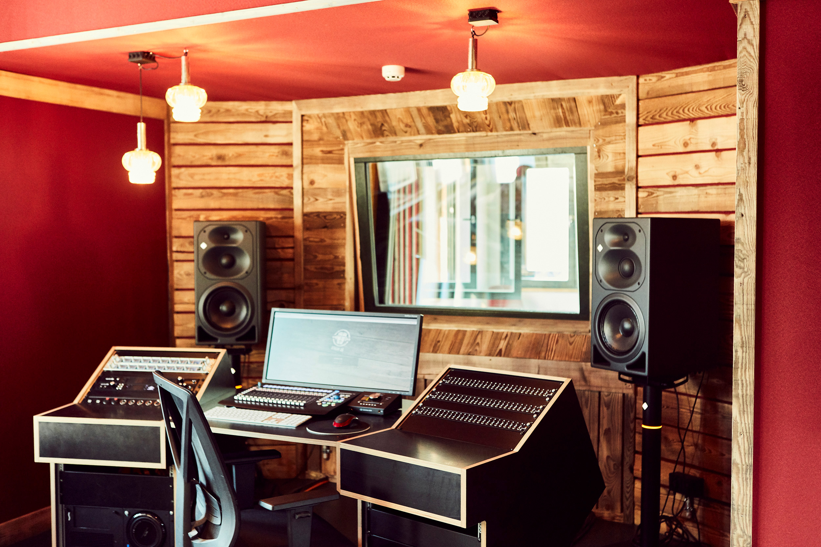
The newly constructed recording studio is at the center of a multimedia, interconnected production complex. Covering 110 m², the complex includes three recording booths and a control room with an equally large roof terrace, immediately adjacent.

As part of the cooperation, Neumann will be using Studio 25 for the production of video tutorials but this unique location will also provide an ideal venue to proactively engage with producing musicians of all stripes: In particular Neumann is keen to work with artists who have typically recorded at home, but now can make use of the studio – whether by the day or even hour – to expand their possibilities.

At the end of September, the new studio complex hosted a prestigious group of Chinese talent that included artists and producers, as well as journalists. The visiting VIPs included Zhang Yadong, the “Godfather of Chinese pop music”, Geng Sihan, known from “The Voice of China,” best-selling author Zhuang Yating and singer Queen Wei.

The visitors were impressed by the loving attention to detail with which the studio has been furnished: As well as being a feast for the eyes, Neumann technology has ensured it is a delight for the ears as well. With no persuasion needed, the musicians present were happy to put on an amazing impromptu performance. The language of inspiration and music is truly universal.

Link to photo and text material: https://www.neumann.com/exchange/Studio25.zip

About Neumann
Georg Neumann GmbH, known as “Neumann.Berlin”, is the world’s leading manufacturer of studio microphones and the creator of recording legends including the U 47, M 49, U 67 and U 87. Founded in 1928, the company has been recognized with numerous international awards for its technological innovations. Since 2010, Neumann.Berlin has expanded its expertise in electro-acoustic transducer design to also include the studio monitor market, mainly targeting TV and radio broadcasting, recording, and audio productions. The company manufactures its microphones in Germany, while its world-class monitors are built in Ireland. Georg Neumann GmbH has been part of the Sennheiser Group since 1991, and is represented worldwide by the Sennheiser network of subsidiaries and long-standing trading partners. www.neumann.com

Press contact:

Andreas Sablotny
andreas.sablotny@neumann.com
T +49 (030) 417724-19

