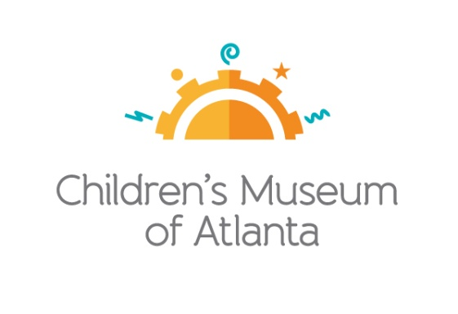

CONTACT
Alison Wentley
BRAVE Public Relations, 404.233.3993
awentley@emailbrave.com

*MEDIA ADVISORY*
Children’s Museum of Atlanta to host TinyCON®, August 31 and September 1
Families invited to Museum for third-annual celebration of all things fantasy, fiction, gaming and more!

ATLANTA (August 29, 2019) – Tiny adventures await! Children’s Museum of Atlanta will once again host TinyCON®, a celebration of favorite comics, games, fantasy books and more, Saturday, August 31 and Sunday, September 1. Throughout the weekend, little ones can compete in Pokémon scavenger hunts, create a custom fantasy or superhero mask, participate Jedi training courses, blend a wild smoothie in Princess Zelda’s cooking class, make new discoveries in Indiana Jones’ Archaeology Lab and much more! Costumes are welcome and families are encouraged to purchase tickets in advance.

WHAT: TinyCON®
Celebrate the beginning of Fall with a celebration of fantasy, science fiction, comics, gaming and technology…for kids!

WHEN: Saturday, August 31
10 a.m.- 5 p.m.
Sunday, September 1
10 a.m. – 5 p.m.

WHERE: Children’s Museum of Atlanta
275 Centennial Olympic Park Drive, NW
Atlanta, GA 30313

HOW: Due to the popularity of TinyCON®, guests are encouraged to purchase tickets online in advance for guaranteed entry and the best value. For additional details and to purchase tickets, please visit bit.ly/TinyCON2019

For more information or to support Children's Museum of Atlanta, visit childrensmuseumatlanta.org
or call 404.659.KIDS [5437]

###

