**DRAFT**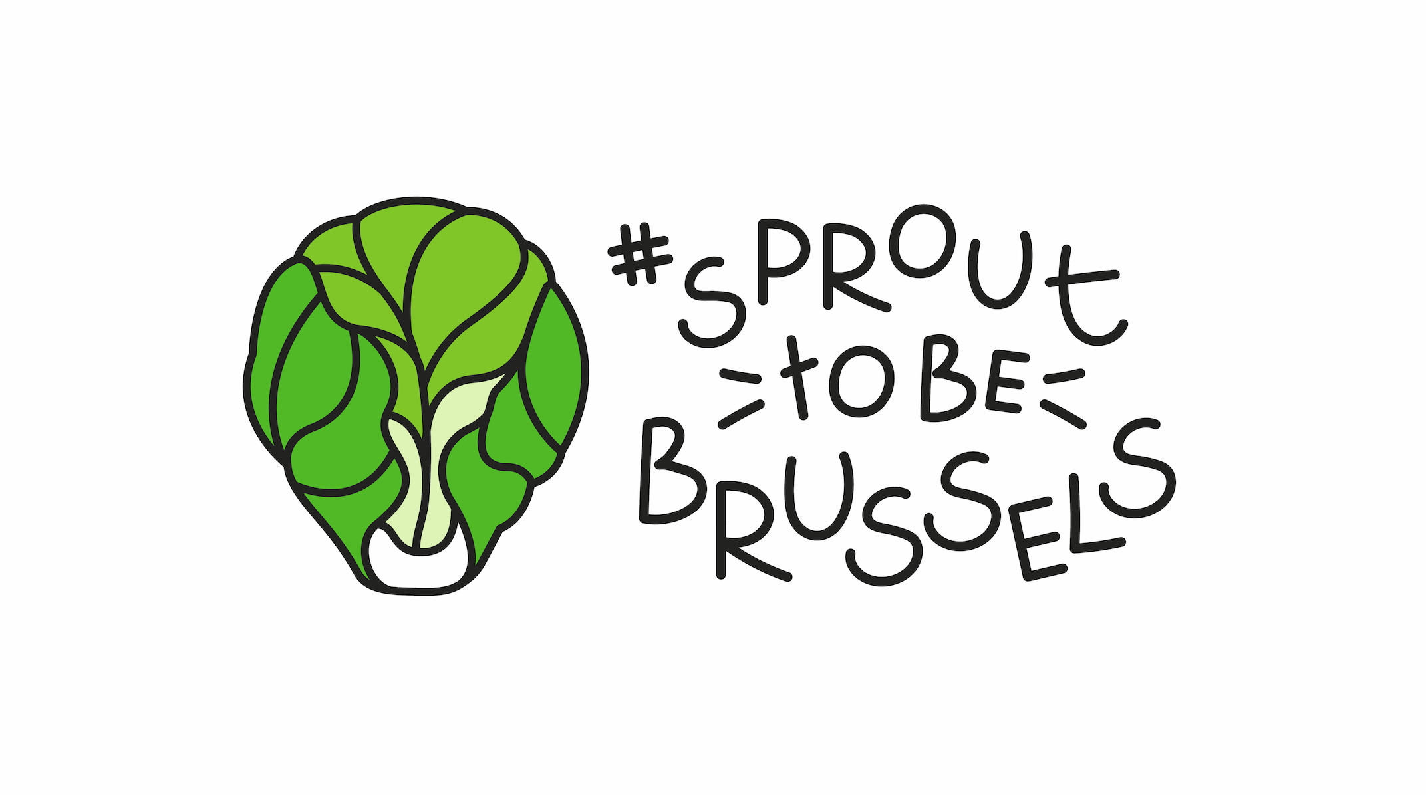

**PRESS RELEASE**

**The *#sprouttobebrussels* movement picks up speed**

**The movement now has the active support of over 100 partners**

* **For several weeks already, people that love Brussels have been showing their pride thanks to #sprouttobebrussels and its Facebook page. A total of 60 businesses and more than 18,000 fans have joined the movement. As of today, anyone can share their Brussels “sprouts” on the** [**sprouttobebrussels.be**](http://www.sprouttobebrussels.be) **platform.**
* **Given this popular success, the movement’s founding members – bpost, BECI, Brussels Airlines, Brussels Hotel Association, ING, Partena Professional, Partenamut and Rossel – have decided to create a non-profit association to give a longer lifespan to the movement and its missions.**
* **The #sprouttobebrussels association designs and develops its own projects thanks to the active support of more than 100 partners from every sector: 60 from business, 13 cultural partners, 17 academic partners, 12 media partners, 18 economic partners, 5 associations and 2 institutional partners. They enable a unique level of cooperation and impact.**
* **Projects in the service of 3 major goals for the people of Brussels, Belgium and beyond: improving the image of the city, emphasizing the attractiveness of the city and uniting a maximum of ambassadors around the movement.**

**Brussels, May 25 2016 –** The sprout is the work of a Brussels-based designer at the TBWA agency. As part of a briefing on the deteriorating image of Brussels, he revisited a slightly surreal and typically Brussels symbol, the Brussels sprout, enabling it to be used to show one’s pride and affection for the city: #sprouttobebrussels. The first idea rapidly took on a life of its own. Very quickly, some 30 private parties wanted to get things moving and were enthusiastic at the idea of spreading the sprout in the heart of the city, involving its shops and businesses. *“The movement first came to life amongst Brussels’ businesses, hotels and restaurants with the distribution of 30,000 stickers and 24,000 badges. It was welcomed enthusiastically and after sowing some sprouts, requests for more material came flooding in. Showing one’s pride for Brussels thanks to #sprouttobebrussels became a hit on Facebook, the page now has more than 18,000 fans.”,* notes Cédric Swaelens, coordinator of the association.

**The surprising coalition of more than 100 partners**

*“The power of the #sprouttobebrussels movement comes from having rapidly welcomed into its missions partners from all the major sectors in Brussels: 60 from business, 13 cultural partners, 17 academic partners, 12 media partners, 18 economic partners, 5 associations and 2 institutional partners[1]. This is a first.”,* adds Swaelens. More than 100 diverse partners with which the association can now launch concrete initiatives focused on its three concrete goals and the implementation of these goals: improving the image of Brussels, emphasizing the attractiveness of the city and uniting a maximum of ambassadors around the movement.

A few of the local and international initiatives:

* In June and July, three companies - Ticket Restaurant Edenred, Sodexo and Monizze – will launch an action to encourage people to return to Brussels’ restaurants. Holders of restaurant tickets will be prompted to eat out in Brussels, and possibly win a CityTrip there (accommodation, restaurant and cultural activity).
* Another project will improve the appeal of the city and attract more tourists by embellishing the places that greet them, such as the South and Central station, with giant 3D sprouts created by Brussels designers. A competition will enable a jury and the general public to designate the best projects.
* We are going to choose places in Brussels that have been forgotten and ask street artists to turn them into “Sprout to be Brussels” masterpieces. The first forgotten space will be the Petillon tunnel that will be transformed into a graffiti-sprout.
* Happy Belgian Day: for the Belgian national holiday, travellers born on July 21 will be invited for a weekend in Brussels thanks to our partnership with Brussels Airlines, the Brussels Hotel Association and others.
* Brussels Airlines and the Brussels Hotel Association will also launch some promotions for weekends in Brussels, to bring back more visitors.
* Brussels’ cultural scene is very present through many partners and artists. Between Tuesday 28/06 and Sunday 3/07, upon presenting a Sprout badge, visitors can enjoy the 1 + 1 free action at all the BOZAR exhibitions. In August, the association will organise an exhibition of the best Sprout photos at BOZAR.

*“We are currently still actively working on many other initiatives and we also support all existing projects that meet our goals. Lastly, the association also wants to be the driving force behind initiatives from any companies that would want to join the movement to restore the image of Brussels and Belgium.”,* concludes Swaelens.

***

**Press contact**

PRIDE

Aurélie Coeckelbergh – 0479 261 613 – [aurelie.coeckelbergh@pr-ide.be](mailto:aurelie.coeckelbergh@pr-ide.be)

Laure Miquel-Jean – 0477 317 161 – [laure.miquel-jean@pr-ide.be](mailto:laure.miquel-jean@pr-ide.be)

1. The complete list of Sprout partners can be found in the press file