For immediate distribution

WATCH THIS: Producer/Engineer Vance Powell Demonstrates Acoustic Guitar Miking Technique with BAE 1073 Dual Channel Mic Pre

Grammy award-winning producer/engineer trusts BAE preamps to deliver classic warmth in the studio

Nashville, TN, March 23, 2020 –Vance Powell has become the producer/engineer of choice for an enviable portfolio of artists from all corners of Americana, from the rootsy singer-songwriter stylings of artists like Chris Stapleton and Randy Newman to high-energy rockers like Jack White, The Stray Cats, and Illiterate Light. Operating out of his Nashville studio Sputnik Sound, the six-time Grammy Award winner is known for his uncanny ability to capture the subtle nuances of human performance through his signature production style and attention to detail. A key part of his sound has been his use of BAE 1073 preamps to capture these performances with warmth, personality, and detail.
In an exclusive video for BAE, Powell explains his method for the ultimate studio acoustic guitar sound, which he achieves with a carefully placed XY stereo pair of microphones, a stereo compressor, and the BAE 1073MP Dual Channel Mic Pre. “Acoustic guitar can be a complicated instrument to mike up,” he explained. “but with the BAE 1073 I’m capturing the natural warmth and movement of the instrument that can make or break a track.”
Watch here:
https://youtu.be/oXQWZB0b19A
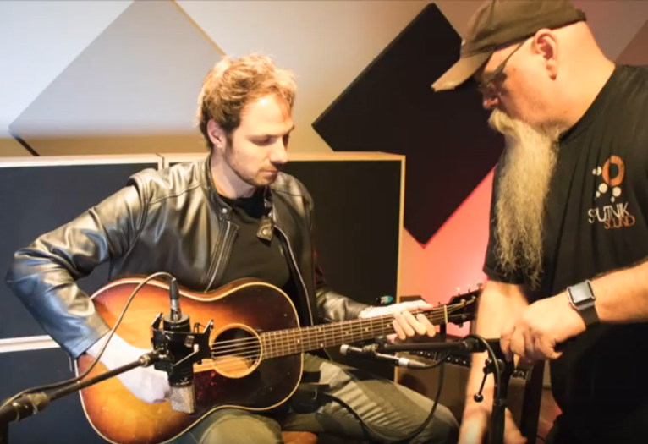
“I can never have enough of these.”
Powell’s aural fixation with the BAE 1073 preamp began six years ago when he was first setting up Sputnik Sound and acquired several of the preamps from BAE. They quickly became his go-to preamps for vocal and guitar sounds for their warmth and three-dimensional quality. “It’s such a familiar sound that you’ve heard on so many classic records,” explained Powell. “For me I can never have enough of these, because I always want to use them on everything.”
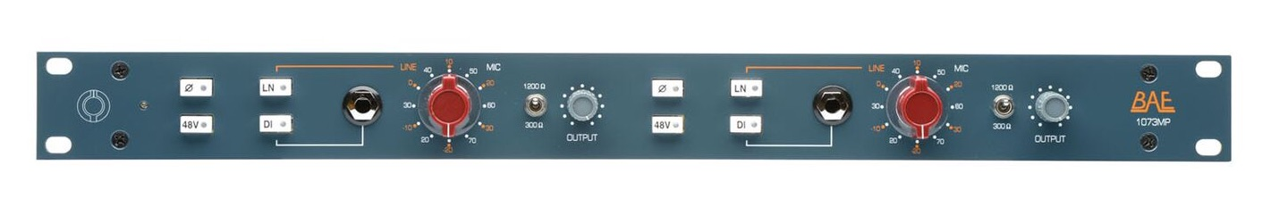
For more information on Vance Powell and Sputnik Sound, please visit: http://www.sputniksound.com/
For more information on the BAE 1073 Dual Channel Mic Pre please visit: http://www.baeaudio.com/products/1073mp

About BAE Audio
BAE Audio is a U.S.-based manufacturer of high-end microphone preamp and equalizers, all of which are faithful to vintage designs of the seventies and before. The company is committed to the vintage philosophy of hand wiring and hand soldering all of its components to achieve a high quality and authentically vintage sound. For more information on BAE Audio, please visit our website at www.baeaudio.com.

Media contact
Jeff Touzeau
Public Relations
Hummingbird Media
+1 (914) 602 2913
jeff@hummingbirdmedia.com

Steve Bailey
Public Relations
Hummingbird Media
+1 (508) 596 9321
steve@hummingbirdmedia.com

