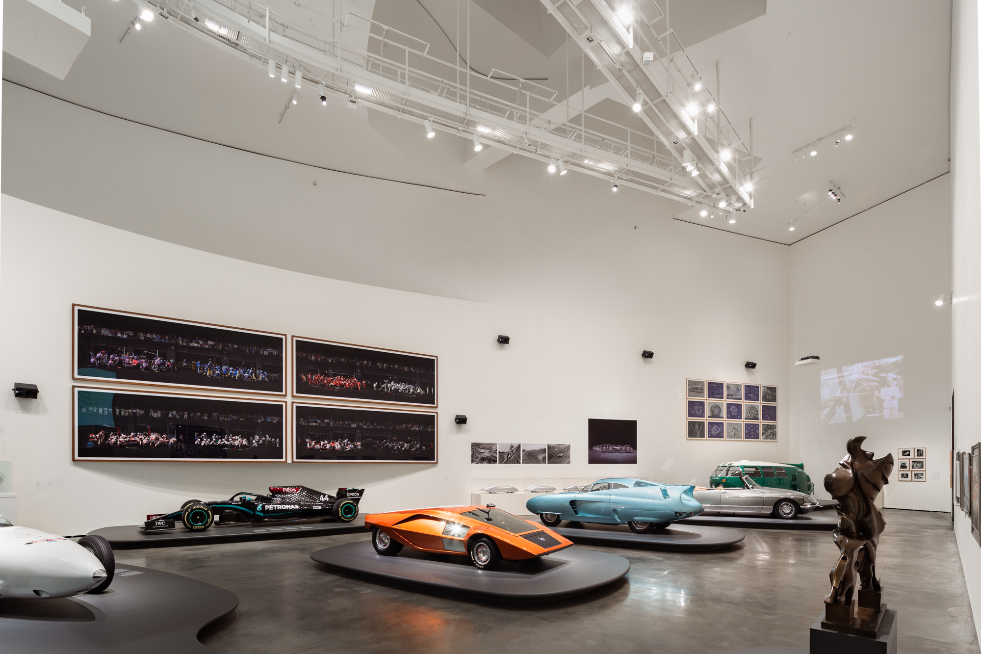

Sennheiser brings sound to life in milestone Guggenheim Museum Bilbao automotive exhibition Motion. Autos, Art, Architecture.
Audio specialist’s AMBEO Mobility suite of immersive audio solutions revolutionises the future of in-car entertainment and communication

Bilbao, Spain, July 2022 – ‘Motion. Autos, Art, Architecture is a landmark exhibition organized by the Guggenheim Museum Bilbao in collaboration with the Norman Foster Foundation. The legendary architect and renowned car enthusiast curated the exhibition, and collaborated with another well-known car fanatic, Nick Mason of Pink Floyd, for the sound design of some of its galleries. Immersive sound specialist Sennheiser was invited to deliver an innovative audio experience for the showcase.

Running between April and September this year, Motion. Autos, Art, Architecture is an epic installation that plots the history of the automobile with the evolution of modern art, celebrating the artistic dimension of the car and linking it to the parallel worlds of painting, sculpture, architecture, photography and film. Installed into seven themed galleries, namely Beginnings, Sculptures, Popularising, Sporting, Visionaries, Americana, and Future, Foster and his co-curators from the Guggenheim Museum Bilbao, Manuel Cirauqui and Lekha Hileman Waitoller, have brought together 38 automobiles, each an architype of the theme in terms of beauty, rarity, technical progress and a vision of the future: alongside an outstanding selection of masterworks from modern and contemporary artists and architects.

“These are extraordinarily beautiful objects, and they co-exist at an equal level with great works of art and architecture,” Foster declared to the press at the opening of the exhibition. “There’s a cultural synergy and that is against the silo mentality where we think of something as fine art and these objects as just a kind of car.”

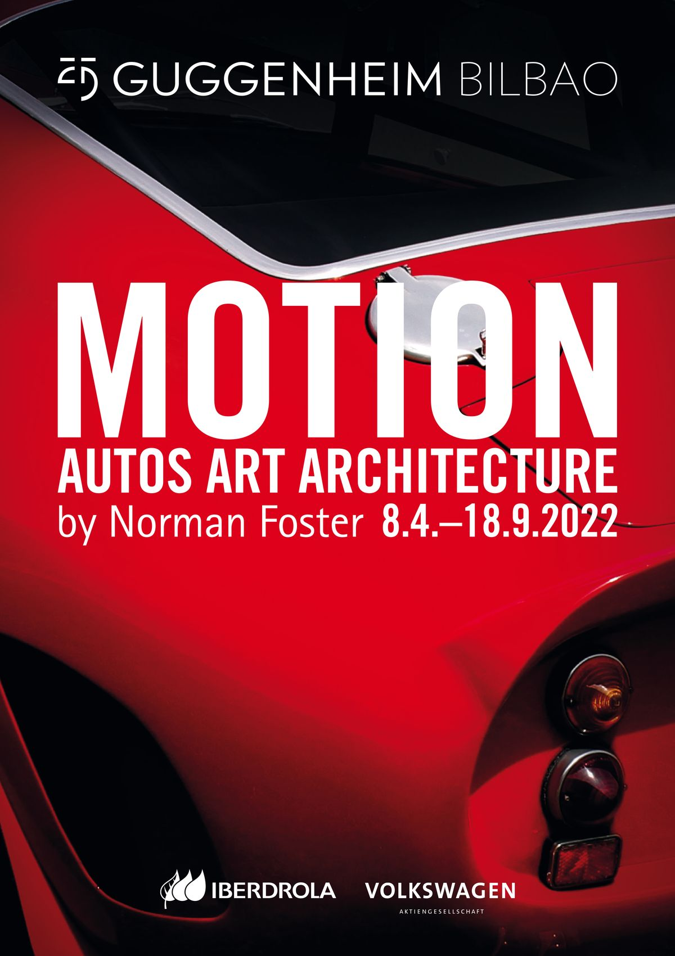 | ‘MOTION. Autos, Art, Architecture’ is an epic installation that plots the history of the automobile with the evolution of modern art

Sennheiser was invited to partner with the exhibition, alongside other automotive industry partners, including Iberdrola, Volkswagen Group and Cadillac, due to its expertise in the automotive arena via its AMBEO Mobility division. AMBEO Mobility comprises Sennheiser’s suite of immersive audio solutions, which the company is actively developing to revolutionise the future of in-car entertainment and communication.

One of the exhibition’s sections is a dedicated learning spaces as part of the Guggenheim Museum’s Didaktika project, which designs educational content and activities to complement its exhibitions. Musician, Nick Mason, who also owns one of the iconic cars on display, was approached to conceptualise the soundscape in this area of the exhibit, additionally to having given the sound to a contemporary racing vehicle on display in the Visionaires hall at racetrack sound levels played back immersively.

Two of the exhibition’s halls are dedicated learning spaces as part of the Guggenheim Museum’s Didaktika project, which designs educational content and activities to complement its exhibitions. | 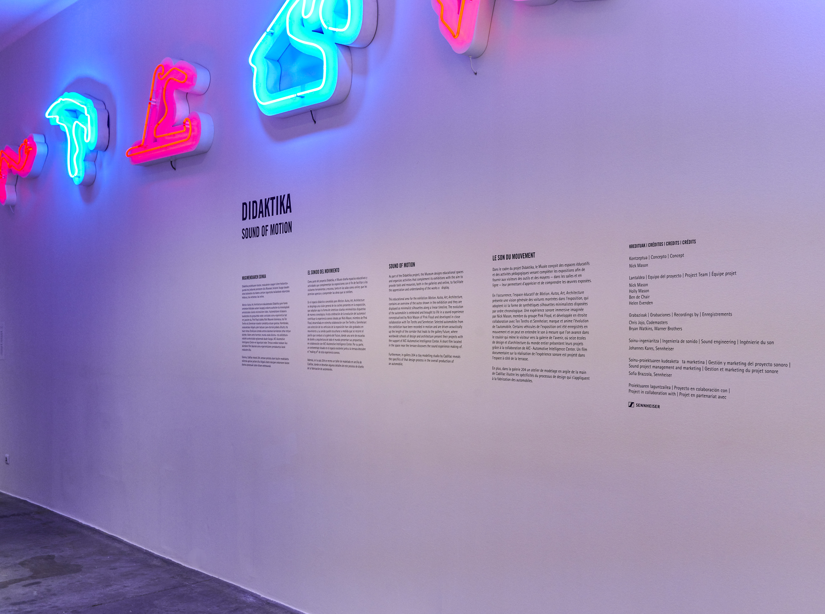

In the Didaktika galley, Mason’s concept was to present a linear timeline of the automobiles shown throughout the exhibition, selecting and recording the sound of ten engines from the most iconic and representative cars in the collection. To compose and enable the soundtrack, Nick Mason and his team at Ten Tenths selected and recorded cars in motion, and and partnered with Sennheiser to bring to life the vision of an emotion-rich, realistic sound experience powered by immersive audio technology and expertise.

The finished piece is evocatively played along the length of the corridor that fittingly leads to the Future gallery, where worldwide schools of design and architecture are presenting their visionary automotive concepts, with the support of AIC-Automotive Intelligence Center, a European centre for the generation of value for the automotive sector to address the challenges of the 21st century.

“The composition gives a voice to some of the world’s most forward-thinking cars in automotive history, portraying the evolution of automotive engine sounds over time,” explains Johannes Kares, sound engineer at Sennheiser. “Neumann speakers were selected for their compact and invisible design, and their intimate and immersive audio quality, which was the perfect fit for this installation.”

The exhibition includes many rare examples, such as Nick Mason’s 1962 Ferrari 250 GTO, a 1950 Porsche 356 Pre-A, one of the 1964 Aston Martin DB5s used in Goldfinger, a 1970 Lancia Stratos Zero concept car, and Lewis Hamilton’s 2020 Mercedes F1 car. Many of the cars derive from private collections and public institutions, meaning this exhibition is providing access for a wider audience for the first time.

“This truly is a ground-breaking, unique exhibition. Never before has such a collection of automobile history and future concepts been gathered in one space, and with the dawn of the electric power revolution, the timing could not be more fitting,” concludes Sofia Brazzola, Brand & Marketing Manager, AMBEO Mobility at Sennheiser. “Sennheiser’s AMBEO Mobility venture is committed and invested in the future of automotive audio and communication technology, and we are proud to be at the forefront of this milestone exhibition.”

About the Sennheiser brand
We live and breathe audio. We are driven by the passion to create audio solutions that make a difference. Building the future of audio and bringing remarkable sound experiences to our customers – this is what the Sennheiser brand has represented for more than 75 years. While professional audio solutions such as microphones, meeting solutions, streaming technologies and monitoring systems are part of the business of Sennheiser electronic GmbH & Co. KG, the business with consumer devices such as headphones, soundbars and speech-enhanced hearables is operated by Sonova Holding AG under the license of Sennheiser.

www.sennheiser.com
www.sennheiser-hearing.com

Press Contacts

Ann Vermont Maik Robbe
Ann.Vermont@sennheiser.com Maik.Robbe@sennheiser.com
+33 (0) 1 49 87 44 20 +49 (0) 5130 / 600 1028

