NEUMANN HONORED WITH 90TH ANNIVERSARY ‘SERVICE TO INDUSTRY’ AWARD DURING AES 145TH PRO AUDIO CONVENTION IN NEW YORK CITY

NEW YORK CITY/BERLIN – November 5, 2018 – During the AES 145th Pro Audio Convention recently held in New York City, Neumann.Berlin was presented with a 90th Anniversary ‘Service to Industry’ award by the AES — which celebrated its own 70th anniversary in parallel. The award was presented to Neumann President Wolfgang Fraissinet during a special ceremony on Thursday, October 16th in celebration of the company’s standard-setting legacy of engineering prowess in the development of microphones for studio and live performance, and for Neumann’s advancement of microphone technology.
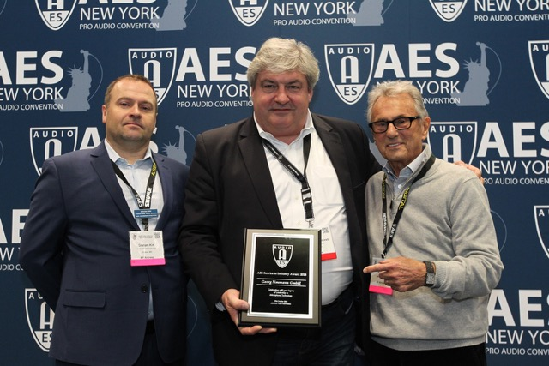
The award ceremony took place on the first day of the exhibition at the PSE Recording Stage inside the Jacob Javitz Center complex, where Graham Kirk, AES International Sales Director and Al Schmitt, multi-GRAMMY® Award winning engineer/mixer presented on behalf of the AES.

“It is a great honor to be recognized by such a stalwart organization such as the AES, and by Al Schmitt, who is a celebrity in his own right and also a great friend,” commented Wolfgang Fraissinet. “I am proud of Neumann’s accomplishments over the last 90 years, and humbly accept this award on behalf of all my colleagues, past and present. We are committed to excellence in everything we do and already looking forward to our 100th in ten years!”

During the exhibition, Neumann displayed many of innovations, both past and present. For instance, its limited-edition U 87 Rhodium Set and a re-issue of its famous U 67 microphone were at the stand, while more recent products on display included the Neumann.Control app for iPad, which opens up the full potential of the KH 80 DSP studio monitor. Neumann.Control, which utilizes standard IP networking, allows users to define loudspeaker systems from mono to 3D audio set-ups, align them for a well-balanced in-room sound, and then operate them centrally.

Caption:
AES international sales director Graham Kirk (left) and multi-Grammy Award winning engineer/mixer Al Schmitt (right) present the award to Neumann president Wolfgang Fraissinet (center)

Link to photo and text material: https://www.neumann.com/exchange/AES-Award.zip

About Neumann
Georg Neumann GmbH, known as “Neumann.Berlin”, is the world’s leading manufacturer of studio microphones and the creator of recording legends including the U 47, M 49, U 67 and U 87. Founded in 1928, the company has been recognized with numerous international awards for its technological innovations. Since 2010, Neumann.Berlin has expanded its expertise in electro-acoustic transducer design to also include the studio monitor market, mainly targeting TV and radio broadcasting, recording, and audio productions. The company manufactures its microphones in Germany, while its monitors are built in Ireland. Georg Neumann GmbH has been part of the Sennheiser Group since 1991, and is represented worldwide by the Sennheiser network of subsidiaries and long-standing trading partners. More information at www.neumann.com.

Contact USA: Contact Global:
Jeff Touzeau Andreas Sablotny
jeff@hummingbirdmedia.com andreas.sablotny@neumann.com
+1 (914) 602-2913 +49 (030) 4177 24 –19

