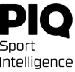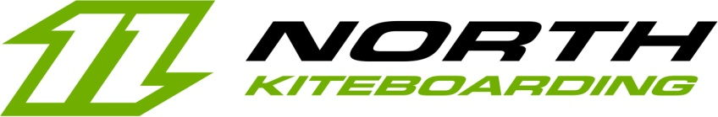

North Kiteboarding and PIQ Sport Intelligence present
a major innovation at ISPO 2017:
the first-ever connected kiteboard

Paris, February 6th 2017 – Embarking on a new step in an already fruitful partnership, PIQ and North Kiteboarding have now created the first-ever connected kiteboard – The new product integrates a PIQ ROBOTTM artificial intelligence device in the mythic Jaime board.

PIQ and North Kiteboarding are announcing the world premiere of this truly disruptive innovation at the ISPO 2017 and will be demonstrating a working prototype at the PIQ booth. The Jaime board prototype, the first of its kind in the world, will be embedded with the GAIA Intelligence — the first Artificial Intelligence system that autonomously analyzes sports motions.
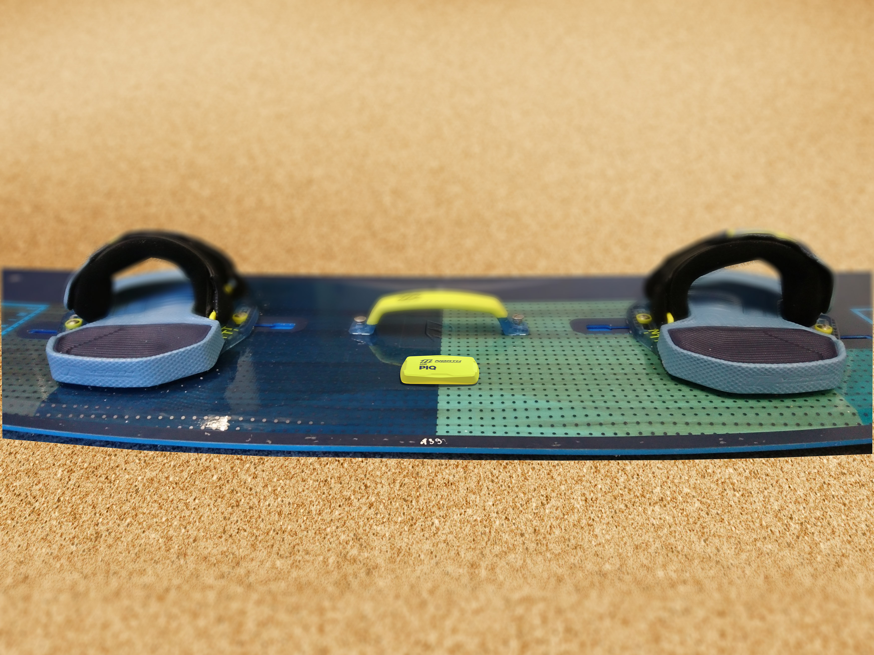
The world-premiere of the 'connected kiteboard’
The PIQ ROBOTTM nano-computer — now embedded within the Jaime board — is bound to revolutionize the kiteboarding experience thanks to a LED display right that appears between the rider’s feet.
Thanks to this new technology smartly embedded in already advanced sport equipment, the rider can now get all of the GAIA intelligence in real-time.

GAIA, the first Artificial Intelligence system that autonomously analyzes sports motions in real-time, utilizes advanced algorithms to analyze movement in real-time and is able to deliver information directly to the kiteboarder on the screen and its EZ-reading gauges — even while he or she is still in the water.

The multi-algorithmic machine-learning intelligence featured in North and PIQ is the result of both fundamental and applied research. As a result of PIQ's relentless innovation, the technology is now able to understand and analyze microscopic variations in kiteboarding movements.

Specifically, the PIQ ROBOTTM embedded in the Jaime board is able to measure the rider’s speed, their height for each jumps, their hangtime, as well as the smoothness of their landings, and many other metrics.

When the best of Freestyle and Freeride are combined, you get the Jaime. As one of the North Kitboarding’s longest standing Freestyle boards with a legendary status, the Jaime is great for both hooked-in and unhooked riding. Its Quattro V Bottom delivers an engaging grip, whilst the medium Flex pattern ensures comfort and outstanding Freestyle characteristics.
Fast and with great pop, Freestyle riders looking for an explosive, yet forgiving ride will relish in the Jaime’s all-round attributes.
In combination with PIQ ROBOTTM the Jaime will push your kitesurfing skills to your next level!

North Kiteboarding and PIQ are now moving forward to a new step in their partnership by integrating their respective technologies in one single product.
Beyond this prototype, the long-term objective is to integrate the PIQ ROBOTTM technology in several boards within the North Kiteboarding range.

Cédric Mangaud, CEO of PIQ Sport Intelligence states ““Since the founding of PIQ, we’ve always had that vision of embedding PIQ directly in the players’ gear to give them the best experience possible. Thanks to the work of our two teams, we’re now extremely proud to unveil today at ISPO what is truly a breakthrough innovation with the world’s first connected kiteboard.”

« We’re entering a new era for kiteboarding thanks to the integration of the PIQ’s technology within the North Kiteboarding boards», states Till Eberle, CEO of Boards and More, parent company of North Kiteboarding. “This will incredibly enrich the experience of the riders and allow them to better understand and analyze their performance in real-time”.

PIQ will present prototypes of this revolution at its booth – BN54 in Hall B5 – for the duration of show.

Contact:
Jeff Touzeau
Hummingbird Media
jeff@hummingbirdmedia.com
+1 914 602-2913

About North Kiteboarding

North Kiteboarding is the world’s leading Kiteboarding brand. The high-tech performance, premium quality, innovative design and versatility of our products form the foundation that we have built the brand on.

Over the last 10 years, our passion and drive has seen great success and achievements. We are continually working towards the support and growth of the Kiteboarding industry and the lifestyle it represents.

North Kiteboarding is a subsidiary of Boards&More, which was founded in 2000 to design and deliver products under the brands Fanatic, ION, North Kiteboarding and North Sails Windsurfing.

About PIQ Sport Intelligence:

Cedric Mangaud and Ongan Mordeniz form the explosive duo behind PIQ Sport Intelligence. Cédric and Ongan are both whiz kids in the tech industry, and true sport fans.

Before PIQ, Cédric used to manage the Added Values Services at HTC group where he was on the Management Board. Before joining HTC, Cédric was the founder and CEO of Abaxia, a company specialized in mobile software, twice crowned leader in its market.

Ongan was VP of Values Added Services at HTC group. Before joining HTC, Ongan used to manage near-shore R&D sites in Belarus for companies he held shares in.

Since its creation, PIQ has raised €13m from Taiwanese Foxconn (FIH Mobile Ltd), Ginko Ventures, Orkos Capital, Swisscom and Almaz Capital. PIQ employs today 67 people.

About ISPO

Every year, more than 2,600 international exhibitors present their latest products from the segments of Outdoor, Ski, Action, Performance Sports, Textrends, Health & Fitness and Sourcing at ISPO MUNICH to over 80,000 visitors from 110 countries.

For over 45 years the global leader has provided a comprehensive overview of the entire range of sporting goods, athletic footwear and fashions, as well as the latest trends from these segments. Year for year the custom-tailored trade show concept with special communities and authentic side events guarantees a very unique, personalized and communication-rich atmosphere.
As the only multi-segment trade show the event also offers its participants an opportunity to discover discipline-overlapping synergy and cross-selling potential, as well as recognize new segments and trends in advance.

Thanks to close cooperation with the industry ISPO can identify market requirements and offers international sports business professionals the best possible presentation and networking platform at ISPO MUNICH.

