Sennheiser highlights Campus-wide Audio at ISE 2020
New IT-friendly audio solutions for higher education and corporate customers

Wedemark, 17 December 2019 – Reliable audio solutions for the entire university campus or the company premises: At ISE 2020, Sennheiser will show how easily its audio systems can be deployed and integrated, as well as controlled and maintained in campus-style installations. At the world’s largest AV show, audio specialist Sennheiser will showcase the latest generation of its MobileConnect assistive listening system. Consisting of the MobileConnect Station, MobileConnect Manager and the MobileConnect App, the streaming solution provides students with a fully inclusive and individually adaptable listening experience. In addition, Sennheiser’s successful SpeechLine Digital Wireless microphone system will be expanded by a new multichannel receiver, whose form and function recommends it to modern IT infrastructures.

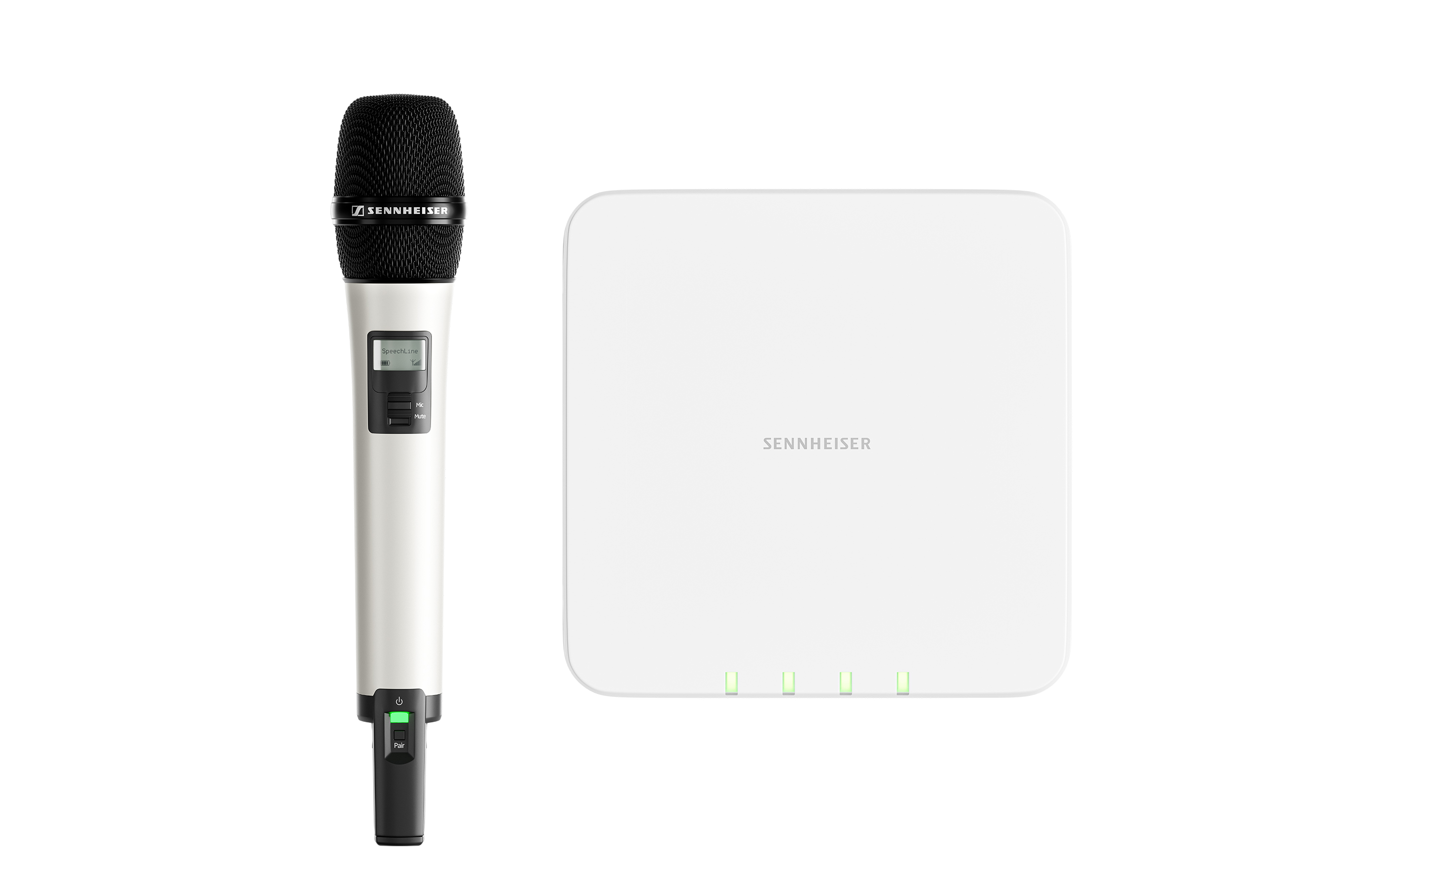 | The multichannel microphone receiver of Sennheiser’s SpeechLine Digital Wireless series is a perfect match for modern IT infrastructures
Also on show will be a major update for the Sennheiser Control Cockpit software, which allows centralized control and monitoring of campus- and company-wide audio installations with Sennheiser’s wireless microphone series such as SpeechLine Digital Wireless, evolution wireless G3 and G4, Digital 6000, as well as the TeamConnect Ceiling 2 microphone.

TeamConnect Ceiling 2, a certified for Microsoft Teams product, can be tried and tested in a live demo room at the Sennheiser stand. Visitors can experience the crystal-clear audio transmission and interconnectivity of the adaptive beamforming microphone.

Ron Holtdijk, Director Business Communications at Sennheiser: “We see the integration of technologies and inclusion of people as being crucial goals that inspire our focus. Our microphone and streaming solutions help our customers achieve these objectives, covering all audio and communication requirements on campus, whether it’s for lecture halls, smaller seminar rooms or even conference rooms.”

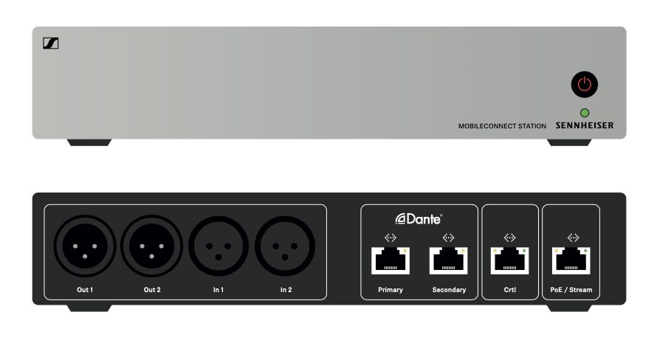 | At ISE, Sennheiser will launch the latest generation of MobileConnect – pictured is the MobileConnect Station
The new Sennheiser solutions can be experienced from 11 to 14 February 2020 at the Sennheiser stand B50 in Hall 2.

The images accompanying this press release can be accessed here: https://sennheiser-brandzone.com/c/181/vdRsPWMr. More detailed information on the new products will be available in the ISE press kit.

About Sennheiser
Shaping the future of audio and creating unique sound experiences for customers – this aim unites Sennheiser employees and partners worldwide. Founded in 1945, Sennheiser is one of the world’s leading manufacturers of headphones, loudspeakers, microphones and wireless transmission systems. Since 2013, Sennheiser has been managed by Daniel Sennheiser and Dr. Andreas Sennheiser, the third generation of the family to run the company. In 2018, the Sennheiser Group generated turnover totaling €710.7 million. www.sennheiser.com

Global Press Contact

Stephanie Schmidt
stephanie.schmidt@sennheiser.com
T +49 (5130) 600 – 1275

