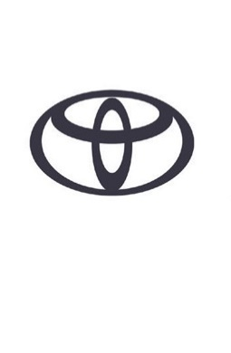

TOYOTA GR SUPRA MANUAL TRANSMISSION – SPECIFICATIONS

POWERTRAIN
TYPE | B58B30M1, 6-CYLINDER, IN-LINE
VALVE MECHANISM | 24-VALVE, DOHC, CHAIN DRIVE WITH VARIABLE VALVE TIMING (IN/EX)
FUEL SYSTEM | DIRECT INJECTION
TURBOCHARGER | TWIN SCROLL TURBOCHARGER
DISPLACEMENT (CM³) | 2,998
BORE X STROKE (MM) | 82 X 94.6
COMPRESSION RATIO (:1) | 11.0
POWER OUTPUT (DIN HP / KW @ RPM) | 340 / 250 @ 5,000-6,500
TORQUE (NM @ RPM) | 500 @ 1,600-4,500

TRANSMISSION
TYPE | 6-SPEED MANUAL (GS6L50TZ)
FINAL GEAR RATIO (:1) | 3.460
1ST | 4.110
2ND | 2.315
3RD | 1.542
4TH | 1.179
5TH | 1.000
6TH | 0.846
REVERSE | 3.727

PERFORMANCE
MAX. SPEED (KM/H) | 250 (ELECTRONICALLY LIMITED)
ACC. 0-100 KM/H (SEC) | 4.6

FUEL CONSUMPTION (L/100KM)
WLTP COMBINED CYCLE | 8.788
FUEL TANK CAPACITY (L) | 52

CO₂ EMISSIONS (G/KM)
EURO CLASS | EURO6(ECE)
WLTP COMBINED CYCLE | 198.3

CHASSIS
FRONT SUSPENSION | DOUBLE-JOINT TYPE MACPHERSON STRUT
FRONT SUSPENSION STABILISER BAR DIAMETER (MM) | 23.5
REAR SUSPENSION | MULTI-LINK
REAR SUSPENSION STABILISER BAR DIAMETER (MM) | 18.0
STEERING  OVERALL RATIO (:1)  LOCK TO LOCK  MIN. TURNING RADIUS TYRE (M)  MIN. TURNING RADIUS BODY (M) | 15.1  2.1  10.4  11.0
BRAKES  FRONT (DIAMETER MM)  REAR (DIAMETER MM) | VENTILATED DISC BRAKE WITH FIXED CALLIPER 4-CYLINDER (348)  VENTILATED DISC BRAKE WITH FLOATING CALIPER 1-CYLINDER (330-345)

WHEELS  FRONT  REAR | 9.0Jx19”  10.0Jx19”

EXTERIOR DIMENSIONS (MM)
OVERALL LENGTH | 4,379
OVERALL WIDTH | 1,854
OVERALL HEIGHT | 1,299
TREAD FRONT | 1,594
TREAD REAR | 1,589
WHEELBASE | 2,470
FRONT OVERHANG | 958
REAR OVERHANG | 951

CARGO (DM³ VDA)
CAPACITY | 290

WEIGHT (KG)
KERB WEIGHT (WITH DRIVER: 75 KG) | 1,577
GROSS WEIGHT | 1,795

SPECIFICATIONS SUBJECT TO HOMOLOGATION

