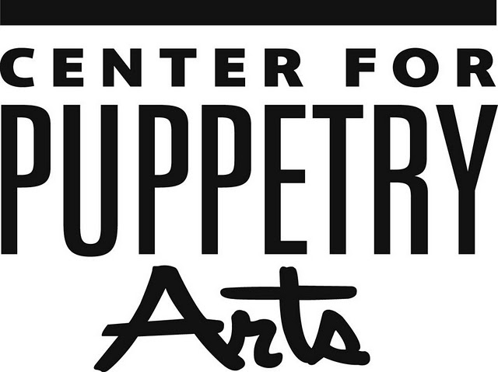

08
Fall

FOR MORE INFORMATION:

Becca Meyer/Jennifer Walker
BRAVE Public Relations
404.233.3993
bmeyer@bravepublicrelations.com/
jwalker@bravepublicrelations.com

Krystal Contact:
Peyton Sadler
305.631.2283
peyton@inklinkmarketing.com

Krystal® Donates Puppets to the Center for Puppetry Arts®
Krystal to Donate Henson Puppets used in Advertising to Create Special Display

ATLANTA (July 20, 2017) — Krystal, famous for its iconic square hamburgers, announced that it will donate puppet versions of its classic Krystal foods to the Center for Puppetry Arts® in Atlanta, Georgia. The Center for Puppetry Arts is the largest non-profit organization dedicated to the art of puppetry in the country and has introduced millions of visitors to the wonder and magic of puppetry through performances, curriculum-based workshops, and interactive installations in its Worlds of Puppetry Museum. The Museum features the largest collection of Jim Henson puppets and props in the world and will soon be home to a special area designated to the Krystal puppets.

The Krystal puppets were created by the Jim Henson Creature Shop in support of The Krystal Company’s 2016 “Shun the Ho-Hum” advertising campaign. The campaign featured playful puppet versions of the classic Krystal, Krystal Chik, Krystal fries and the Country-fried Krystal.

“We are absolutely thrilled that our Krystal puppets will continue to entertain millions of children and adults from all over the world for years to come,” said Heather Schlesinger, Director of Calendar, Program and Promotions at The Krystal Company. “We believe that our brand values are well-aligned as both of our organizations support ongoing education for school-age children designed to fuel their imagination.”

The donation fits in with the mission of the Krystal Foundation, which was established to provide much-needed funding for educational enrichment programs such as STEAM (Science, Technology, Engineering, Arts and Math) education, music and the performing arts, culinary instruction, and various sports programs.

“The Krystal puppets are truly an exciting addition to the Center. They showcase the power of puppets in our pop culture. Jim Henson’s career actually has its roots in advertising, so these puppets are a powerful reminder how the art of puppetry continues to spark the imagination and engage people of all ages. We look forward to collaborating with Krystal to get the word out that these puppets are right here in Atlanta…along with the Atlanta-based company that brought them to life,” said Vincent Anthony, The Barbara and Billy Wylly Executive Director for the Center for Puppetry Arts. “Our goal is to educate and enrich the world through the art of puppetry. We believe that highlighting figures like the Krystal puppets is a great door into the world of puppetry.”

Visitors to the Center for Puppetry Arts will be able to see the Krystal Puppets on display next summer.

About The Krystal Company
Founded in Chattanooga, Tennessee, in 1932, The Krystal Company is the oldest quick service restaurant chain in the South. Its hamburgers are still served fresh and hot off the grill on the iconic square bun at more than 350 restaurants in 11 states. Krystal’s Atlanta-based Restaurant Support Center serves a team of 6,000 employees. For more information, visit http://www.Krystal.com or http://www.facebook.com/Krystal or follow the brand on Twitter and Instagram @Krystal.

About the Center for Puppetry Arts®
Center for Puppetry Arts® is a unique cultural treasure – a magical place where children and adults are educated, enlightened, and entertained. Since 1978, the Center has introduced millions of visitors to the wonder and art of puppetry and has touched the lives of many through enchanting performances, curriculum-based workshops, and the hands-on Worlds of Puppetry Museum as well as Distance Learning and Outreach programs. Center for Puppetry Arts is a non-profit, 501(c)(3) organization and is supported in part by contributions from corporations, foundations, government agencies, and individuals. Major funding is provided by the Fulton County Board of Commissioners and the City of Atlanta Mayor’s Office of Cultural Affairs. These programs are also supported in part by the Georgia Council for the Arts through the appropriations of the Georgia General Assembly. GCA is a partner agency of the National Endowment for the Arts. The Center is a member Theatre for Young Audiences (TYA/USA/ASSITEJ) and serves as headquarters of UNIMA-USA, the American branch of Union Internationale de la Marionnette, the international puppetry organization.
###

