CX PLUS TRUE WIRELESS: SUPERIOR SOUND. NO COMPROMISE.
Sennheiser’s new earphones deliver premium sound with Active Noise Cancellation all day long

Wedemark, September 14, 2021 – When it comes to true wireless listening, superior sound and great wearing comfort are essential. Sennheiser’s new CX Plus True Wireless earphones deliver on both fronts and more, offering a thrilling, high-quality listening experience with Active Noise Cancellation, effortless smart interaction, and a sleek design for supremely comfortable all-day enjoyment.

The superior sound of Sennheiser’s new CX Plus True Wireless earphones is a world apart – at an accessible price point. This is made possible thanks to the clarity of its German-engineered TrueResponse transducer, an acoustic system that brings audiophile technology to everyday listening. Developed for the audio specialist’s premium earphones, this bespoke acoustic system delivers high-fidelity stereo sound with deep basses, natural mids and clear, detailed treble.

The Active Noise Cancellation function ensures that listeners do not miss a note, allowing them to experience all the clarity, detail and thrilling bass without distractions – even in noisier environments. Meanwhile, the Transparent Hearing feature makes it easy to focus on external sounds when desired without the need to remove the earbuds. This feature is particularly useful in letting outside sound in, so users are more aware of their surroundings.

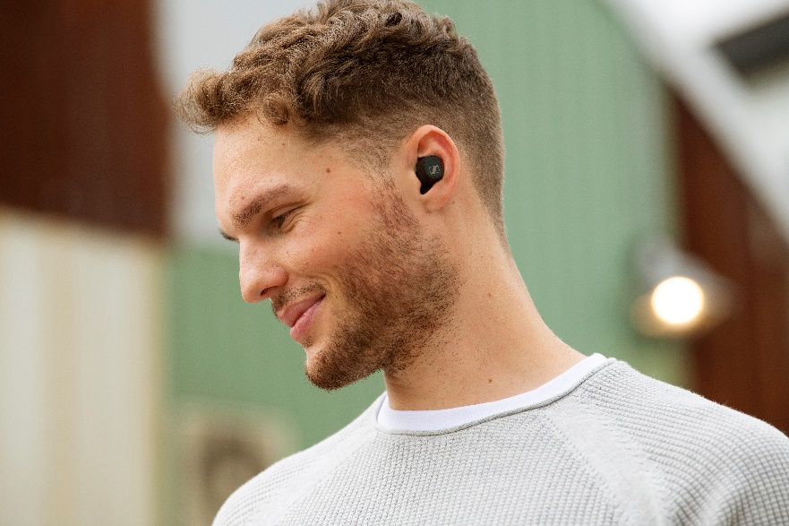 | The CX Plus True Wireless expands Sennheiser’s True Wireless portfolio by offering a superior listening experience with Active Noise Cancellation at an attractive price point

“Hot on the heels of our stylish CX True Wireless, we are now bringing an even more exceptional consumer earphone offering to the market,” says Frank Foppe, Product Manager at Sennheiser. “With audiophile-grade technology and added features like Active Noise Cancellation and Transparent Hearing, the CX Plus True Wireless provides a high-fidelity listening experience that’ll last the whole day.”

Everyday life, simplified
Thanks to the customizable touch controls, every interaction, touch, and moment shared with the CX Plus True Wireless can be conducted effortlessly. Users can even tailor bespoke commands to ensure that controlling audio, calls and accessing voice assistants is both convenient and intuitive. Each earbud is equipped with a pair of dual mics that optimizes speech for calls and voice assistant access to ensure crystal clear voice pick-up. The independent earbud use allows the right and left earbuds to be used individually or as a pair.

Another intelligent feature, Smart Pause, has been developed with the fast pace of modern life in mind. It automatically pauses audio when the earbuds are taken out and instantly resumes playback when replaced. The earbuds also automatically power up when removed from their charging case and switch off when put away, so they are ready when you need them. The CX Plus True Wireless also offers the latest connectivity options for a high-tech listening experience: Bluetooth 5.2 compatibility and SBC, AAC, aptX and aptX Adaptive codec support for high resolution, low latency audio that syncs perfectly with video content. Bluetooth connections can be easily managed via the Sennheiser Smart Control app, while the built-in EQ delivers a personalized audio experience and a thumping Bass Boost preset.

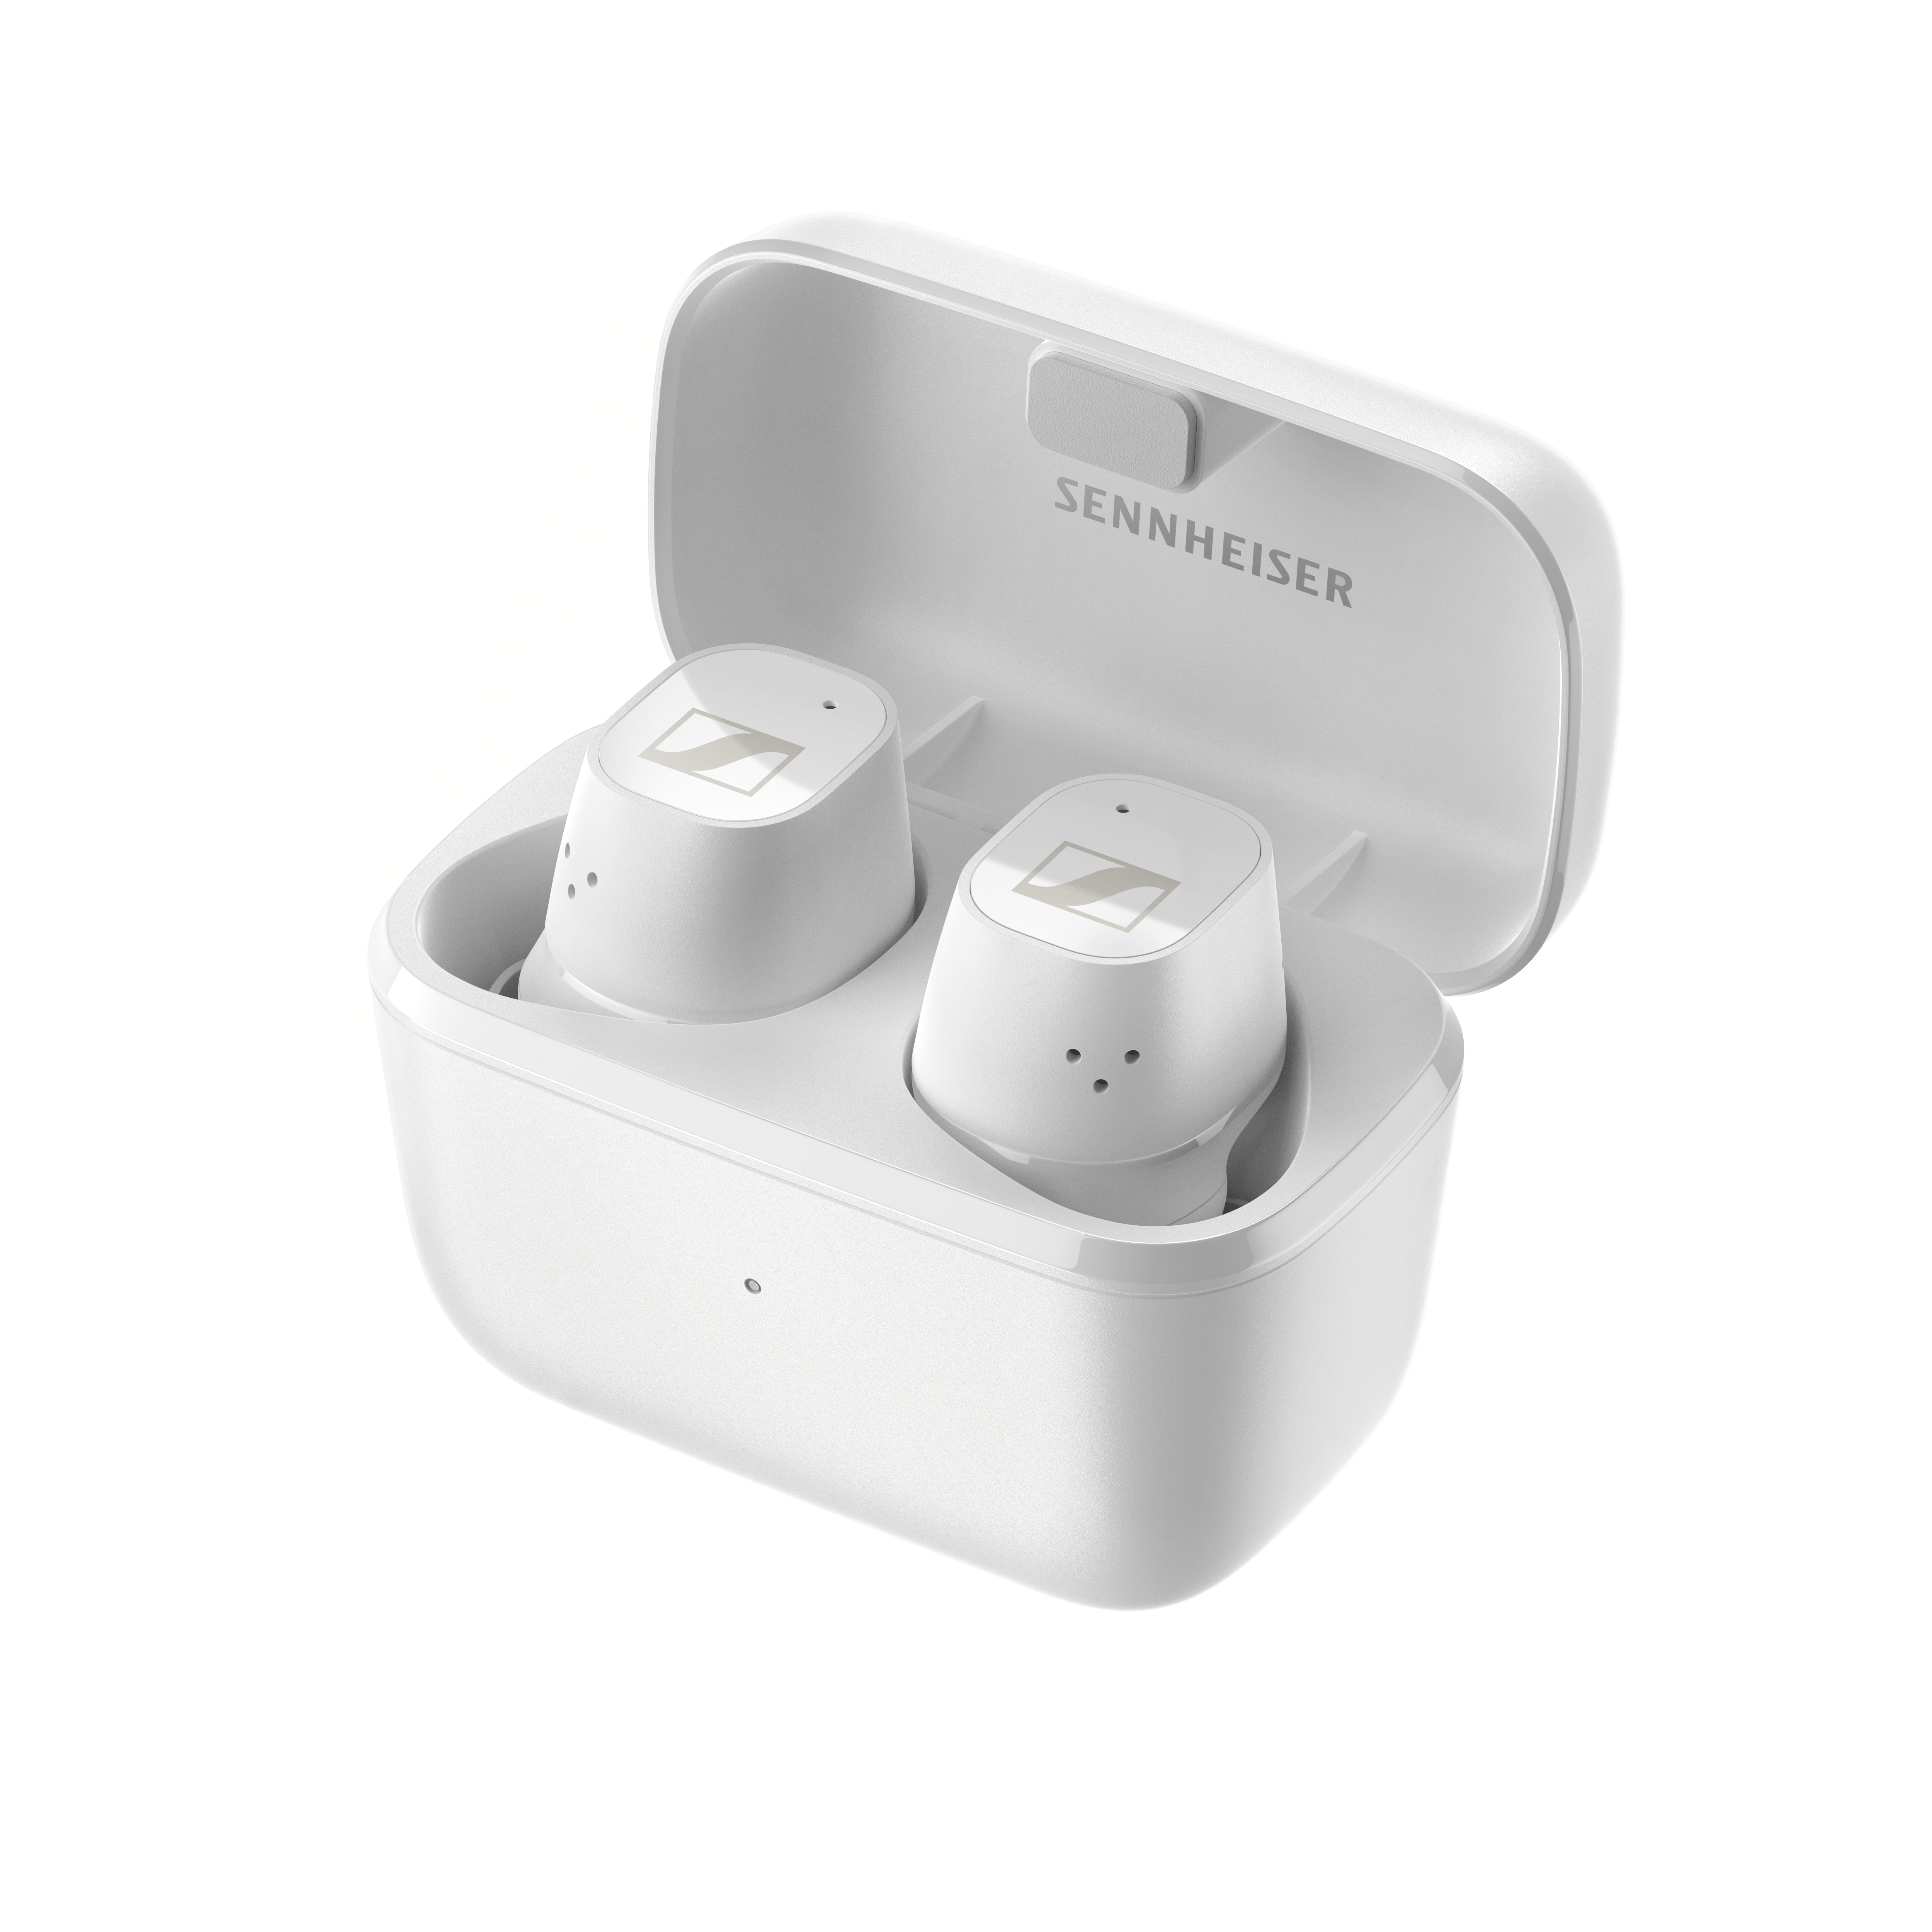 | The CX Plus True Wireless offers customizable touch controls and up to 24 hours playback time with on the go charging
Designed for all-day enjoyment
All Sennheiser’s True Wireless earbuds have been developed in line with the latest ergonomic research, and the sleek, smaller design of the CX Plus True Wireless guarantees fatigue-free all-day enjoyment. The compact earbuds also securely fit in the ear canal, so they stay in place when listening on the move. Optimal comfort is assured thanks to the four-size selection of silicon ear adapters, which add further passive noise isolation to complement the earbuds’ ANC.

With IPX4 rated splash resistance, listeners can enjoy the CX Plus True Wireless wherever they go. And, as life doesn’t slow down, the CX Plus True Wireless is ready to keep pace with its long-lasting battery and portable charging case, providing an impressive 24 hours of playback time.

The CX Plus True Wireless is available in black or white from September 28 for 159.90 EUR (MSRP).

ABOUT SENNHEISER
Shaping the future of audio and creating unique sound experiences for customers – this aim
unites Sennheiser employees and partners worldwide. The independent family company,
which is managed in the third generation by Dr. Andreas Sennheiser and Daniel Sennheiser, is
today one of the world’s leading manufacturers of headphones, loudspeakers, microphones
and wireless transmission systems. In 2020, the Sennheiser Group generated turnover totaling
€573.5 million. www.sennheiser.com

Global Press Contact
Sennheiser electronic GmbH & Co. KG
Milan Schlegel
PR and Influencer Manager EMEA
T +49 (0)5130 600-1139
milan.schlegel@sennheiser.com

