For more information, please contact Marta de Paco
On +34 670 780 664 or email press@comunicahair.com

Important:
These images are only available for editorial content.
Credits must be included.
Notification of their publication is expected.

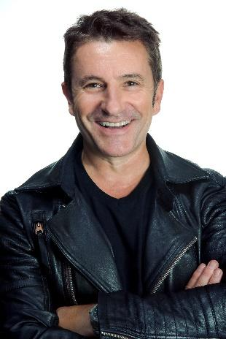
MIKEL LUZEA
INVERSO Collection

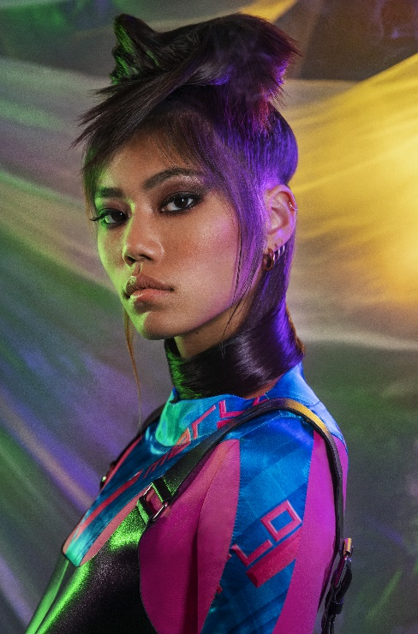
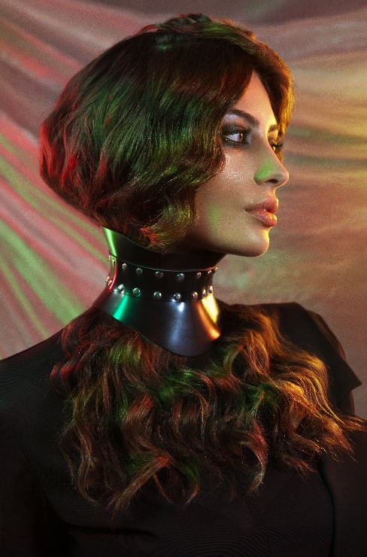
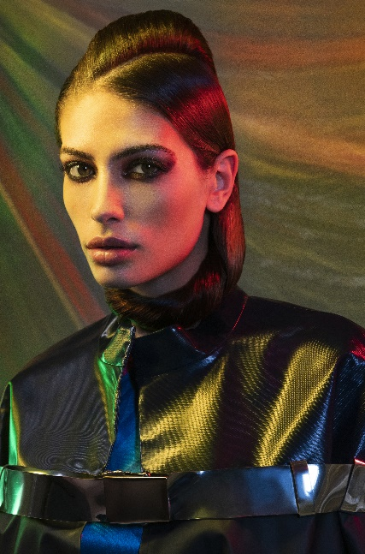
Hair: Mikel Luzea @mikelluzea
Photography: David Arnal @davidarnalteam
Make up: Alicia Najera
Styling: Eunnis Mesa @eunnismesa
Products: Revlon Professional @revlonprofessional_es

MIKEL LUZEA
INVERSO Collection

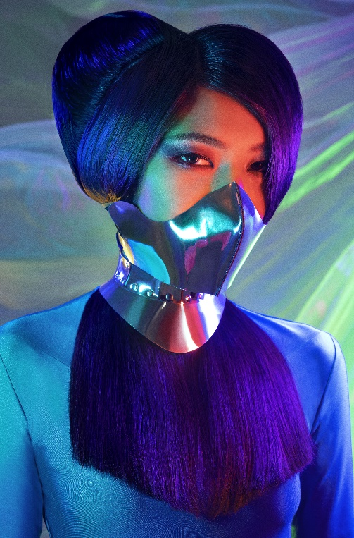

When everything is reversed, it is time to turn the situation around to find the way, and sufficient clarity to grasp reality. A change in perspective, techniques, and resources always leads us to a different result that breaks with the predictable and expected.
In this collection, hair is the main protagonist, without the support of other means than knowledge, raw materials and creativity. And this is how it becomes an art piece of the image, a complement that arises to become an object, transcending from its mere function. Volumes are clean and show great technical skill by not resorting to hairpieces or hairpins. It is a demonstration of the infinite possibilities that images present to transform our beliefs, the perspectives of what is real.

