For immediate distribution

Powersoft Appoints Gary Pace as New North American OEM Sales Manager
Pace will focus on expanding existing OEM portfolios and introducing Powersoft technologies to more North American manufacturers

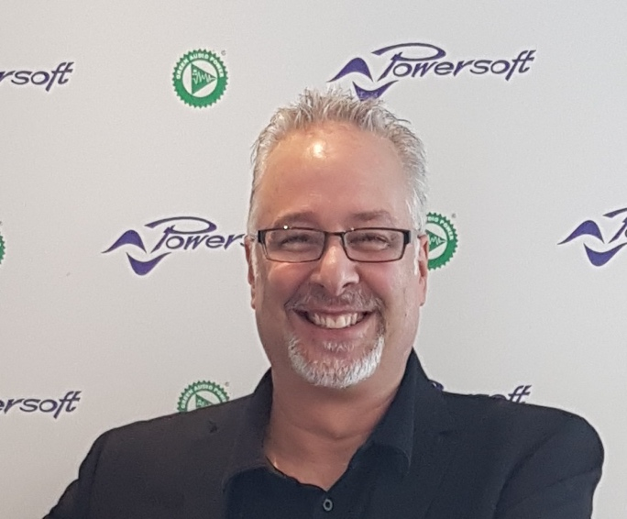
Detroit, Michigan, November 7, 2018 – Powersoft, leading manufacturer of professional power amplifiers, has announced the appointment of Gary Pace as Sales Manager – OEM – North America. Pace will be responsible for connecting Powersoft technologies to North American-based audio engineering teams.

An industry veteran of MI and entertainment technology, Pace has over two decades of experience working with people from various aspects of the industry — from equipment manufacturers to engineers, system integrators and retailers. He will impart his experience to existing and new Powersoft manufacturer partners by helping to incorporate Powersoft technologies for original equipment manufacturers (OEMs) — which include amplifier modules, DSP and transducers.

“Gary’s extensive experience in our industry will be an indispensable asset to Powersoft as we continue to grow our North American OEM footprint,” said Luca Giorgi, General Manager – North America. “Powersoft has spent the time and money developing our powerful OEM technologies so that manufacturers don’t have to. Gary understands this, and will leverage his knowledge of the engineering process to help manufacturers accelerate production time while increasing the efficiency and functionality of the end-product.”

Pace also brings to Powersoft his specialization in installation products, most recently in his role as Sales Manager at beyerdynamic, and before that, as Systems Integrator at Advanced Lighting and Sound in his home state of Michigan. While Pace started his career on the retail end at a local music store and would later also serve as National Sales Manager for Bosch Security Systems Dynacord brand, it was his role as Global Sales & Marketing Manager at Littlite from 1998 to 2006 that introduced him to the engineering side of OEMs.

"During this time, I worked with a lot of engineers," Pace explained. "As much as we were selling to retail resellers, more of our business was with original equipment manufacturers, where we could provide a small collection of components that would be one less process they had to engineer and produce, and we allowed them to go to market more quickly.”

Expanding the OEM Footprint
Pace is looking forward to using the experience he gained during his long career and helping manufacturers grow their business through Powersoft’s OEM solutions.

“Powersoft technology allows me to help manufacturers of goods to expand their portfolio and get to market more rapidly while being associated with a premium brand,” Pace explained. “Smaller companies benefit from being associated with Powersoft for both performance and because of our strong brand awareness. We can give larger brands an advantage to add products more quickly to take market share from competitors and find new customers. I look for these kinds of synergies, because we are all trying to grow our business, and shortening the engineering cycle is really important regardless of how big the company is.”

Now, with the brand’s growing footprint in the U.S. — including its new office in Kearney, New Jersey — Pace said that he looks forward to making it easier for OEMs in North America to expand their own base of opportunities with Powersoft technology. With his extensive background in the audio industry and a deep understanding of the manufacturers’ and engineering teams’ needs, Pace intends to introduce premium Powersoft products to more manufacturers in North America.

“I get to talk to OEM manufacturers every day who are dedicated to their ideas,” Pace said. “If they are in the audio business, they all could benefit from a Powersoft partnership.”

###

For further information, contact:

Jeff Touzeau (media contact)  Hummingbird Media  Tel : +1 (914) 602 2913  Email: jeff@hummingbirdmedia.com | Francesco Fanicchi  Powersoft (Florence, Italy)  Tel: +39 339 6381206  Email: francesco.fanicchi@powersoft.it

Or visit www.powersoft-audio.com
About Powersoft:
Powersoft is the world leader in lightweight, high power, single rack space, energy efficient amplifiers for the professional audio market. Founded in Italy in 1995, headquartered in Florence, Italy, with offices in New Jersey, Powersoft couples the experience and precision of its production department with exceptional components to deliver products with perfect audio response and high-performance reliability. Its state-of-the-art amplifiers can be found in an array of markets, ranging from stadiums, sporting arenas, theme parks, performance venues and airports to convention centers, churches, and clubs, and are used by the world's leading tour sound companies. For more information, visit the Powersoft website at www.powersoft-audio.com.

