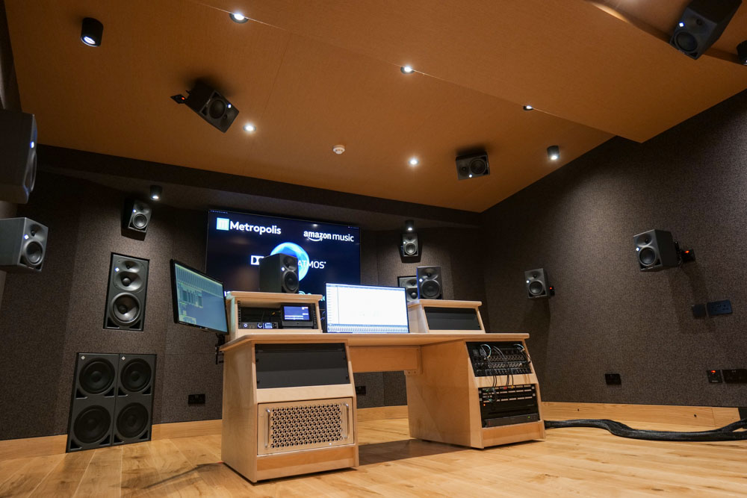
Neumann Monitors For Immersive Audio
At Metropolis Studios / London
London, September, 2021 – London’s Metropolis Studios and immersive audio specialist Sonosphere collaborate on ultimate immersive room

From the moment it opened 35 years ago, Metropolis has been a unique studio. Its home is The Power House in Chiswick, West London, a showpiece of Victorian architecture built to house the London Tram System. The building was, in fact, never used for that purpose and sat derelict for 80 years, before being lovingly restored to keep its industrial heritage to the fore but allowing its five floors to hold Metropolis’s four state-of-the-art recording studios, five iconic Mastering Rooms, over a dozen writing, production and mixing rooms and a full-service bar. It has now added a fifth studio to this impressive list, which features a fully certified Dolby Atmos system, based entirely around Neumann monitors.

It has always been Metropolis’s philosophy to reflect its unique environment and build an atmosphere of creativity and collaboration. This has paid dividends with a list of artists - Queen, Eric Clapton, Elton John, George Michael, Amy Winehouse, Adele and Stormzy, to name just a few - coming through its doors that reads like a Who’s Who of musical legends.

“We’re committed to being the most relevant and diverse studio in the UK,” says Metropolis Brand Director, Gavin Newman. “I think the fact that two thirds of all domestic Brits nominations in 2021 use the studio and that we’ve become a go-to venue for brand partnerships with the likes of Clash Magazine, Nordoff Robbins, London Fields Brewery, Ellesse, Mastercard, Record Store Day, Amazon Music, Notion Magazine, Fred Perry, Harman, Clarks, Shure, Jack Daniels and WaterAid says a lot.”

Versatility was the key
The journey to ensure Metropolis stays relevant and technically up to date has led to the creation of its new immersive studio. Developed in conjunction with immersive audio and live streaming specialist Sonosphere, versatility was the key for the Munro Acoustics-designed room. Its centrally located mix position and immersive monitoring environment ensures it can cater for all current surround formats. The room fully meets Dolby Atmos specifications, is capable of delivering 11.1.8 Atmos and includes a Dolby Atmos Mastering Suite server.
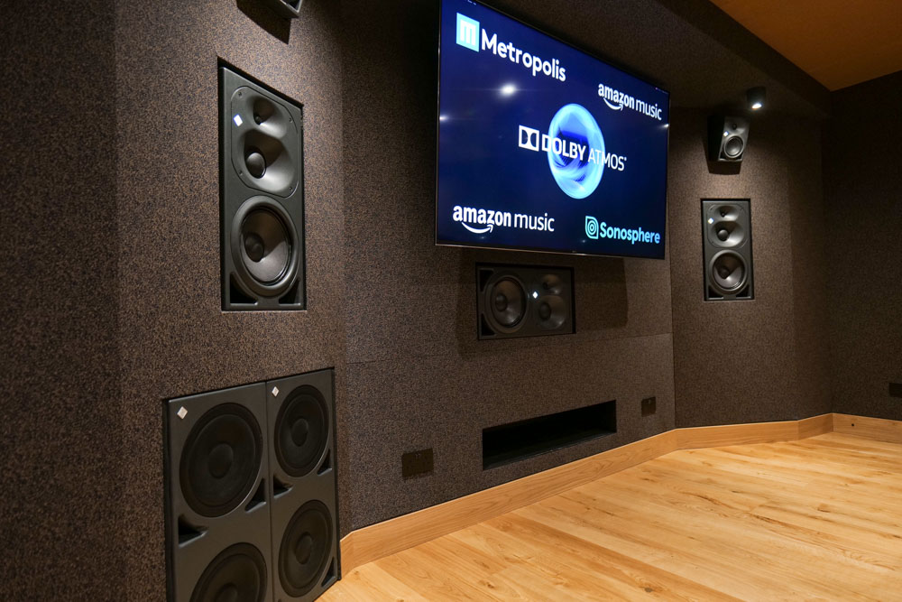
Whilst Metropolis has not traditionally been a Neumann house, the Sonosphere team has a long history with the brand and were keen to demonstrate its benefits. A key mission was to ensure clean and extended low frequency, with the required isolation to accurately judge tone-shaping a full octave below the effective range of many monitoring systems. As a result, three Neumann KH 420 tri-amplified monitors are soffit-mounted to the front wall, with one KH 420 positioned horizontally beneath its video screen and twin Neumann KH 870 400 W subwoofers flanking the three-way monitors, with deep bass response up to 18 Hz. Surround monitoring is handled by 17 Neumann KH 120 compact bi-amplified studio monitors, renowned for uniformity between units, and with a ± 1.0 dB linearity deviation between 100Hz–10kHz.

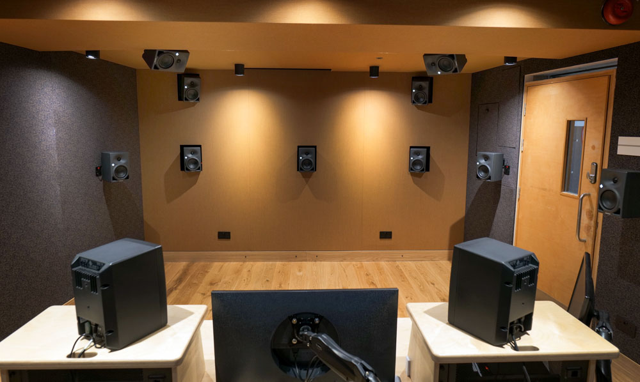
“We decided on three loudspeakers across the back wall, with all the loudspeakers around the room arrayed at 30° of separation to each other, so the setup was completely symmetrical for doing third-order [high-order Ambisonic] work,” explains Sonosphere mix engineer, Phil Wright, who was a key member of the design team. “Atmos is more ‘front-centric’, so for that format one of the rear loudspeakers will not be in use, and two of the others will be electronically adjusted for Dolby using a DAD AX32 monitor controller.”
Choosing Neumann was a no-brainer
The new studio adds an immersive dimension to Metropolis’ comprehensive array of recording studios and mastering rooms. Whilst the facility is already well known for music, there are a host of opportunities in the pipeline for the new studio, with streaming and delivery options provided by the Sonosphere team.

“There is already a significant order book for the room in terms of record labels, who want well-known catalogue content remixed in Atmos so they can add it to HD streaming services,” concludes Sonosphere director Jamie Gosney. “Choosing Neumann was a no-brainer for us as they produce some of the very best professional studio monitors in the world. We are proud to be able to collaborate with the team at Metropolis on building this top-notch immersive facility, and we cannot wait to see all the creative opportunities that the new studio will bring to their new and existing clients.”

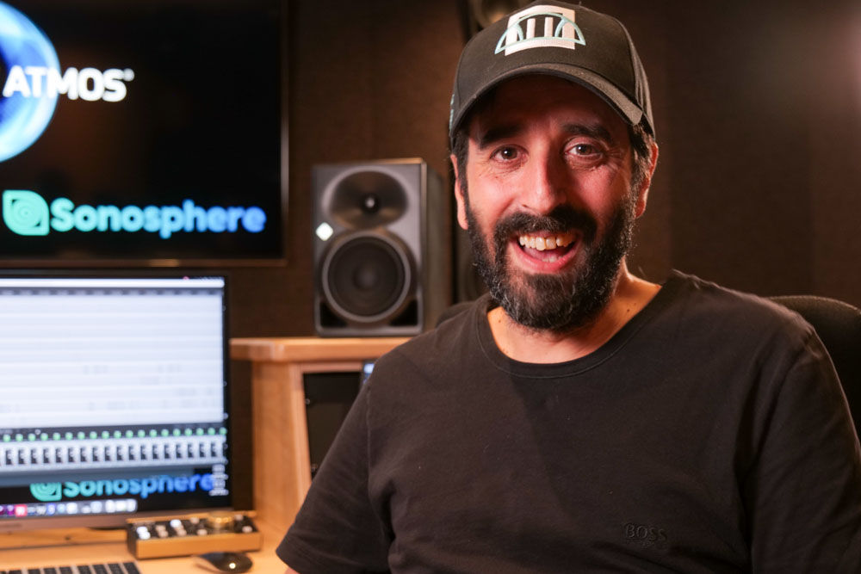
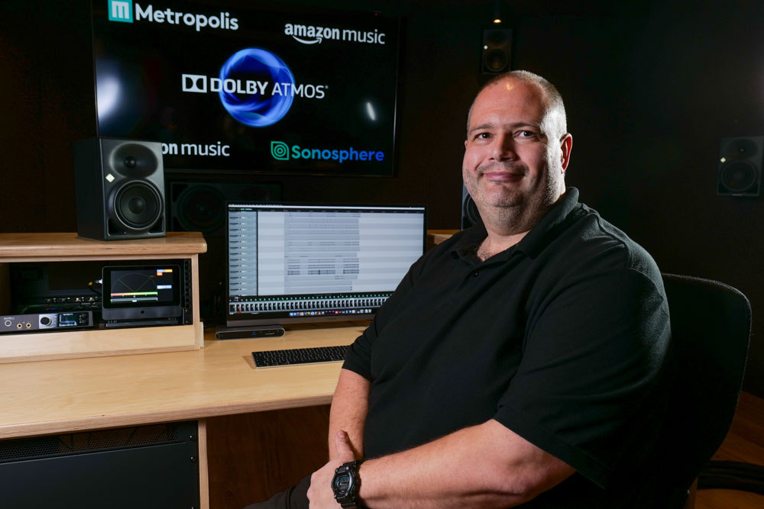
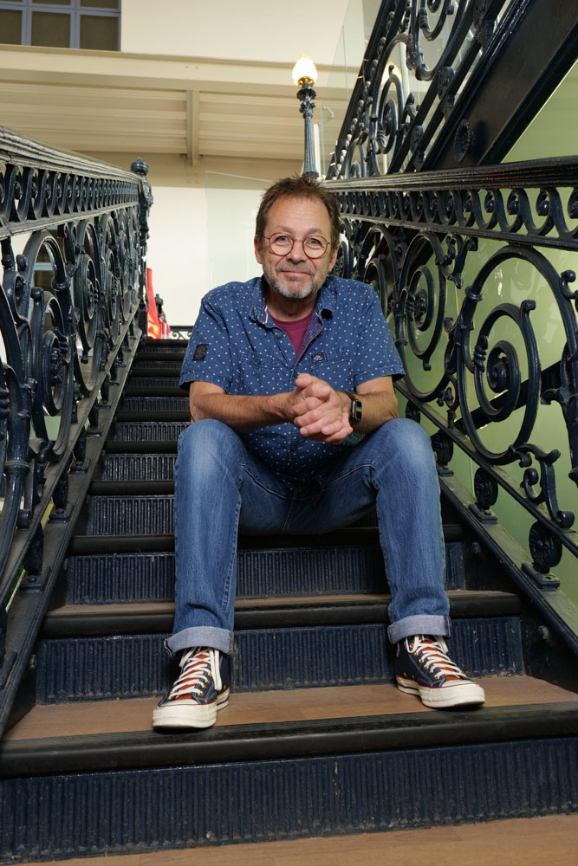
Sonosphere Director
Jamie Gosney
Metropolis Brand Director
Gavin Newman
Sonosphere Mix Engineer
Phil Wright

Photos: James Cumpsty

About Neumann
Georg Neumann GmbH, known as “Neumann.Berlin”, is one of the world’s leading manufacturers of studio-grade audio equipment and the creator of recording microphone legends including the U 47, M 49, U 67 and U 87. Founded in 1928, the company has been recognized with numerous international awards for its technological innovations. Since 2010, Neumann.Berlin has expanded its expertise in electro-acoustic transducer design to also include the studio monitor market, mainly targeting TV and radio broadcasting, recording, and audio production. The first Neumann studio headphone was introduced at the beginning of 2019. Georg Neumann GmbH has been part of the Sennheiser Group since 1991, and is represented worldwide by the Sennheiser network of subsidiaries and long-standing trading partners. www.neumann.com

Local press contacts UK:
Sarah James
sarahj@gasolinemedia.com
+44 1483 223 333

Global press contact:
Andreas Sablotny
andreas.sablotny@neumann.com
+49 (030) 417724-19

