The Power and the Glory: Powersoft Keeps Tabernacle of Glory Amped Up for Four Days with X Series and T Series amplifier platforms at University of Miami’s Watsco Center
Multi-day worship experience attended by over 8,000 congregants for annual non-denominational worship services, with Powersoft amps working overtime

Coral Gables, Florida
3 September 2019
With locations in Miami, New York, Boston and Haiti, Tabernacle of Glory's non-denominational Christian congregation gathers annually at the Watsco Center in Coral Gables, Florida, on the University of Miami campus to celebrate the final four days of its yearly 40-day fast. Throughout four days of worship, song and prayer, guest pastors from all over the world deliver sermons during two four-hour worship services each day, while a seven-piece band playing Haitian Caribbean music keeps the packed house pumped.

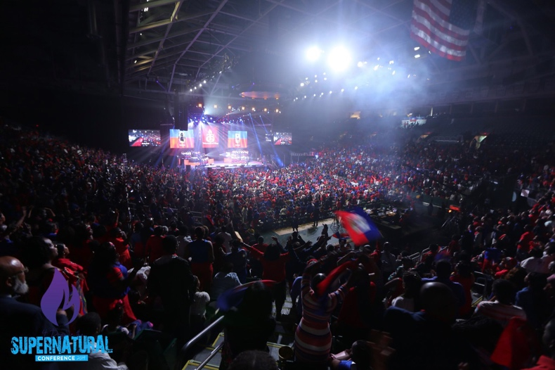
In preparation for 8,000-plus congregants filling the Watsco Center, Tabernacle of Glory brought in Lennox Foster from Sound Media to design a system with enough headroom to keep the system volume above the level of crowd noise, while maintaining the speech intelligibility for the pastors and simultaneously supplying enough low-end intensity for the music. Without hesitation, Foster turned to Powersoft’s X Series amplifier platform.

"One of the characteristics of this event is that the crowd is very responsive," Foster said, "and the sound system has to have enough dynamic headroom to surpass the crowd noise, which can get up to around 110 dB. When we were working at the event, the amps still had about 12-16 dB of headroom, even when the crowd was at its loudest."

New dimensions of loudspeaker management
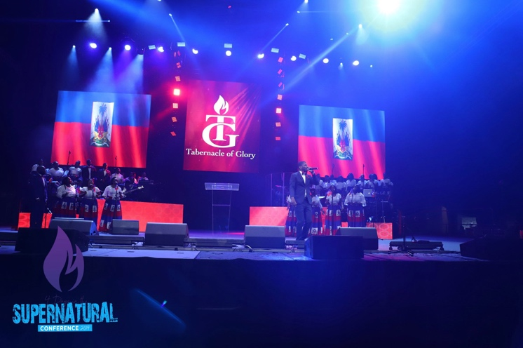
Raising the bar in terms of both design and functionality, the Powersoft X Series expands the concept of the amplification platform to include complete loudspeaker management — including all signal processing functions — in a single, lightweight unit, setting the standard for sound quality and usability.

The X Series also includes full Armonía integration, which Foster employed to design the entire sound system at the Watsco Center. With ArmoníaPlus, loudspeaker system designers and operators have powerful new tools to improve sonic performance and system reliability, including customizable, user-friendly setup options, which are flexible in all touring applications. Using ArmoníaPlus, Foster was also able to manage the entire system at the Watsco Center thoughout the day-long services, letting to control and calibrate the speakers into zones and keeping sound at optimum levels.

Making spirits rise
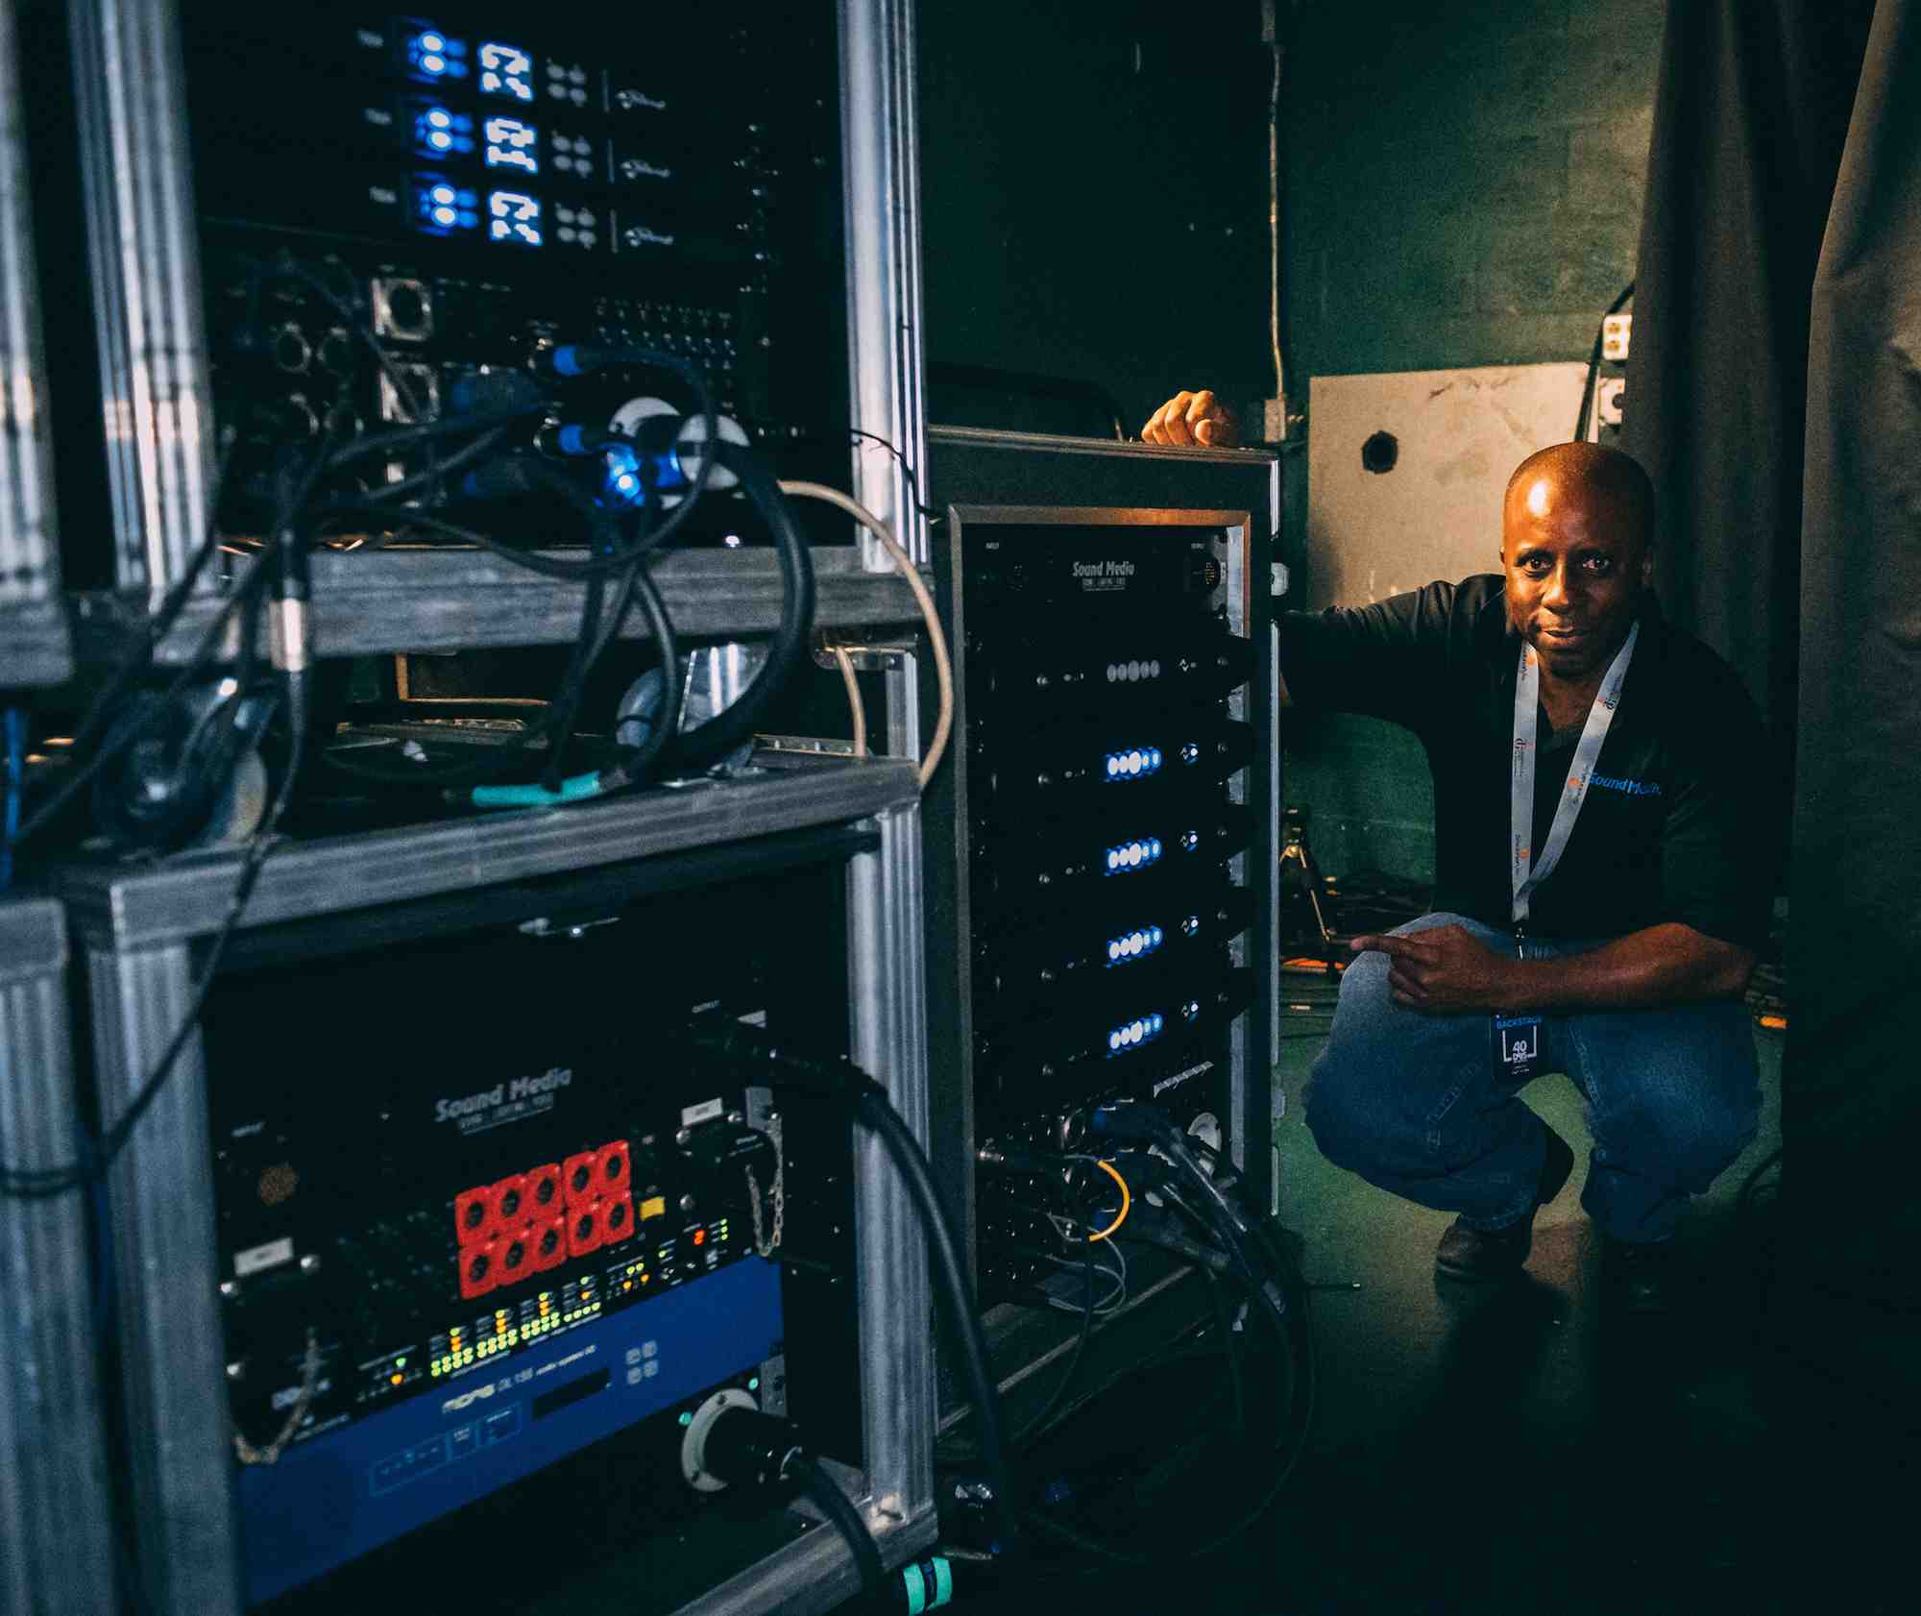
As the largest facility of its kind south of downtown Miami, the 200,000-square-foot Watsco Center is a multipurpose entertainment facility. Built in 2003, the center has since hosted a number of memorable concerts, televised events and awards, including The X Factor and the 2004 Presidential Debates, in addition to having welcomed world renowned figures like His Holiness the Dalai Lama and former U.S. presidents Bill Clinton and Barack Obama.

To power the array of Turbosound Flashline loudspeakers and subwoofers used at the Watsco Center during the Tabernacle of Glory 40-day fast celebration, Foster employed 18 Powersoft X4 four-channel amplifiers platforms to power 24 flown TurboSound TFS-900H speakers, 18 flown TFA-600L and 16 flown TFA-600H speakers, in addition to 10 TFA-600HW speakers used for front fills. And, to power 24 TurboSound TFS-900L ground subs, Foster used four brand new Powersoft X4L amplifiers, which are able to deliver the highest output voltage and highest output current on the market.

Additionally, for the monitors he employed nine units of the flexible and cost effective T Series amplifier platform, recently launched by Powersoft at the NAMM Show earlier this year. "We chose this combination of TurboSound loudspeakers and Powersoft amplifiers because we needed to cover the whole spectrum of sound, and these are truly full-range loudspeakers," Foster said "It's very in your face."

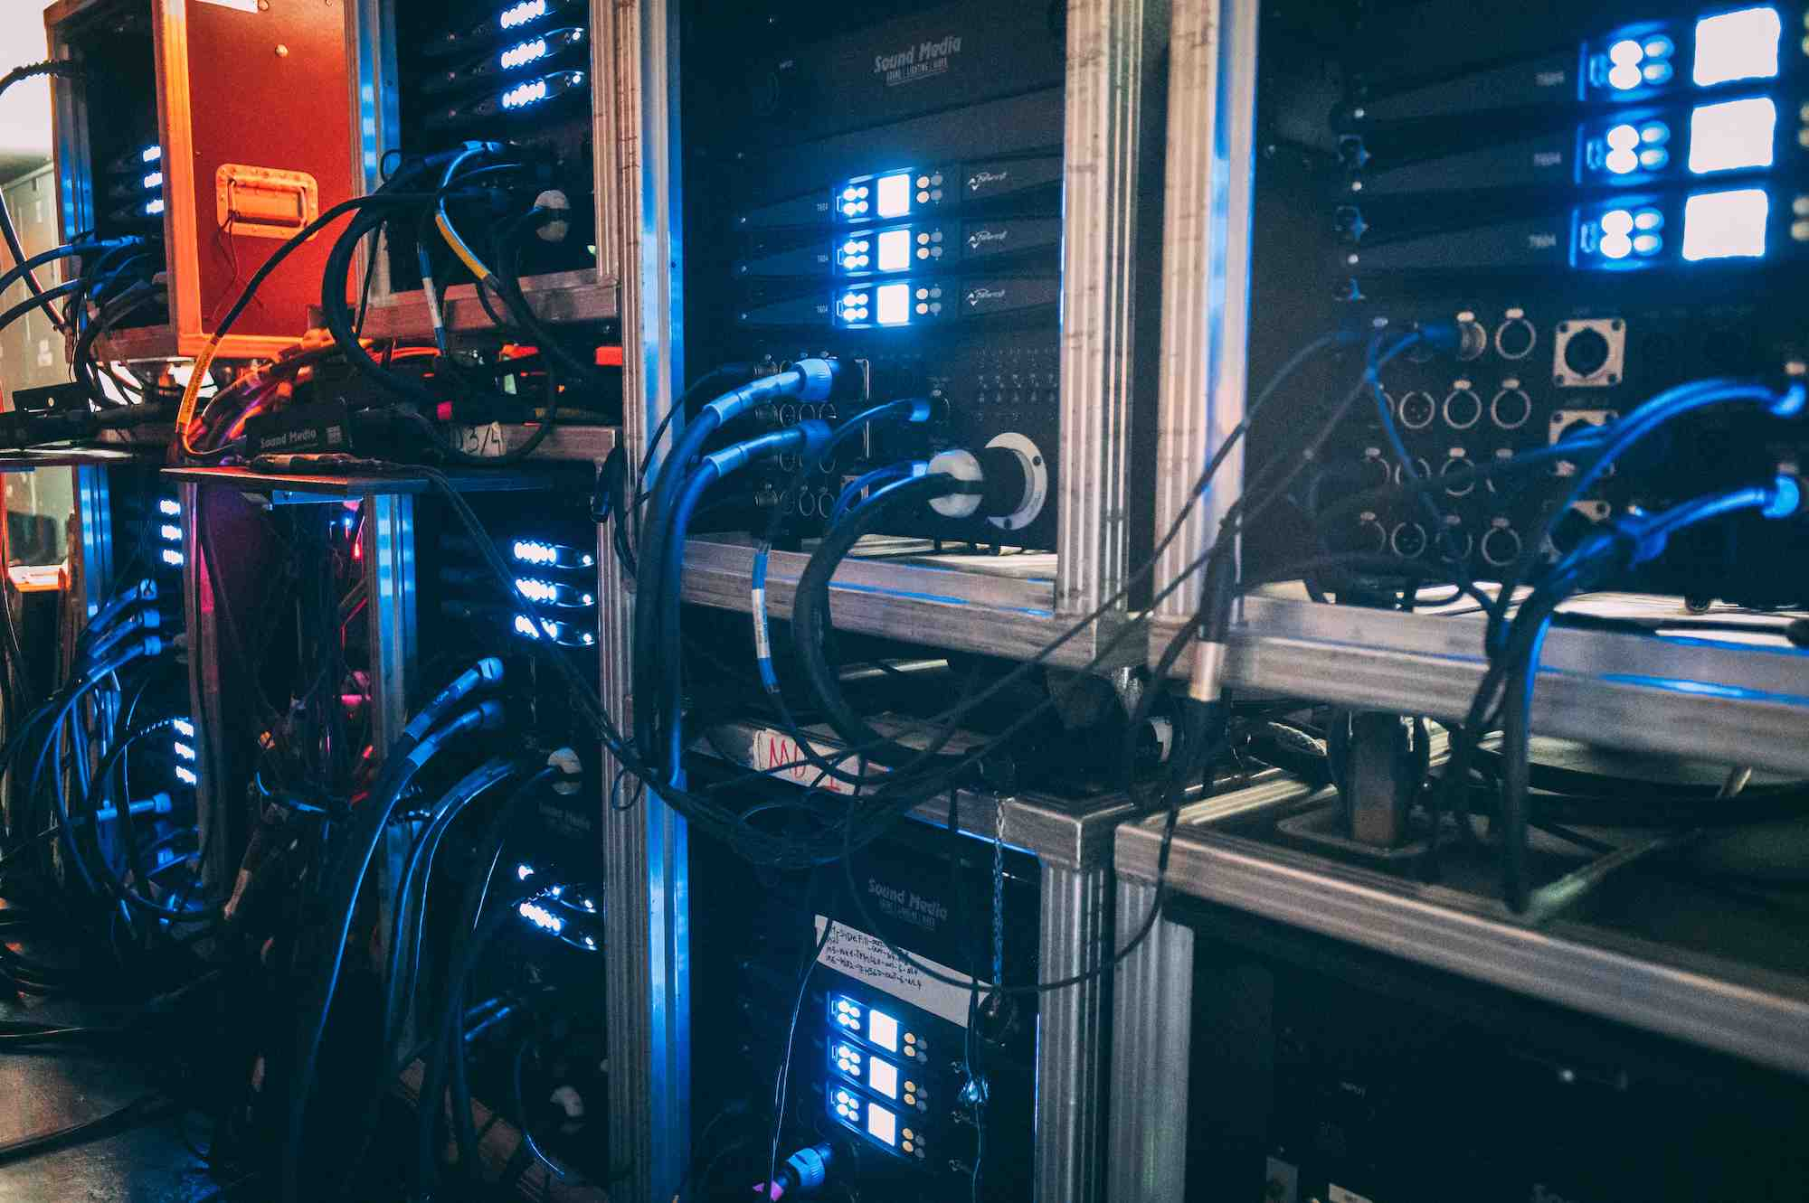
"The situation throughout Tabernacle of Glory's 40-day fast celebration is very intense," he continued. "There's a lot of demand on the amplifiers to perform in this space at a very high energy level, because this event is very musically based, with a lot for low-frequencies from the subs. But at the same time the amplifiers need to be lightweight and efficient.

"All the Powersoft amps we used performed very well, and were not stressed in any way. In addition, these amps gave us a small footprint on the floor, with less power draw than other amplifiers."

For further information

Francesco Fanicchi  POWERSOFT FIRENZE  francesco.fanicchi@powersoft.com  +39 339 6381206 | Jeff Touzeau  Hummingbird Media  jeff@hummingbirdmedia.com  +1 (914) 602-2913

ABOUT POWERSOFT:
Powersoft is the world leader in lightweight, high power, single rack space, energy efficient amplifiers for the professional audio market. Founded in Italy in 1995, headquartered in Florence, Italy, with offices in New Jersey, Powersoft couples the experience and precision of its production department with exceptional components to deliver products with perfect audio response and high-performance reliability. Its state-of-the-art amplifiers can be found in an array of markets, ranging from stadiums, sporting arenas, theme parks, performance venues and airports to convention centers, churches, and clubs, and are used by the world's leading tour sound companies. For more information, visit the Powersoft website: www.powersoft.com

