For immediate distribution

Sonarworks True-Fi: Connecting Headphone Consumers to 'Studio Sound'
With True-Fi App, Music Lovers Can Maximize Headphone Investment
while Improving Sound Quality
Las Vegas, January 8, 2018 – Innovative European audio software developer Sonarworks announces its new True-Fi technology that removes unwanted sound coloration from headphones so consumers can experience the artists' true intention — on a sonically balanced listening canvas it enables 'studio sound' performance.

True-Fi’s software platform, which supports over 100 of popular headphone models, takes just seconds to configure and employs measurement-based compensation profiles to correct tonal discrepancies that are caused by the headphones' physical construction. The resulting sound is a closer match to what the artist originally created in the studio — so listeners can experience a closer emotional connection to music in any genre.

The True-Fi platform App, which costs just $79, is compatible with both Mac and PC desktops.

Bringing studio sound to the consumer
True-Fi is the company's first consumer offering, building off of Sonarwork's deep expertise in the recording studio industry. Currently, Sonarworks' software is installed in thousands of studios and relied on by top studio mixers and mastering engineers around the world. In 2015, the company's professional audio software offering, Reference 3, received an 'Editor's Choice' award from respected UK-based publication Sound on Sound. More recently, True-Fi was unveiled at CanJam Europe in Berlin last November where it was awarded 'Best-In-Show' in the music listening accessory category.
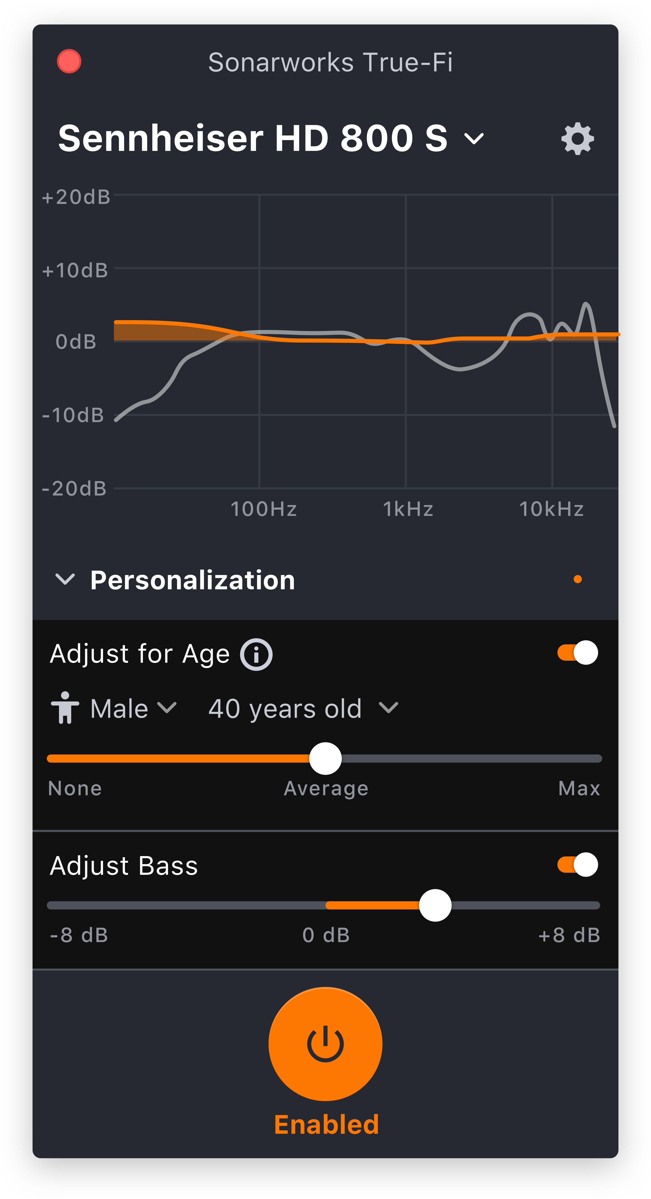
"The biggest problem music listeners experience today is not in the file and stream quality, but the playback," commented Helmuts Bēms, CEO and co-founder of Sonarworks. "True-Fi uses proprietary, research-driven technology to audibly improve the performance of loudspeakers and headphones. True-Fi stays true to the promise in its name, helping listeners experience the artists' true intention."

In addition to offering wide compatibility with most computers, True-Fi is constantly updating its software by adding compatible headphone models. Also, the software enables consumers personalize their listening preferences to meet their own hearing requirements.

Currently, the software supports sample rates of up to 96kHz and the company plans to announce support of higher sample rates in the near future. True-Fi is available for purchase on Sonarworks' website.
For more information about Sonarworks' True-Fi, please visit https://www.sonarworks.com/truefi.
About Sonarworks
Sonarworks is a Europe-based audio software development company specializing in acoustic calibration and DAW plugins. Accurate sound is our passion. The company was founded in 2013 and entered the pro audio market in 2015. Sonarworks software is relied upon by many Grammy winning artists and engineers around the world.

Media Contacts:
Roberta Lewis
Hummingbird Media
+1 (713) 408-9401
roberta@hummingbirdmedia.com

Jeff Touzeau
Hummingbird Media
+1 (914) 602-2913
jeff@hummingbirdmedia.com

