

Biuro prasowe better. gaming agency
bettergamingagency.prowly.com

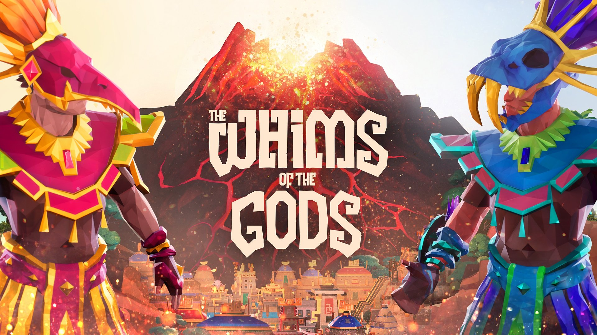

The Whims of the Gods is a city-builder that allows players to cooperate in building an ancient city

The Whims of the Gods is a cooperation-focused city-builder in which players are tasked with constructing and managing an ancient city. In addition to constructing buildings, they will have to satisfy the needs of their citizens and defend against aggressors emerging from the volcano at the heart of the island. The Whims of the Gods is set for an Early Access launch on PC in Q3 2024.

The Whims of the Gods offers a fresh perspective on the city-building genre by building the gameplay around cooperation among players. As rulers of a thriving city, players have the freedom to choose their duties. However, it is important to emphasize that regardless of their chosen roles, they pursue common goals, such as increasing the city's population or researching technologies. Both local and online cooperation will be possible.

The Whims of the Gods - announcement trailer


https://www.youtube.com/watch?v=iZx5CAUOYCI&ab_channel=PJGAMES

In The Whims of the Gods, players are primarily tasked with creating production chains, utilizing their citizens to gather resources and move them to places where they can be processed. This starts from constructing simple gathering spots and warehouses but expands to growing plants, breeding animals, supplying energy to buildings, maintaining armies and trading with the gods.

Monsters will periodically emerge from the volcano at the heart of the island, threatening to damage the players' city. The implemented combat module is based on auto-battler mechanics and features escalating levels of threat. Players will have to train soldiers and maintain their army to fight back. To further influence the course of the battle, players can activate special abilities such as mass healing or increased attack damage.

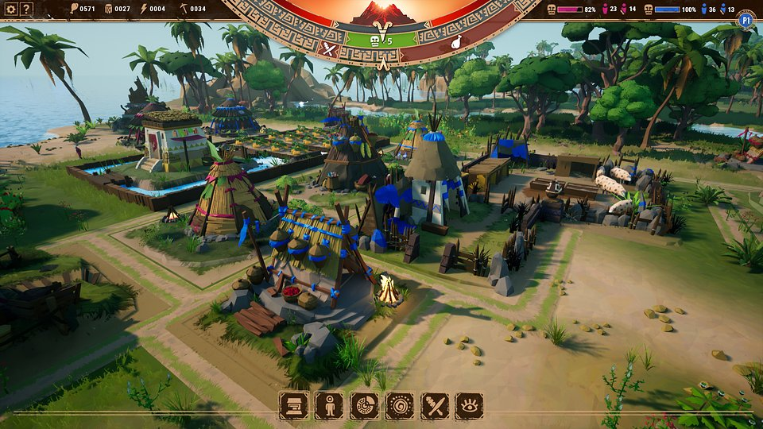

The land on which players will develop their city is full of unpredictable events that are revealed through a mystical calendar at the foot of the volcano. This will enable them to prepare themselves for various, often unexpected, situations such as epidemics or exceptionally bountiful harvests. Players can also turn to helpful gods, offering prayers in exchange for gifts and blessings.

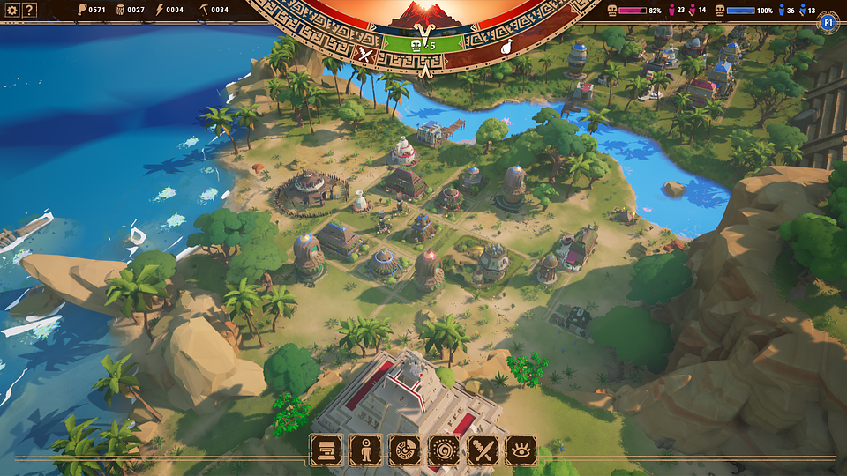

The Whims of the Gods - key features:

🌋Two pairs of hands – The Whims of the Gods relies on two players jointly transforming a village into a big city. Each of them has different tasks and tools, but they share a common goal.
🌋Making lives better – as rulers of a small village, players will have to make every effort to fulfill the needs of their citizens. The challenge will lie in not only constructing additional buildings to satisfy such needs and ensure their well-being.
🌋Divine assistance from above – elaborate religion and faith mechanics will allow players to turn to the gods to receive helpful blessings and trade for resources.
🌋 Like clockwork – players will learn about the future from a calendar predicting upcoming events, such as monster attacks, natural disasters, bountiful harvests, and much more. This will inform them to prepare for both the good and bad things.
🌋 How will it all end? – depending on the course of the gameplay, players will be able to unlock different endings, making The Whims of the Gods a game worth revisiting.

The Whims of the Gods is being developed for PC, and the game will be available on Steam. Players intrigued by this cooperative city-builder can already add the game to their wishlist.

The press kit is available here.

Important links:
The Whims of Gods official page: https://pjgames.pl/games/thewhimsofthegods
Facebook: https://www.facebook.com/PJGAMESPL
Twitter: https://twitter.com/PJGAMESPL
Instagram: https://www.instagram.com/pjgamespl
YouTube: https://www.youtube.com/@PJGAMESPL
Discord: https://discord.gg/5FRAakY9w6
TikTok: https://www.tiktok.com/@pjgamespl

About PJ Games

PJ Games Ltd. was created in 2021 in Warsaw. The studio is the result of the cooperation of two strong players in the branch of game development: Platige Image S.A. - a company known for producing spectacular visual content, animation and VFX - and Juggler Games, a team consisting of game dev veterans who created the critically acclaimed game My Memory of Us. Currently, the studio is working on the upcoming game The Whims of the Gods.



Jakub Smolak
PR Specialist at better. gaming agency
jakub.smolak@bettergaming.pro
Twitter

