The Media Operations Platform™: A Command Center for Modern-Day Content Creation
Xytech empowers every media team to deliver content on-time and on-budget
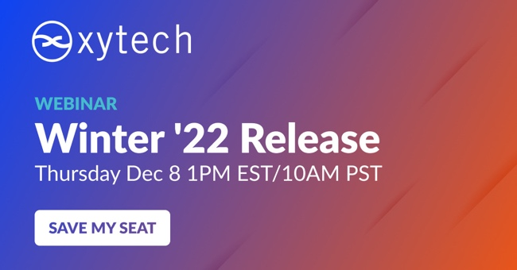
Chatsworth, California — November 30, 2022 —Xytech has announced the latest release of its Media Operations Platform™. The Granite Release combines a single, feature-rich package with the most important customized feature sets implemented across customers that include AMC Networks, Paramount and BBC America, as well as many other worldwide media companies. In support of this new release, Xytech will host an upcoming live webinar on December 8th at 10am PST, led by Xytech’s Chief Product Officer, David White.
As a powerful command center for content producers across media, broadcast and technology companies, media teams can implement the Granite Release to manage the production and delivery of visual media efficiently, on-schedule and on-budget. With over 350 user-hours logged by our beta testing clients for the Granite Release, the latest and most stable release to-date, Xytech enables the management of people, equipment, resources, facilities, and logistics, as well as the automation of manual operations, making it a powerful back-end operational solution for media companies.
The Media Operations Platform™ manages the entire media production process for companies of various sizes in multiple industries and for any distribution platforms by automating manual tasks and triggering workflows through a centralized command center. Organizations can seamlessly get a single view of Personnel Management, Media Asset Management, Production Management, Media Transmission, and Media Workflow, enabling teams to stay on task as a cohesive unit to meet deadlines. The Media Operations Platform is an evolution of Xytech’s operations software and ScheduAll, which are deployed in nearly 500 of the world’s largest and well-known media producers.
Every Company is Now a Media Company
The expanded direction is driven by the new executive team led by CEO, Keith Buckley, who has observed the massive changes in media production.
“Consider the ways we are consuming media, and you start to see the magnitude of change,” Buckley begins. “In a relatively short time, media production and distribution has grown exponentially from its original, limited group of producers and networks, but the tools used to manage that huge increase haven’t evolved to the current media environment’s requirement.”
To keep up with the evolving content capabilities, each media company can layer on applications and customize their operations experience. By choosing to integrate specific solutions, Xytech’s Media Operations Platform™ yields access to an infinite number of applications. “Xytech is taking an innovative approach to serving not only the biggest customers operating in the media industry today, but also media producers of all sizes across any industry creating media,” Buckley adds.
Xytech’s Growing Media Operations Experience
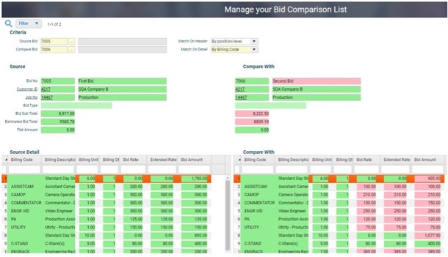
The Personnel Management application, one of five applications within the Media Operations Platform, provides easy scheduling and visibility across an entire company on multiple platforms. Media teams can easily schedule shifts, and manage payroll, entitlement tracking, timecard management, approval workflows and remote crewing. Media Asset Management, another application on the Platform, organizes, shares and tracks media assets through managing and tracking physical and digital media, configurable meta data, index search, title management, display keyframes and proxies, and QC session management applications.
The Production Management application includes configurable scheduling views, calendar scheduling, rental management, equipment tracking, and can maintain outsourcing options and pricing, bidding and budgeting. The Media Transmission application provides a stable and untethered remote monitoring experience through automated feed management, device automation, bandwidth utilization and accurate billing, delivered on any device connected to the internet.
The Media Workflow application enables media collaboration from anywhere and accelerates content turnaround with automated tasks. From media ingest, search, and logging to editing, distribution and publishing, the entire production process is streamlined. Dispersed teams are enabled to create better content faster, and deliver to more outlets and devices, ultimately maximizing the value of the content. With 20 platform integrations, 60+ customizable SaaS integrations and 40+ custom integrations to proprietary business systems, Xytech empowers each team member with the flexibility to create, click and connect from anywhere.
“As we successfully expand our offerings and build a stronger, agile and innovative company, the Xytech Media Operations Platform™ will strengthen and maintain its capabilities at the center of any Media Operations environment,” White said. “It addresses the dynamic demands of Media Operations environments, with more third-party integrations than anyone in the Media Operations space. The Xytech Media Operations Platform™ will continue to evolve and leverage the benefits of the platform while addressing the industry’s growing needs.”
To RSVP and attend the Granite Release webinar on Thursday, December 8th at 10am PDT please click here.
Learn more about how The Media Operations Platform can help your media team scale at xytechsystems.com.
About Xytech
Xytech provides media, operations, and production teams with a Media Operations Platform that helps them scale by efficiently managing people, resources, and assets on time, on budget, and on schedule. Media teams have one command center to manage all assets, people, resources, and facilities in one view. Xytech’s Media Operations Platform delivers the most comprehensive platform, with the most expertise, with the deepest integrations. Over 400+ global customers like CBS, FOX, and Sony run their media production on the Xytech Media Operations Platform. For more information, visit xytechsystems.com.

Media Contacts:
Shelby Coppola
Hummingbird Media
203-598-8167
shelby@hummingbirdmedia.com
Sarah James
Gasoline Media
+44 7702 421635
sarahj@gasolinemedia.com

