Wijchen, May 2017

First extendible Manoovr with excavator trough
for Van der Vlist

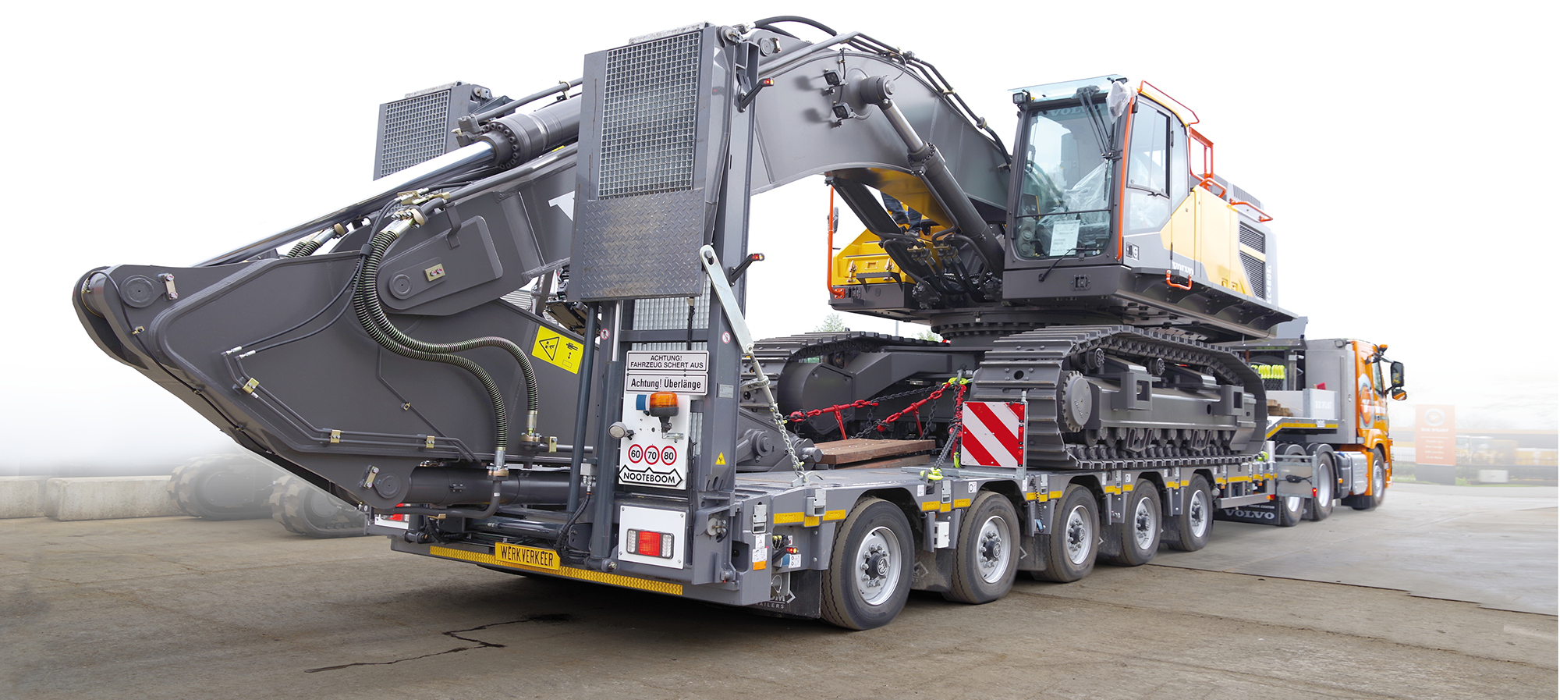
At Van der Vlist they are always looking to optimise their transport fleet with vehicles for abnormal transport that are even more efficient. Therefore Van der Vlist has added to their fleet the latest 5-axle extendible Manoovr semi low-loader to transport construction machinery weighing up to around 60 tonnes. When carrying excavators or demolition machines the boom can be placed in the trough so that the total height of the load is considerably reduced. This latest investment concerns two 5-axle Manoovr semi low-loaders with extendible load floor. Internationally there is a great deal of interest for the Manoovr with excavator trough. By now around 20 of these have been sold already and the first two were delivered to Van der Vlist.

Load capacity
The 5-axle Manoovr with excavator trough has approximately the same load capacity as a 4-axle Pendel axle low-loader with a single-axle Interdolly. The semi low-loader with pendle axles has 12 tonnes per axle in Europe and provides the transport operator with a load capacity of around 67 tonnes. In Great Britain this goes up to around 92 tonnes in Category 3.
Further advantages of the Manoovr semi low-loader, compared with a 2+4 low-loader, include a shorter combination length, exemptions, routes to take and a lower purchase price. The height of the construction machinery is often the main factor when deciding whether it is better to use a Manoovr semi low-loader or a EURO-PX low-loader. The new excavator trough of the Manoovr now makes it possible to transport more types of construction machinery.
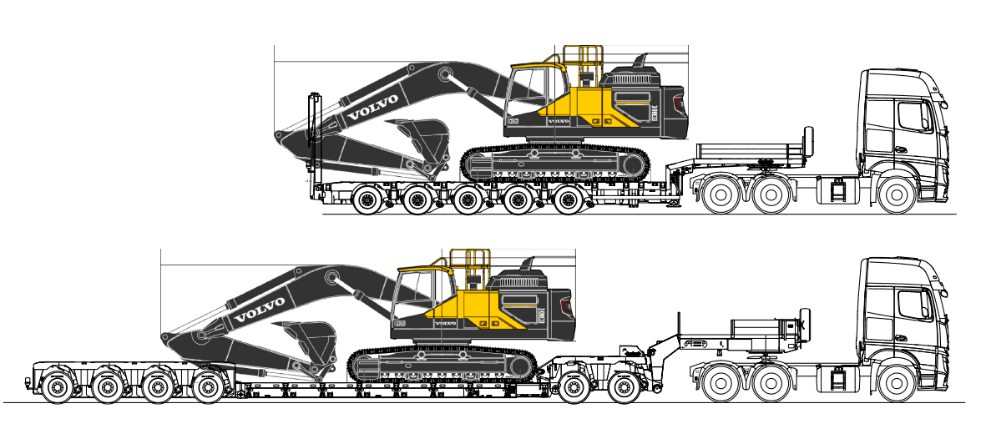

Delivery programme
The excavator trough is available on all Manoovr semi low-loaders in the programme and comes in several versions.
Excavator trough width: 800mm or 950mm
Axle distance: 1360 mm and 1510 mm
Load floor: single and double extendible

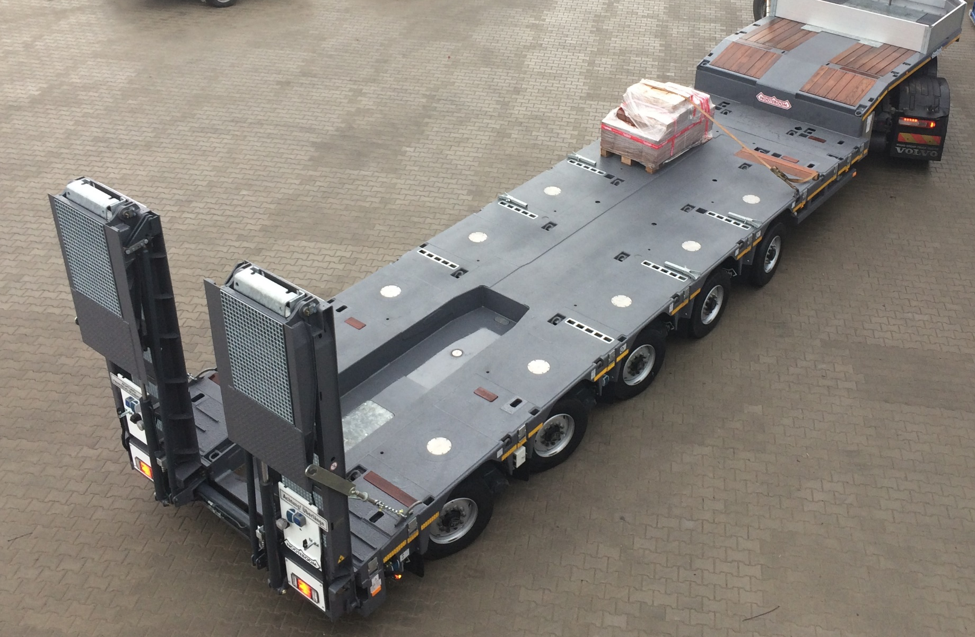

Advantages.
The load floor width on both types can be extended by 2x 250mm using optional outriggers. Extra strong extension bolsters are available to extend by 2x 375mm (=750mm) for heavier machines!! The width of the excavator trough depends on the chosen vehicle width. On vehicles that are 2,740 mm wide the excavator trough is 800 mm wide. On a Manoovr with a vehicle width of 2,890 mm the excavator trough is 950 mm wide.
This latest Manoovr with excavator trough keeps all the important advantages the Manoovr technology provides. Load floor height of 780mm, suspension stroke of 500mm, 12-tonne axle load at 80 km/h and optimal steering in any situation which results in an extremely long life of the tyres.

Van der Vlist about his choice for the
extendible Manoovr with excavator trough

Requirements
At Van der Vlist they are constantly looking to optimise their transport fleet with vehicles for abnormal transport that are even more efficient. With the two new Volvo – Nooteboom Manoovr combinations they have taken another step forward. This was not so simple, because the list of requirements was a long one: a high legal load capacity, low dead weight and a low load floor almost speak for themselves. The cab of the tractor had to be low so that a road planer can be loaded over the cab. And there was more: the combinations had to measure less than 16.5m in length. For the transport of excavators an excavator trough was a necessity and for the driver the vehicle must be comfortable, straightforward and safe to drive. The final requirement: lower cost per kilometre.
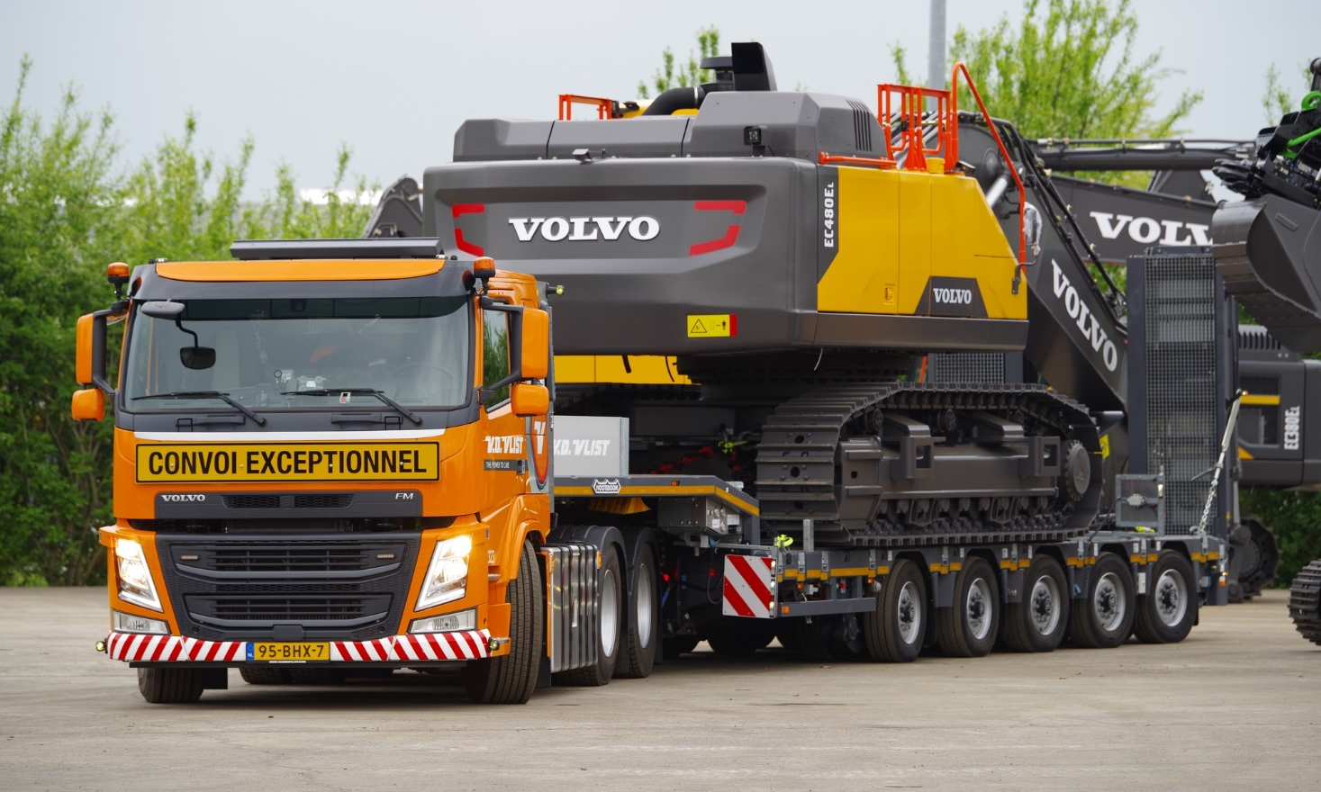
The numbers
The technically-permissible total laden weight of the combination is 92 tonnes. This high value is mainly due to the Manoovr’s axles, which have a rated load capacity of 12 tonnes per axle line at 80 km/h. The low dead weight makes it possible for the combination to carry a load of more than 60 tonnes with exemption and with the low load floor it is possible – with exemption - to transport loads up to a height of 3.5 metres. Thanks to the excavator trough, the low load floor and the high load capacity the 5-axle Manoovr semi low-loader can carry machinery that previously needed a 4-axle axle low-loader with pendle axles and 2-axle Interdolly. With the Manoovr the combination is shorter, multi-functional and the purchase price is lower. An excavator trough is essential In order to restrict the total height when carrying excavators. In the ‘Van der Vlist’-version the excavator trough is 800 mm wide, with a vehicle width of 2.74 metres. And for the transport of road planers the length of the load floor can be extended by 3.5 metres.

Cost per kilometre
When the Manoovr was being developed, lowering the cost per kilometre was a priority. Lower maintenance costs and a high residual value helped to achieve this. Replacing the tyres on a heavy semi low-loader is a major cost factor. The steering of the Manoovr considerably reduces tyre wear. On self-steering semi-trailers with a comparable load capacity the tyres sometimes need to be replaced after 50,000 km. Depending on the use the tyres of Manoovr are good for 300,000 km, which hugely reduces the cost per kilometre.

+++++++++++++

Note to the editor (not for publication): Digital photographs in high resolution are attached and free for publication.

