PRESS RELEASE
URBANISTA LOS ANGELES - THE WORLD'S FIRST SELF-CHARGING HEADPHONES ARE AVAILABLE NOW
The highly anticipated solar-powered Los Angeles headphones are available now in Midnight Black

14TH OCTOBER, STOCKHOLM, SWEDEN
Urbanista, the Swedish lifestyle audio brand, are pleased to announce that the world’s first self-charging solar-powered, wireless active noise-cancelling headphones, Urbanista Los Angeles, are now available now in Midnight Black at www.urbanista.com/losangeles and Sand Gold is available for pre-order.

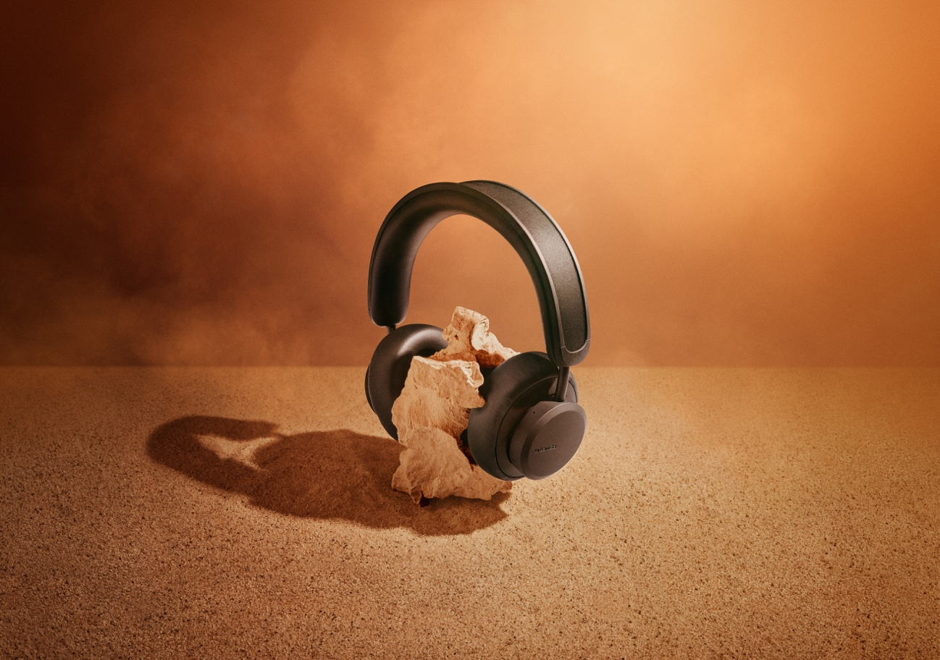

Urbanista Los Angeles brings a rare leap in headphone technology innovation to the market with a product that is designed to revolutionize your listening experience. With Urbanista Los Angeles, for the first time ever, you can experience virtually unlimited playtime with solar charging. Los Angeles never stops charging when exposed to light, both outdoors and indoors, providing a nonstop audio experience.

Enhance Your Experience with the Urbanista Mobile App
To allow customers to get the most out of their product experience with Los Angeles, Urbanista launched their mobile companion app that is available at www.urbanista.com/app for both iOS and Android users. The app provides information on how to get the most of the product’s playtime, including visual indications of solar charge levels and usage, and the option to customise the headphones controls.

Anders Andreen, CEO, comments: “Los Angeles has been a highly anticipated product and an advancement in technology that our industry has been waiting for. We are pleased to announce Urbanista Los Angeles is now shipping worldwide and we are excited to be delivering this ground-breaking technology to the market. It is not often innovations such as this one come along and I am personally looking forward to seeing how our customers enjoy an entirely new way of consuming content on the go.”

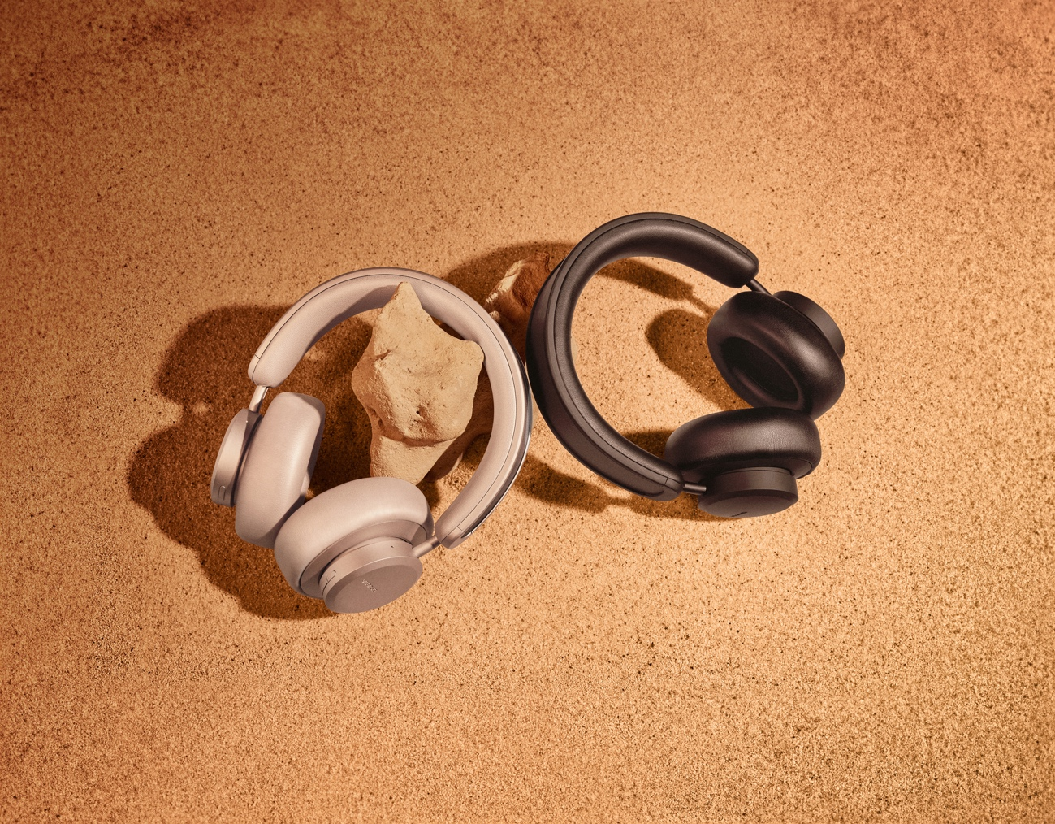

Priced at $199 USD MSRP, Los Angeles comes in two stylish colors: Midnight Black and Sand Gold.

Urbanista Los Angeles is now available at www.urbanista.com/losangeles
Watch the full Urbanista Los Angeles “A New Dawn” campaign film and enter the dawn of a new era of solar powered headphones: https://www.youtube.com/watch?v=Oc2pVLlQirw&feature=youtu.be&ab_channel=Urbanista

Urbanista Los Angeles Key Features

- Virtually infinite playtime
- Always charging when exposed to light, both outdoors and indoors
- 50h battery reserve
- Hybrid active noise cancelling
- Ambient sound mode
- On-ear detection
- USB type-C charging
- Bluetooth 5.0
- Siri and Google Assistant
- Compatible with iOS, Android and Windows

ENDS

Press Contacts

Shelby Coppola
US Media Relations, Urbanista
shelby@olexcommunications.us

Marina Daniel
PR Coordinator
marina@urbanista.com

About Urbanista
Urbanista was born in 2010 in Stockholm, Sweden out of love for cities and urban life. Our products are rooted in Scandinavian tradition and inspired by music, arts, fashion and urban culture. We believe that lifestyle audio products should not only sound great, but also look good. Today, our products are available in over 90 countries, and sold in 30,000 stores worldwide.

For more information visit www.urbanista.com
Follow Urbanista on: Facebook | Instagram

