#DontStopTheMusic
Get ready for some dubstep, jazz and electro!

Wedemark/Germany, June 30, 2020 – It’s Summer in the Northern hemisphere – and Sennheiser’s #DontStopTheMusic series of online concerts is providing the soundtrack! Tune in to Sennheiser’s Facebook channels and enjoy jazz music, dubstep and hip/hop electro music.

Live concert streams for the beginning of July
Enjoy the music – confirmed artists for the beginning of July are listed below. Please also check our social channels for details of further artists performing.

- Hatcha (@hatchadj):
Wednesday, July 1 at 17:00 UTC (20:00 London time, 15:00 New York time, 21:00 Berlin time)
- Lindsey Webster (@lindseywebster):
Monday, July 6 at 17:00 UTC (20:00 London time, 15:00 New York time, 21:00 Berlin time)
- DJ Fly (@djflyone):
Wednesday, July 8 at 15:00 UTC (18:00 London time, 13:00 New York time, 19:00 Berlin time)
- Mamas Gun (@mamasgun):
Monday, July 13 at 18:00 UTC (21:00 London time, 16:00 New York time, 22:00 Berlin time)

More music
Please also check out http://www.sennheiser.com/anniversary for a great selection of music videos to watch and listen to. Just put on your headphones (or turn up the speakers) and immerse yourself in immersive jazz club recordings, electro sets, or live takes from recording studios.

It’s free but why not donate to fight the coronavirus?
At Sennheiser, we’re delighted to be working with these fantastic artists to help spread positivity by putting on exclusive concerts. They’re totally free, but if you do want to say thank you, do consider supporting the WHO in its fight against the coronavirus:
https://www.who.int/emergencies/diseases/novel-coronavirus-2019/donate

For your social media channels:
Enjoy your favorite artists at home and check out the live concerts on Sennheiser’s Facebook channels! #DontStopTheMusic

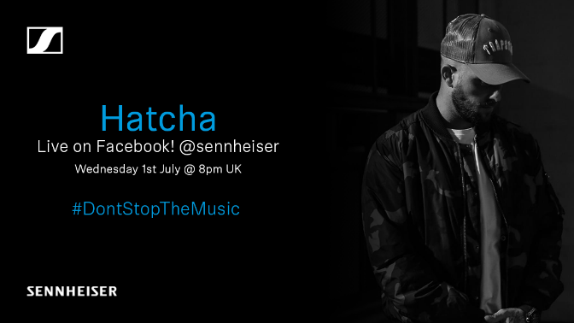 |  | 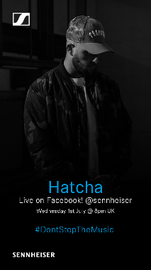
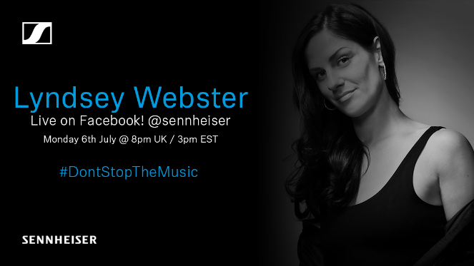 | 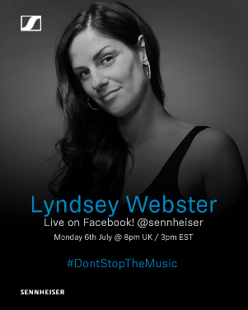 | 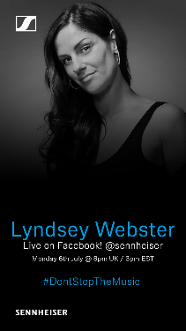
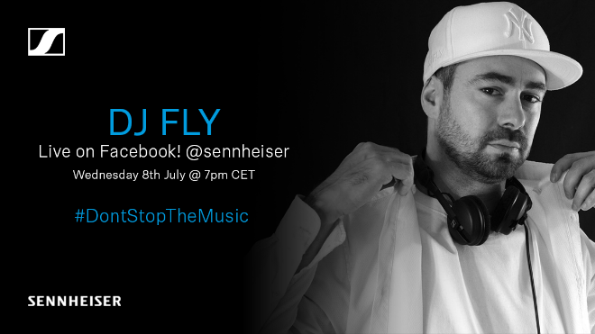 | 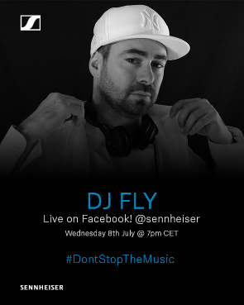 | 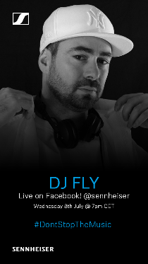
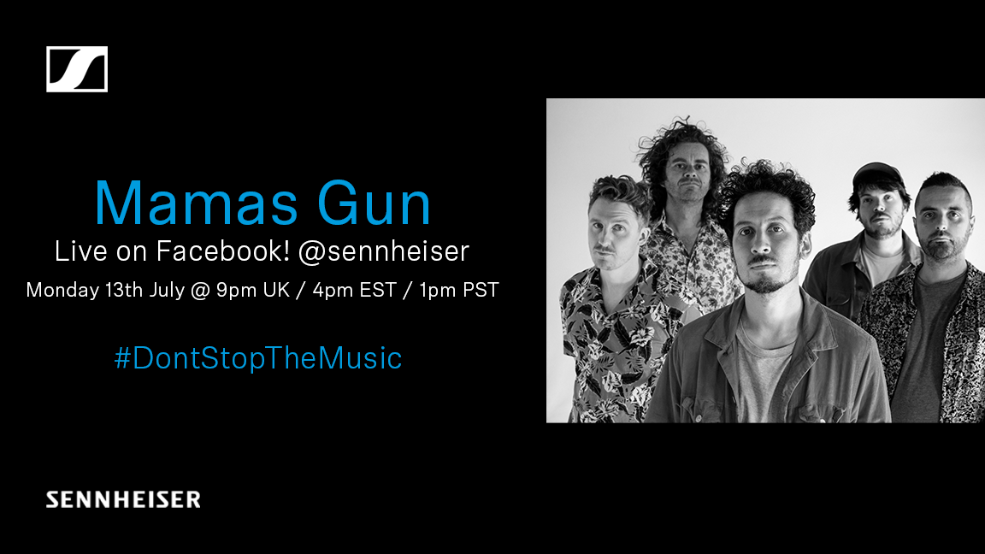 | 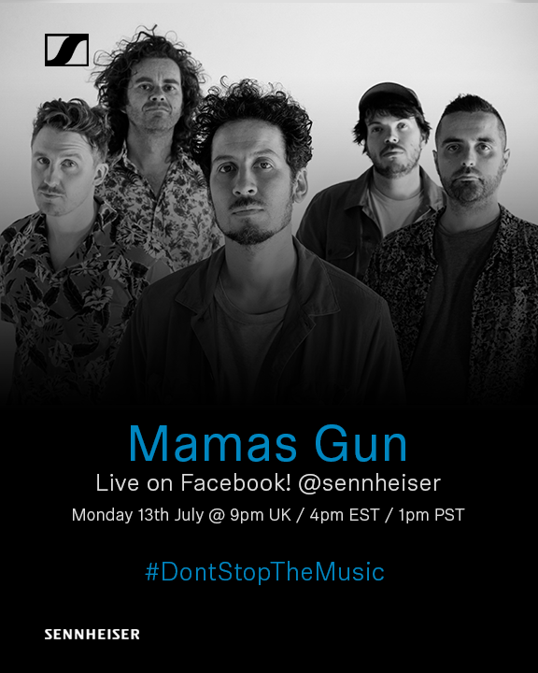 | 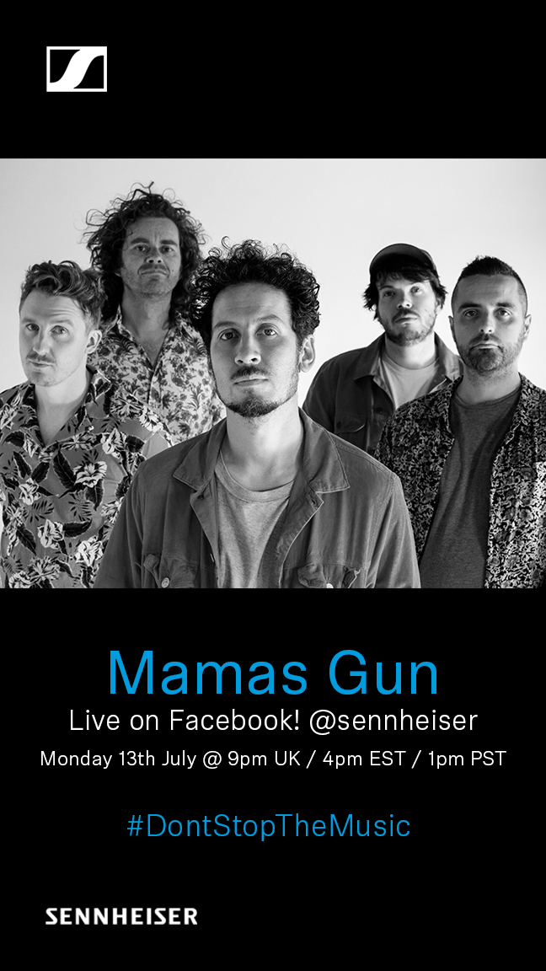

The images accompanying this press release can be downloaded at https://sennheiser-brandzone.com/c/181/quUU4mt8.

About Sennheiser
Founded in 1945, Sennheiser is celebrating its 75th anniversary this year. Shaping the future of audio and creating unique sound experiences for customers – this aim unites Sennheiser employees and partners worldwide. The independent family company, which is managed in the third generation by Dr. Andreas Sennheiser and Daniel Sennheiser, is today one of the world’s leading manufacturers of headphones, loudspeakers, microphones and wireless transmission systems. In 2018, the Sennheiser Group generated turnover totaling €710.7 million. www.sennheiser.com

Press Contacts

Mareike Oer Stephanie Schmidt
mareike.oer@sennheiser.com stephanie.schmidt@sennheiser.com
T +49 0(5130) 600 – 1719 T +49 0(5130) 600 – 1275

