Bring in the Holiday Spirit with High-Fidelity
Great savings on Bluesound, PSB Speaker and DALI premium audio products for a limited time only.

Pickering, Ontario, Canada, December 4, 2023— What’s better than giving the gift of sound to the ones you love? Groove to the music as you bake to holiday favorites and make memories with loved ones streamed directly with Bluesound, PSB Speakers and DALI products.

Save sitewide on PSB Speakers this Holiday Season
Save up to 25% on all PSB headphones, towers, and bookshelf speakers including the Alpha iQ’s until December 31.

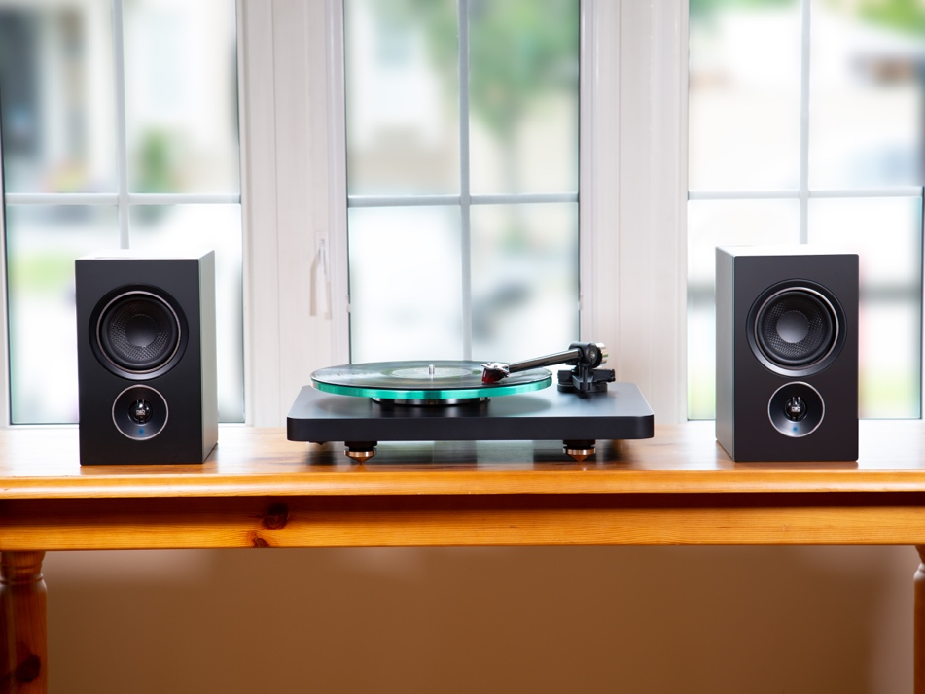

Make a statement with the Alpha iQs, the first compact bookshelf speakers based on the award-winning BluOS multi-room music platform. Alpha iQ listeners will enjoy PSB’s acclaimed “true-to-nature” sound with more than 20 streaming services like Spotify, Tidal, Qobuz, Amazon Music plus hundreds of Internet radio stations. The Alpha iQs are equipped with a built-in amplifier, an elegant touch panel and connect directly to a home network without anything except for one power cable. Enjoy an array of inputs to connect to source components such as a turntable, TV, CD player, game console, and other BluOS-enabled components for a multi-room streaming experience. The iQs are available in Tangerine Yellow, Midnight Blue, Dutch Orange, Black and White.

Escape from the Holiday Hustle and Bustle with M4U 9
Now available for up to 25% off through the PSB Website.

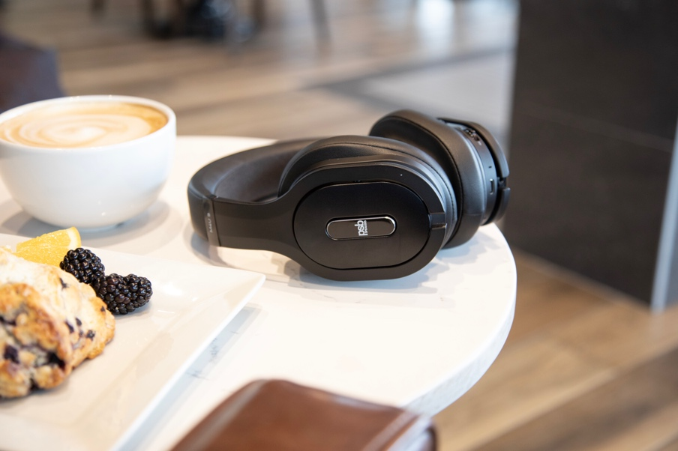

Take a break from the family gathering and relax with the PSB M4U 9 Premium Wireless Noise Cancelling Headphones. The M4U 9 improves on three generations of award-winning headphone design, crafted with premium materials with adaptive audio technologies and intelligent features, bringing the ultimate in mobile luxe listening. The new graphene-infused drivers improve on damping, stiffness and efficiency to reveal PSB’s “true-to-nature” sonic signature, more crisp and powerful than ever before. Using the PSB Headphone app, users can access Personal Sound by Audiodo to calibrate to your unique hearing so the music sounds just right, while PSB’s proprietary RoomFeel™ technology offers a natural and open sound. The gyro-suspended super-soft ear pads are tilted at 15 degrees to provide an excellent seal and ergonomic comfort for an extended listening time of up to 25 hours in Active Mode.

Just Add Streaming with the Bluesound Node
Now available for $449.00 through January 2 on Amazon and Bluesound.com
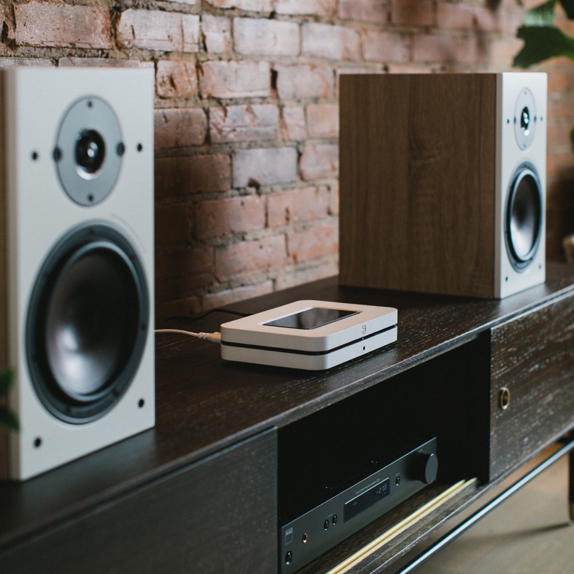
The Bluesound NODE unlocks the world of hi-res music streaming and multi-room audio through the powerful BluOS platform. The award-winning platform is the only program in the world that supports up to 64 streaming players all in 24-bit hi-res audio. Incorporate this streamer to existing hi-fi systems or your favorite set of bookshelf speakers for a bit-perfect listening experience. With a few taps of the BluOS 4.0 Controller app for iOS, Android, Mac or PC, you can access hundreds of internet radio stations, dozens of streaming music services, or even your own digital music library. The NODE offers quick access touch controls like play/pause, track skipping, volume along with 5 programmable presets. Connect wirelessly through WiFi or ethernet, Apple AirPlay 2, or to other Bluesound or BluOS enabled players. Listen privately to headphones through aptX HD Bluetooth and 3.5mm jack or add the NODE into a pre-existing home entertainment system via RCA, Toslink optical, or HDMI eArc. The NODE can also connect to voice assistants like Apple Siri, Amazon Alexa, or Google Voice, and be integrated into a smart home with full-feature drivers for Lutron, Elan, RTI, Crestron, as well as other popular home control systems.
Save 20% on DALI Speakers and Headphones
Now available for up to 20% off through the regional dealers and Amazon.
The portable, luxurious KATCH G2 Bluetooth speaker from the Danish maker is now on sale for the month of December. Along with the IO-6 premium headphones. The stylish, compact KATCH G2 2-way speaker offers omnidirectional dispersion pattern for prime listening in or outdoors with Bluetooth 5.0, Qualcomm aptX, aptX-HD and AAC included.
Additionally, the OPTICON, OBERON, SPEKTOR series speakers are available to revamp your home theater or listening setup for a limited time discounted price.

About Lenbrook
The Lenbrook Group of Companies is a privately held Canadian corporation who are the owners of NAD Electronics, PSB Speakers, Bluesound and Bluesound Professional. Formed in 1978, Lenbrook initially was a national distributor of electronics and communications products in Canada and has grown to become a leading global supplier to over 80 countries around the world. Lenbrook Americas, a wholly owned subsidiary of Lenbrook International, is responsible for the sales and marketing of NAD Electronics, PSB Speakers, Bluesound and DALI in both the U.S. and Canada. Additionally, it also distributes Tivoli Audio and Master & Dynamic in Canada.

Corporate & Media Contact

Scott Wicks
Manager, Marketing and Communications
swicks@lenbrook.com
905-831-6555

Nadia Lildhar
Marketing, Lenbrook International
media@lenbrookamericas.com

Links:
Bluesound Website: https://www.bluesound.com/
PSB Website: https://www.psbspeakers.com/
DALI Speakers Website: https://www.dali-speakers.com/en-us/
Lenbrook Americas Website: http://lenbrookamericas.com

# # #

