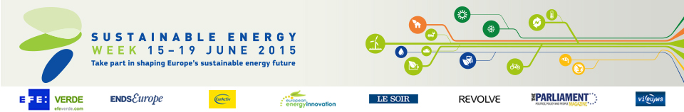

BiciBus-PediBus project

Category

Cities, communities and regions

Location

Regio Emilia, Italy

School kids ride a green wave
A city in northern Italy has made cycling to school a safe, enjoyable communal experience, keeping kids fit and cutting out unnecessary car journeys.
The carbon footprint of school transport in Reggio Emilia has been reduced thanks to a network of safe home-to-school cycling routes and adult volunteers to accompany pupils on bike or by foot. These ‘BiciBus’ routes feature ‘bus-stops’ with timetables for group departures, with free helmets and fluorescent jackets supplied. The project has been going for over ten years, with around 400 children and 250 volunteers taking part every year.
By making cycling more appealing, enjoyable and practical, the scheme has encouraged citizens to be the driving force for change, saving fuel and reducing emissions. Some 40 000 km of unnecessary car journeys are avoided every year, and since 2003, over 150 tonnes of CO2 has been saved. This is just one of a number of innovative initiatives introduced by the Municipality of Reggio Emilia to promote energy efficient mobility, and demonstrates how communities can actively participate in the green transport revolution.

Organisation

The carbon footprint of school transport in Reggio Emilia
Italy
www.municipio.re.it/nuoveideeincircolazione
Project website: www.municipio.re.it/nuoveideeincircolazione

