FOR IMMEDIATE RELEASE

Media Contact:

Hannah Gornto

BRAVE Public Relations

404.233.3993
hgornto@emailbrave.com

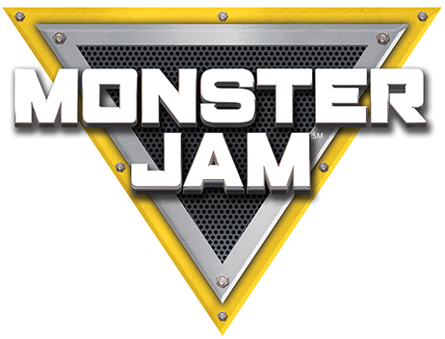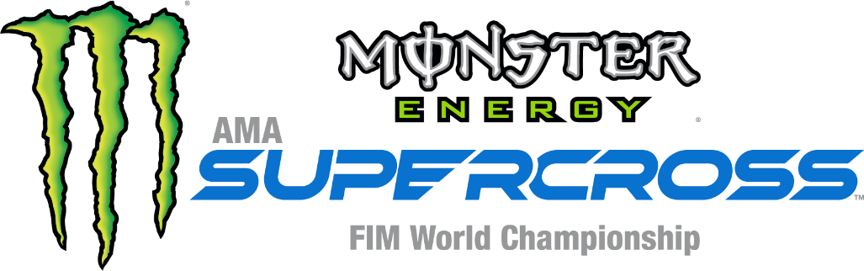
Revved Up for Reading library program
gives children the opportunity to read books
and receive a free ticket to
Monster Jam and Monster Energy Supercross
A Monster Jam driver and Supercross rider
will make special visits to two Atlanta libraries to read to kids
ATLANTA (January 8, 2020) — Monster Jam and Monster Energy Supercross have partnered with Atlanta area libraries on a reading program that is easy and fun for kids to participate and gives them the opportunity to earn a free ticket to the show of their choice. This engaging reading program will encourage children to not only read, but also to discover, dream and learn.
Children are encouraged to visit the nearest participating Atlanta Area Public Library to pick up a Reward Club Card and return when they finish a book. The librarian will stamp the card with a themed stamp for every book read. Once the five boxes are completely filled with the special stamps, the child and their parent/guardian can bring the Reward Club Card to the Mercedes-Benz Stadium box office for up to three free seats to a Monster Jam – at Mercedes-Benz Stadium February 22-23 – or Supercross – at the stadium February 29 – with the purchase of one adult ticket.
Below is a list of participating Atlanta area libraries:
Auburn Public Library, 24 5th Street, Auburn, 30011
Banks County Public Library, 226 Highway 51S, Homer, 30547
Braselton Library, 15 Brassie Lane, Braselton, 30517
Chatsworth-Murray County Library, 100 North Third Avenue, Chatsworth, 30705
Commerce Public Library, 1344 S. Broad St., Commerce, 30529
Coweta Public Library System, 85 Literary Lane, Newnan, 30265
Crossroads Public Library, 909 Harmony Grove Church Road, Acworth, 30101
Dallas Public Library, 1010 E. Memorial Drive, Dallas, 30132
Dog River Public Library, 6100 Hwy 5, Douglasville, 30135
Douglas County Public Library, 6810 Selman Drive, Douglasville, 30134
Ephesus Public Library, 200 Rogers Street, Roopville, 30170
Fortson Public Library, 61 McDonough Street, Hampton, 30228
Gwinnett County Public Library, 1001 Lawrenceville Hwy, Lawrenceville, 30046
Harold S. Swindle Public Library, 5466 US Highway 441, South Nicholson, 30565
Jefferson Public Library, 1000 Washington St, Jefferson, 30549
LaFayette-Walker Co. Library, 305 South Duke Street, La Fayette, 30728
Maude P. Ragsdale Library, 1815 Hiram-Douglasville Highway, Hiram, 30141
New Georgia Public Library, 94 Ridge Road, Dallas, 30157
Peachtree City Library, 201 Willowbend Road, Peachtree City, 30269
Ruth Holder Public Library, 337 Sage Street, Temple, 30179
Sequoyah Regional Library System, 116 Brown Industrial Parkway, Canton, 30114
Statham Public Library, 1928 Railroad Street, Statham, 30666
Toccoa-Stephens County Public Library, 53 W Savannah St. Toccoa, 30577
Troup-Harris Regional Library, 115 Alford Street, LaGrange, 30240
Tyrone Public Library, 143 Commerce Drive, Tyrone, 30290
Villa Rica Public Library, 869 Dallas Hwy, Villa Rica, 30291
Walnut Grove Public Library, 1000 Walnut Grove Pkwy, Loganville, 30052
Winder Public Library, 189 Bellview Street, Winder, 30680
As part of the reading program, Monster Jam and Supercross will visit two libraries to read to children and give them a special interaction with a Monster Jam and Supercross athlete. Both events are free and open to the public.
Monster Jam Driver Bryce Kenny
Thursday, February 20 at 3:30 p.m.
Washington Park Branch
1116 Martin Luther King Jr. Dr., SW
Atlanta, GA 30314
Monster Energy Supercross Rider Jared Lesher
Thursday, February 27 at 10:30 a.m.
Cascade Branch
3665 Cascade Rd.
Atlanta, GA 30331
Monster Jam will battle on February 22 and 23 and Supercross will race on February 29, each in Mercedes-Benz Stadium. Tickets for both shows start at $20, not including fees, and are available by calling Ticketmaster at 1-800-745-3000 or by visiting ticketmaster.com.
# # #
ABOUT FELD ENTERTAINMENT, INC.
Feld Entertainment® is the worldwide leader in producing and presenting live family entertainment experiences that bring people together and uplift the human spirit. Properties include Monster Jam®, Monster Energy Supercross, Disney On Ice, Disney Live!, Marvel Universe LIVE!, Sesame Street Live!, DreamWorks Trolls The Experience and Jurassic World Live Tour. Across the brand portfolio, Feld Entertainment has entertained millions of families in more than 75 countries and on six continents. Visit feldentertainment.com for more information.
ABOUT MONSTER ENERGY SUPERCROSS
Monster Energy AMA Supercross, an FIM World Championship, is the most competitive and highest-profile off-road motorcycle racing championship on the planet visiting 13 different states in 2020. Founded in America and sanctioned by the American Motorcyclist Association (AMA) in 1974, Supercross is currently co-sanctioned by the Federation Internationale de Motocyclisme (FIM), the official global governing body for motorcycle racing, thus making it a formal World Championship. Over 17 weeks and a million-dollar All-Star Race, Supercross attracts some of the largest and most impressive crowds inside the most recognizable and prestigious stadiums in North America to race in front of nearly one million live fans and broadcast to millions more worldwide. For more information, visit SupercrossLIVE.com.

