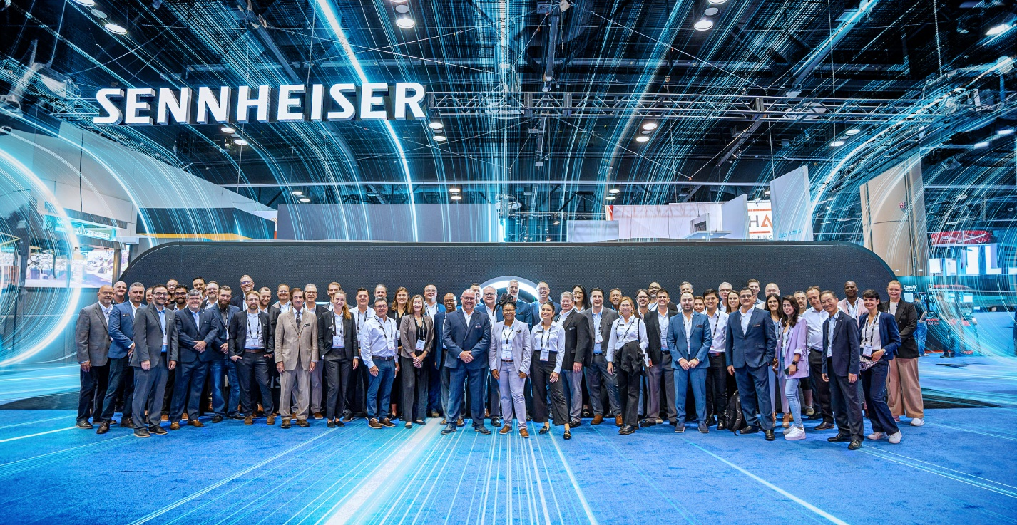

Sennheiser Sets the Bar High for the Future of Business Communication at InfoComm 2024

The Star of the Show Will Be the Sennheiser All-In-One TeamConnect Bars, Shipping to Customers Next Month

OLD LYME, Conn. — May 22, 2024 — Sennheiser, the first choice for advanced audio technology that makes collaboration and learning easier, today announced its solutions lineup for InfoComm 2024, June 12-14, in Las Vegas. Among the solutions presented at the Sennheiser booth (C5335) will be the award-winning TeamConnect Bars (TC Bars), which will begin shipping next month, as well as the currently shipping TeamConnect Ceiling Medium (TCC M) microphone — now with Intelligent Noise Control. In addition to these solutions, Sennheiser’s full range of audio hardware and software solutions for corporate and education environments will be on display.

“We’re excited to welcome attendees at the show into our booth to learn more about the TeamConnect family, with some big news regarding the TeamConnect Bars,” said Jeffrey Horan, Global PR/Media Manager for Business Communication at Sennheiser. “As always, Sennheiser’s presence at InfoComm is not only about products, technology showcases, and demos, but also about networking and reconnecting with industry friends and colleagues. With that in mind, we’re bringing our highly successful Scavify hunt to the show, with the opportunity for one lucky person to win a TeamConnect Bar M.”
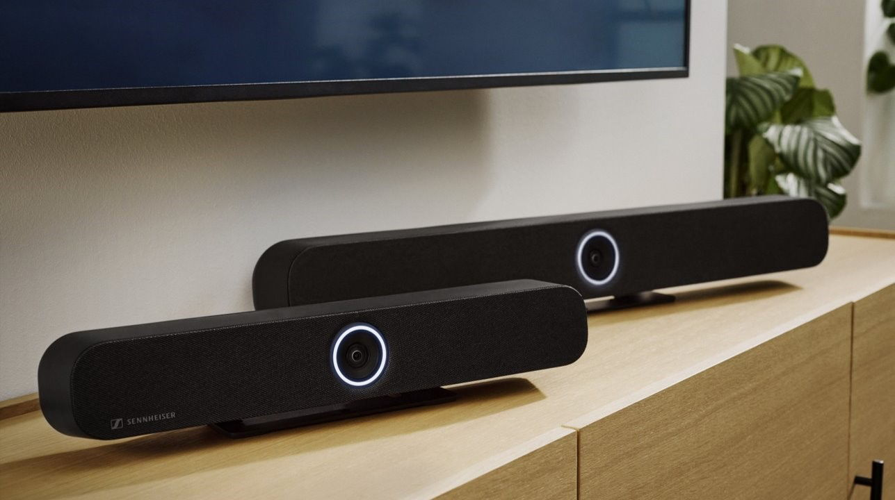
Sennheiser's new TeamConnect Bar solutions will be available for demo at InfoComm booth C535.

At InfoComm 2024, attendees will be able to explore the Sennheiser TeamConnect Family, an extensive range of unified communication solutions tailored for meeting rooms and lecture spaces of all sizes. The company will highlight its TC Bars, the most feature-rich, all-in-one conferencing devices in their class, that not only work for small rooms, but also can scale to large meeting rooms campus-wide. The solution is available in two models depending on the meeting room size — TC Bar S and TC Bar M. The TC Bar S features four microphones and two speakers, while the TC Bar M features six microphones and four speakers. Both deliver Trusted Sennheiser Audio Quality to every meeting.

The Sennheiser TC Bars are plug-and-play devices, meaning quick set-up via USB cable. The integrated beamforming technology is the same technology found in Sennheiser’s trusted TCC solutions, providing freedom of movement and seamless transition among presenters. As the first camera offering from Sennheiser, the TC Bars enable high video quality with a 4K Ultra HD camera equipped with advanced AI features that includes autoframing and person tiling. The full-range stereo speakers provide natural speech and outstanding intelligibility.

Additionally, the TC Bars provide flexible and scalable room setups with an onboard Dante port for extension mics and an option to add an external USB camera, catering to rooms requiring broader coverage. They are easy to integrate with features that include multiple mounting options; built-in remote management via Sennheiser Control Cockpit; brand-agnostic integration with leading control system and video conferencing platforms; and advanced security with encrypted control communication and password protection.
Also, in the Sennheiser booth will be the TCC M, boasting its brand-new feature, Intelligent Noise Control, which improves the focus on voices in a room. The two-step process enhances overall sound intelligibility in noisy environments, ensuring a smoother, more engaging meeting experience. This new feature — to be deployed via a free firmware update — will be demonstrated during InfoComm so that visitors can experience how static background noises can be carefully suppressed with the lowest possible impact on speech signal quality.
The TCC M has a coverage area of up to 40 m², perfect for midsized meeting space, with a sleek design and at an attractive price-point. It has multiple mounting options — surface mounted, suspended, or flush mounted — allowing for cable-free tables and flexible furniture arrangement.
Sennheiser TCC Solutions, including the TCC M and TeamConnect Ceiling 2 (TCC 2), feature patented automatic dynamic beamforming technology and the TruVoicelift function. These offer perfect speech intelligibility while allowing the speaker great flexibility in movement and position. The high-quality built-in electret condenser capsules, which are made in Germany, have already proven themselves in numerous Sennheiser microphones. These features enable the microphone to constantly determine a person’s position, without manually configuring speaker zones ahead of time. If additional control is needed, priority and exclusion zones can be set via the Sennheiser Control Cockpit. This guarantees that no spoken word is lost between the people in the meeting room and the external meeting participants.
Attendees can visit the Sennheiser booth to join the company’s InfoComm 2024 Scavify hunt to win a TC Bar M. The event was incredibly successful was this event at ISE 2024 and it’s now happening at InfoComm 2024! The hunt showcases collaborations that streamline integration and deliver engaging experiences with leading manufacturers such as Airtame, Audac, Crestron, Lightware, Lumens, Q-SYS, MAXHUB, Xilica, and many more. Participants should make sure to claim their stylish Sennheiser socks along the way!

InfoComm attendees can participate in the scavenger hunt by completing the following steps:
- Download the Scavify app to a mobile device.
- Search for ic24 and join the hunt. At the event, complete a series of tasks, with each task worth a certain number of points. Tasks can be completed in any order, and the more points earned, the more chances to win. Just for entering and getting started with the activities, entrants receive a free pair of Sennheiser socks.
- Visit Sennheiser booth C5335 to claim free Sennheiser socks.
- Engage with the Sennheiser touchscreen experience to learn more about the comanpy’s partners and how to get the most out of an investment in Sennheiser solutions.

More information about Sennheiser at InfoComm can be found here. To book an appointment during the show, please get in touch with the press contact listed below.

###

About the Sennheiser brand
We live and breathe audio. We are driven by the passion to create audio solutions that make a difference. Building the future of audio and bringing remarkable sound experiences to our customers – this is what the Sennheiser brand has represented for more than 75 years. While professional audio solutions such as microphones, meeting solutions, streaming technologies and monitoring systems are part of the business of Sennheiser electronic GmbH & Co. KG, the business with consumer devices such as headphones, soundbars and speech-enhanced hearables is operated by Sonova Holding AG under the license of Sennheiser.

www.sennheiser.com
www.sennheiser-hearing.com

Local Press Contacts
Daniella Kohan
daniella.kohan@sennheiser.com
+1 (860) 222-4226

Kirsten Spruch
kirsten.spruch@sennheiser.com
+1 (860) 598-7484

InGear
Peter Schuyler
peter@ingearpr.com
+1 917-496-8970

Global Press Contact
Jeff Horan
jeffrey.horan@sennheiser.com
+1 860-598-7539

