For immediate distribution

Film Composer Jacob Shea Stays ‘in the Groove’ with Flock Audio’s PATCH System
The system has been integral as Shea works on unique ‘sound tapestries’ for German TV program ‘Der Pass’

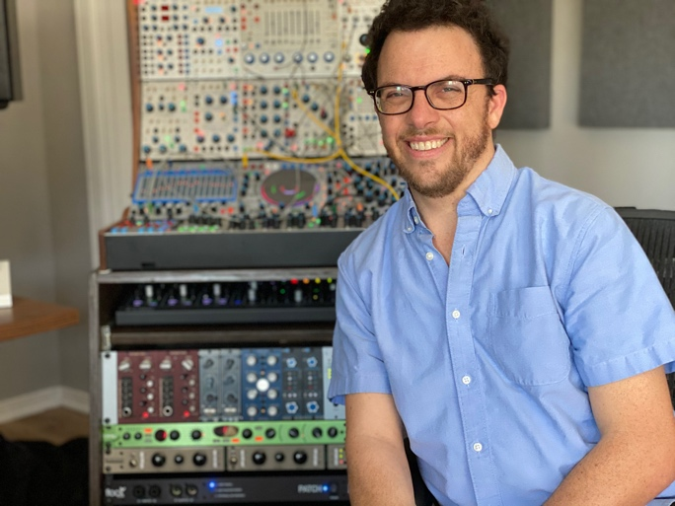
Santa Monica, CA – August 3, 2021 – TV and film composer Jacob Shea has worked on a variety of musical projects since getting his start in the industry 15 years ago. With stints working alongside renown composers Hans Zimmer and Elliot Goldenthal and composing on such blockbusters as ‘Pirates of the Caribbean: On Strange Tides’ and ‘Transformers: The Dark of the Moon,’ Shea’s latest project as lead composer on German Sky TV series ‘Der Pass’ required him to create unique, less conventional compositions — all of which have been recorded using Flock Audio’s revolutionary digitally controlled patchbay routing solution the PATCH System.
While working on ‘Der Pass,’ Shea has utilized a wide range of electronic instruments including synths to create the show’s unique sound which he dubs more of a ‘sound tapestry rather than your typical acoustic instrumentation.’ After acquiring the PATCH System 6 months ago, Shea quickly realized the benefits the PATCH offered him when it came to repeating certain sounds and musical sections across the series.
“The Flock PATCH System has been crucial getting through this season,” Shea said. “I’ve worked with patchbays before an it’s been really cumbersome and annoying. The joy of using external equipment is generally hampered by integrating it into a computer-based setup.”
“Additionally, working on a TV series, I have to be able to recall a piece of work very easily,” he continued. “For example, if I’m looking to use a sound during the 8th episode of the series when a certain character appears on screen, and I also used that sound in the 1st episode, it’s very difficult to refer seven episodes back when using outboard gear because you literally forget in a week how the hell you made something. The PATCH System has changed all that.”
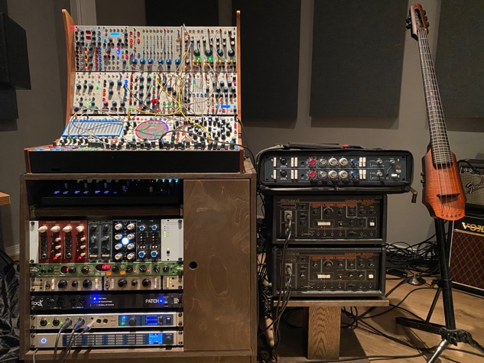
Staying ‘in the Groove’
A major time-saver, the PATCH System has also allowed Shea to experiment where he didn’t think he normally would have time to — opening up his creative process.
“Using a traditional patchbay requires a ton of cables and seven episodes later you have to revise 15 minutes music in one day and can’t spend time repatching everything or you’ll get fired,” Shea joked. “I’ve come up with things on the fly and been able to try out things that I never thought I would have been able to while using the PATCH because it saves me so much time.”
While working on a series featuring sounds as unique as those in ‘Der Pass,’ Shea’s creative mindset is of utmost importance. Eliminating the need to repatch has been essential to his artistic ‘stream of consciousness.’
“Being in a creative mindset is a fragile space and the minute you are taken out of the zone to repatch something, for instance, it affects your flow,” he said. “So having this PATCH System has been crucial. It doesn’t sound like a big deal, but to stay creative and stay focused on the task, it’s made a world of difference when it comes to staying in the groove.”
The PATCH has also allowed Shea to be more creative with his outboard.
“You can create this crazy array, and you are like, ‘Wow, this sounds incredible. Let me save this.’ And then when that actor shows up on screen again, it’s easy to access,” he explained. “So, it’s allowed me to come up with a sound that’s inspiring and not in a piecemeal way. With the Flock, I have all my tools in the studio at the ready. I’m spending more time thinking about what people are paying me to think about which is creating a compelling musical underscore.”
A Rock-Solid Solution
In addition to maintaining a creative flow, the PATCH System has helped Shea while auditioning signal paths.
“Since you can set it up anywhere, when I’m auditioning various signal paths, and I’m in a listening position near my speakers, I don’t have to get up to change the old patchbay that was in the corner and then go back to ‘listening mode,’” Shea explained. “The PATCH System allows me to make a more informed decision about a piece of work instead of getting up and fiddling around with the patchbays.”
Shea said the PATCH System ‘is absolutely transparent,’ which adds to its ‘rock solid’ reputation.
“The PATCH is just rad; it’s a thing of genius,” Shea said. “I’m not going to work without it — it’s that remarkable. It sounds cliché to say it, but it’s literally a gamechanger. It’s been a tremendous boon for me.”

About Flock Audio
Flock Audio Inc. is a pro-audio manufacturer based in Kelowna, Canada, founded in 2017. The company is best known for its PATCH System Series, which is a Digitally controlled, 100% Analog Patch bay routing solution for professional audio environments. For more information on Flock Audio and its products, please visit the company website at http://www.flockaudio.com.

Media Contact
Jeff Touzeau
Public Relations
Hummingbird Media
+1 (914) 602 2913
jeff@hummingbirdmedia.com

