Pilar Zaragozá takes her vision of the male image to stardom
The hairdresser has a long career as an expert in men's hairdressing, providing a different and original perspective on men. This new, fresher, and more modern look has been recognized by the International Visionary Awards. Her collection "Respira" was chosen as a finalist in the "Men’s" category, a recognition that she has received for the second year in a row.

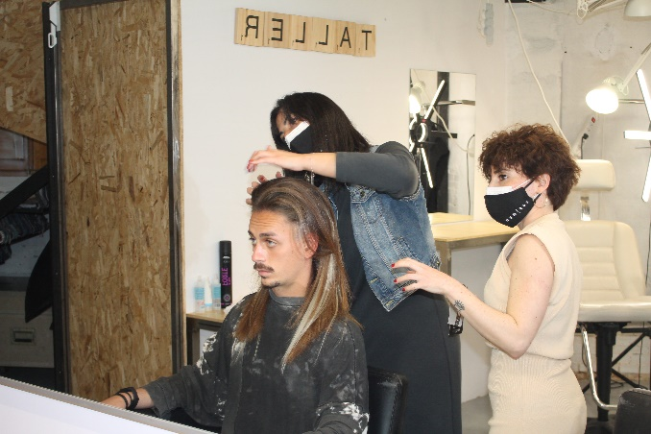
Pilar Zaragozá is a successful businesswoman, a specialist in hairdressing for men who offers a much freer and innovative vision of the male image, bringing it closer to the daring and creativity of the female. The hairdresser breaks the mold, but, at the same time, she opens up new possibilities for men who do not want to feel corseted or labeled. Her contribution is based on integrating the feminine point of view, more open to image changes, with more updated haircuts and more courageous tones, but respecting the essence of men in her approach. For this reason, it is highly commendable what she has achieved with this work, placing it in the final of the International Visionary Award for the second consecutive year in the "Men’s" category.

This way, the hairstylist manages to renew the hairdressing for them, her great passion since the beginning of her career. Furthermore, this recognition is the result of a unique hairdressing perspective forged over years of experience that has never ceased to evolve. The fighting and intelligent spirit of Pilar Zaragozá, the search for excellence, the desire to improve, and a high motivation in everything she does is what has led her to have a methodology of her own. Also, all these values ​​have led her to attend and promote the female image in Eos/Women, hers, her first salon for women.
Hairdressing is not alien to the personality of the person who exercises it and when it is done passionately it is completed with emotions and principles that make each job unique and different. Her method of cut, design, and brand is reflected in impeccable looks in the salon, but also in collections, since creative hairdressing is connected to businesses, projects them and, in the case of creative hairdressers, transforms them personally and professionally. Therefore, it is not a trivial question, but one of individual and professional growth. What we are is reflected in everything we do, also in a collection and there is no gesture more generous than sharing it to inspire others, especially hairdressers who find it difficult to launch into creative hairdressing.

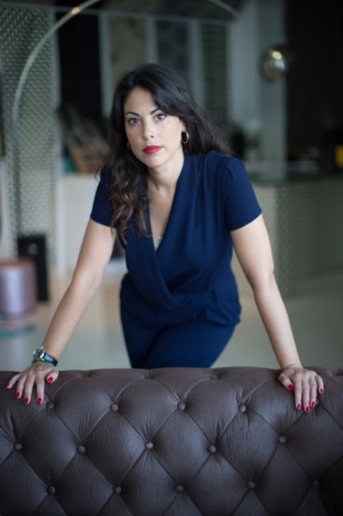
About Pilar Zaragozá:
Pilar Zaragozá has been attracted to hairdressing since childhood and based on a great desire and the constant search for excellence, she has managed to make her passion her profession.
She started in the profession with great enthusiasm and from below, doing manicures in a barbershop, and that's how she discovered the job completely and from within. Without mentors or acquaintances, but eager to progress, she has been training continuously, not only in hairdressing but also in male aesthetics and business management. To make this life project a reality, she has spared no effort in offering excellence and a vision as well cared as personal of male image.
During her professional career, she has taken on different challenges that have shown that, in addition to being an excellent hairdresser, she is extraordinary at running businesses and managing teams. Hence, she currently runs three salons, two male with male aesthetics, Eos | Men, and a female, Eos | Women, which she recently opened. Based on constant training as a driver of excellence, she created her own method of male haircut, design and brand. This new evolutionary methodology and technique, applied in hairstyling, managed to introduce her and her team to the forefront of male aesthetics. Besides that, she has also a more artistic side, having designed and created creative collections that have achieved international renown.
Nominations and Awards:
- Finalist International Visionary Awards 2021, men category
- Finalist International Visionary Awards 2020, men category
- Finalist AIPP Awards 2020/2021, men category

