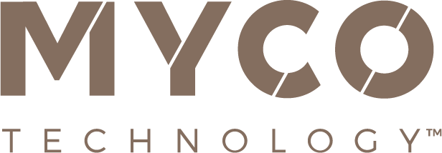

July 10, 2023
PRESS RELEASE

Leading innovation expert Ranjan Patnaik, Ph.D.
named as MycoTechnology’s first CTO

Mycelial fermentation specialist, MycoTechnology, Inc. has appointed industry veteran Ranjan Patnaik, Ph.D. as its new Chief Technology Officer. This newly created role will strategically align R&D, food science and technical services teams under a single executive leader as MycoTechnology gears up for its next stage of global growth.

Patnaik brings over 25 years of experience in the fields of fermentation, strain engineering and bioprocess product development. He joins MycoTechnology from EVERY™ (formerly Clara Foods), where, as CTO, he led a multi-disciplinary technology team of over 50 to pioneer the manufacturing of egg proteins using precision fermentation. During his tenure, the company transitioned from laboratory-phase research to commercial production. Educated in India and the US, Patnaik holds bachelors and doctoral degrees in chemical engineering, and previously spent over 16 years in domestic and international senior leadership roles at DuPont.

As his appointment was announced, Patnaik said: “I’m thrilled to be taking up this new role with MycoTechnology at such an important and exciting stage of its journey. The potential for mycelial fermentation in food and beverage applications is huge and remains largely untapped. MycoTechnology’s fermentation platform is based on highly sophisticated science and technology know-how and intellectual property assets, putting the company many steps ahead of others in this space and on a clear path to success.”

Alan Hahn, MycoTechnology Co-Founder & CEO, added: “Ranjan has an unparalleled track record of steering businesses from the science and tech stage towards becoming manufacturers and suppliers of scalable, commercialized products. His experience and expertise will be invaluable as we execute on our vision to expand our presence globally and establish international partnerships, while continuing to build on our plans in the Middle East.”

Updated branding underlines vision
Meanwhile, MycoTechnology has unveiled its updated branding and new website, showcasing its dedication to fusing science, nature, and food and beverage innovation. The fresh new look represents the company’s brand vision and commitment to harnessing the power of mushrooms to create foods that are better for both people and the planet.

Jonas Feliciano, Director of Marketing, commented: “MycoTechnology has continued to evolve, and this is the perfect time to implement new branding to reflect the huge progress made in recent years. Our aim is to highlight our ability to combine natural food technology with the culinary world to create nutritious and transformative ingredients. This new brand direction reaffirms our position as a trusted partner for chefs and R&D professionals seeking to realize their innovation ideas – all while meeting our goal of evolving the current food system for the benefit of all.”

ENDS

For more information contact:
Richard Clarke, Ingredient Communications
Email: richard@ingredientcommunications.com

About MycoTechnology, Inc.
Established in 2013 and based in Aurora, Colorado, MycoTechnology creates products from mushroom mycelia that solve the biggest challenges in the food industry. The world’s leading explorer of mycelia, MycoTechnology is dedicated to increasing the availability of healthy, sustainable, clean label and high-quality food options through natural mushroom fermentation. Its product portfolio includes ClearIQ™ flavor, a line of transformative mushroom-derived flavor modulation tools that decrease the perception of bitter and off-notes, enable the formulation of products with higher nutrient density, and reduce salt and sugar across a broad spectrum of applications. MycoTechnology also offers FermentIQ™ protein, a line of plant protein products produced via a proprietary fermentation process that harnesses the power of mushroom mycelia to make plant proteins that are more functional, easier to digest, and more delicious. MycoTechnology is a team of near 100 employee-shareholders and continues to recruit additional colleagues to aid expansion and growth.

