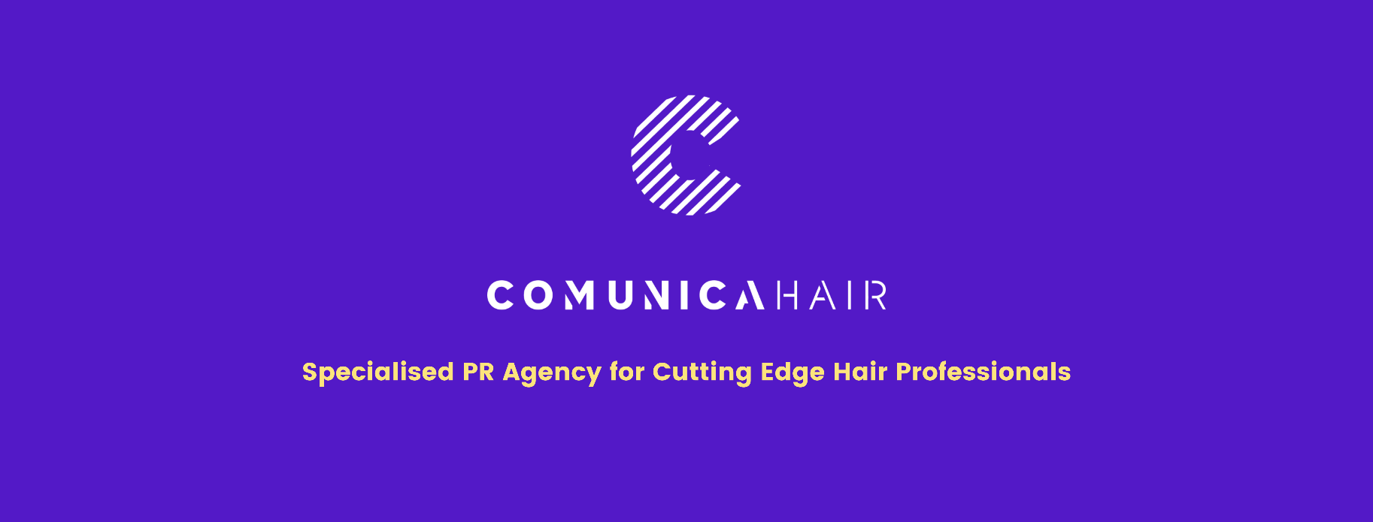

For more information, please contact Marta de Paco
On +34 670 780 664 or email press@comunicahair.com

Important:
These images are only available for editorial content.
Credits must be included.
Notification of their publication is expected.

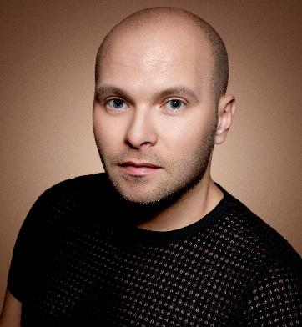
ALEXANDER KIRYLIUK
SK STYLE BARCELONA
ART HAIR GALLERY Collection

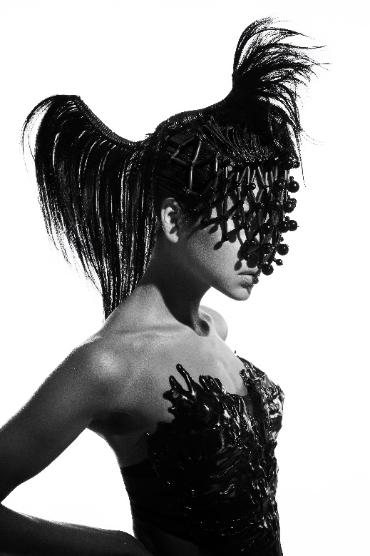
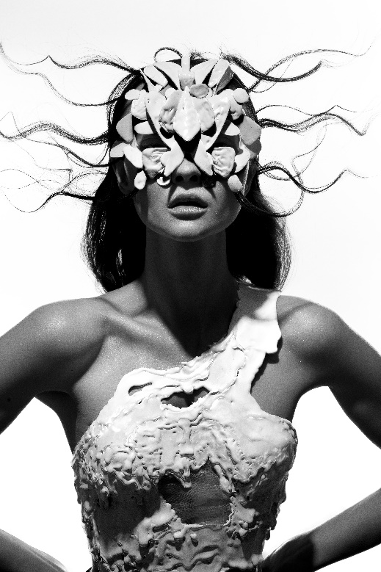
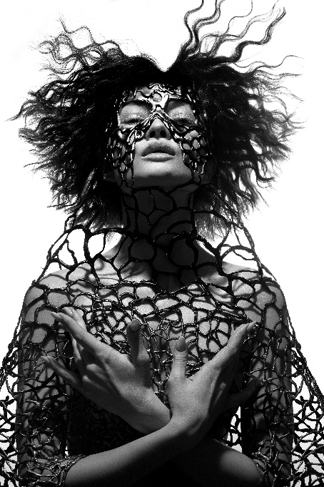
FÍGARO AWARDS 2021
FINALIST - AVANT-GARDE CATEGORY

Creative team: SK Style Barcelona @skstylebarcelona
Hair: Alexander Kiryliuk @alexander_kiryliuk
Hair Assistant: Inna Lipkovich, Anton Perez
Photography: David Arnal Instagram: @davidarnalteam
Retouche: Javier Villalabeitia Instagram: @javiervillalabeitia
MUA: Miguel Silva, Natalia Sidorova Instagram: @miguel.silva , @nsidorova8
Styling: Agata Karobka
Video: German de la Hoz @german_delahoz
Models: Veronika @veronikakas, Anastazia @azia_be, Safu @ssssafu, Belen @belenduarte, Natalia @niahtheron

ALEXANDER KIRYLIUK
SK STYLE BARCELONA
ART HAIR GALLERY Collection

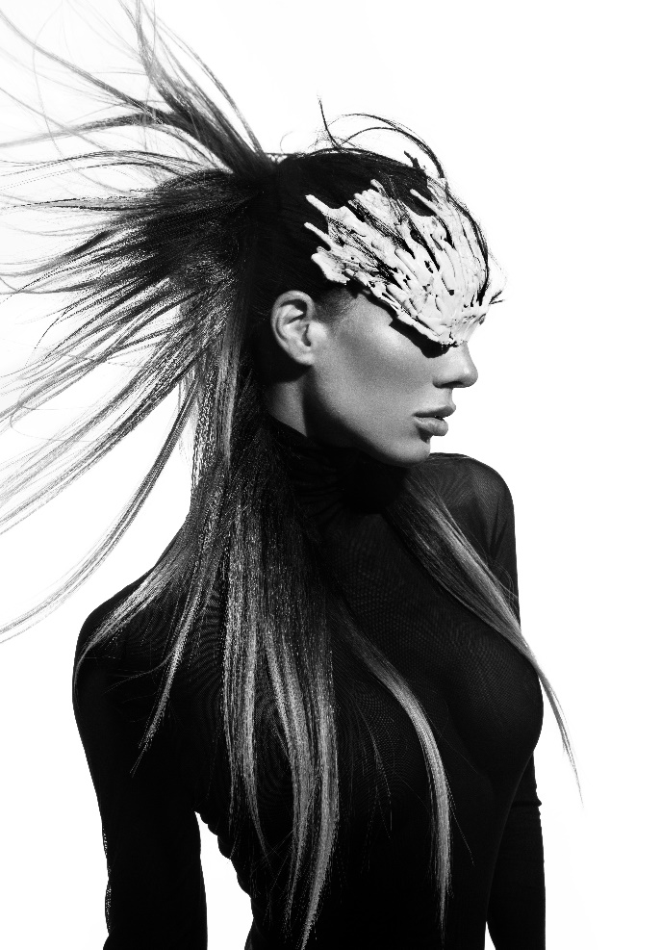

"Each look of the collection is a work of art. It is a creative delusion that makes the most of hair and its expressive possibilities. Hair emerges as the protagonist of images, and in these, it dialogues with other elements such as masks, clothes, volumes, colors, and textures. The result is artistic images of surprising beauty.’’

