
bettergamingagency.prowly.com

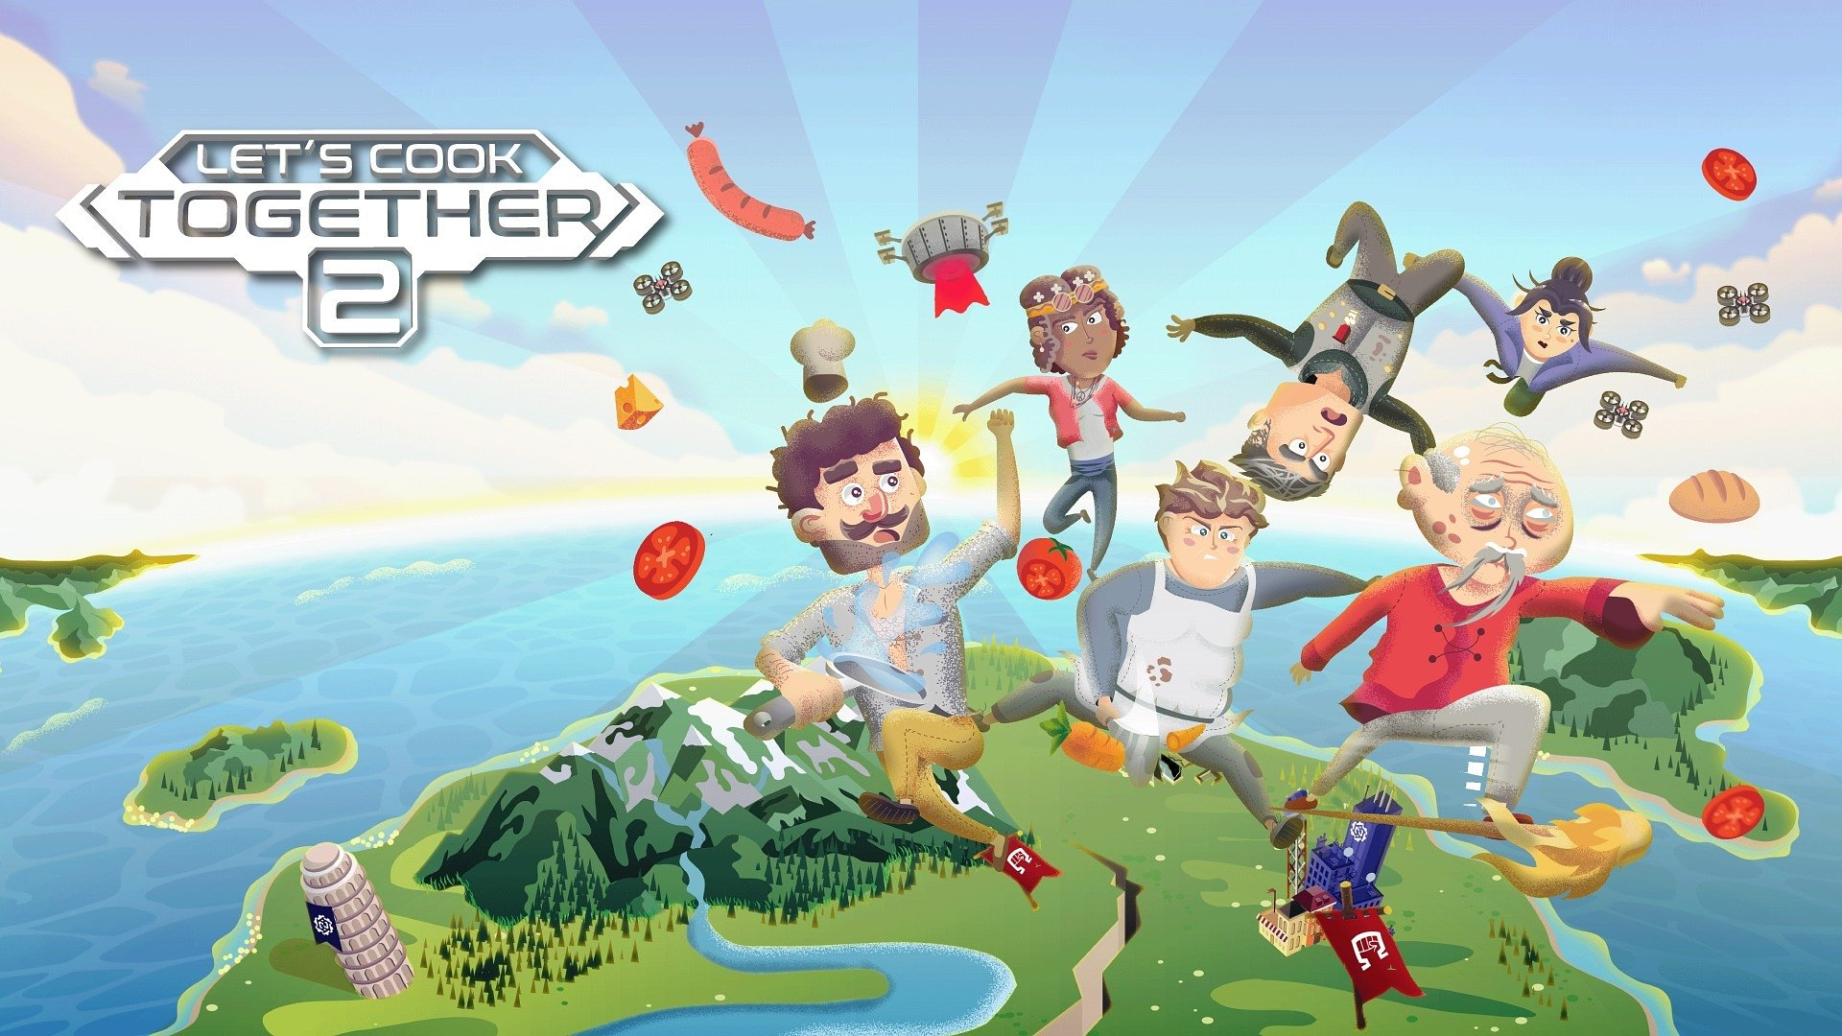

The knives are getting sharp, and the chefs are ready to start! Let's Cook Together 2 – a cooperative hotdish will be served on February 6

You haven’t seen real chaos until you've worked in a restaurant... or tried a cooking game!

Let's Cook Together 2 is the sequel to the crazy cooperative game where players work together to achieve culinary mastery, facing gastronomic challenges inspired by cuisines from around the world. The developers from the Polish studio Yellow Dot don’t want to keep us simmering in the pot of anticipation any longer – they’ve announced that the game will launch on Steam, PlayStation 4, PlayStation 5, Xbox One, Xbox Series S/X, and Nintendo Switch on February 6, 2025. And for those intrigued, a saffron-spiced demo is available to try right now.

They say „Too many cooks spoil the broth,” but four isn't too many, right? These kinds of kitchen heroes will surely handle every task perfectly. Let's Cook Together 2 focuses on cooperation, allowing up to four players to join forces in its co-op mode. However, nothing stands in the way of tackling the challenge solo, discovering the story behind the game, which weaves a tale of food, love, and the price of freedom. Those who want to stir things up can challenge themselves in community created levels – the game comes with a carefully designed level editor, which provides players with a powerful tool to push everyone’s culinary imagination.

Get a taste of Let's Cook Together 2 by watching the latest trailer

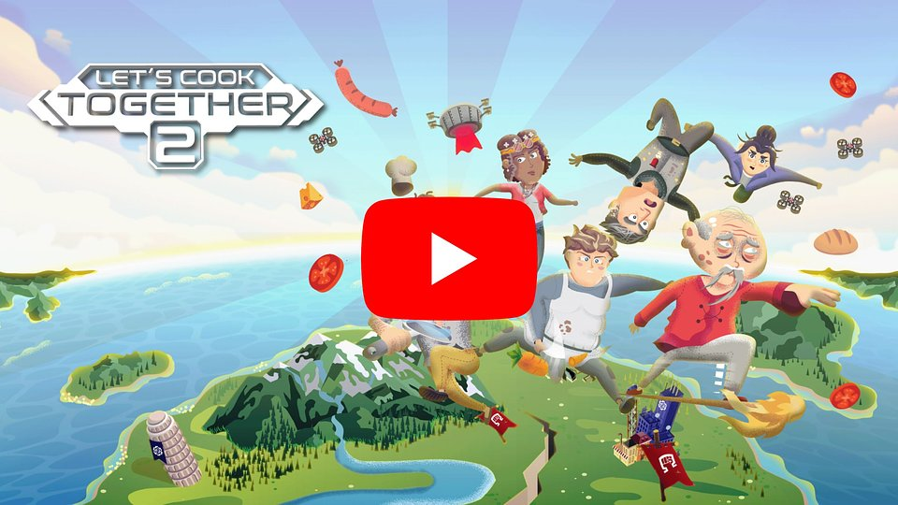
https://www.youtube.com/watch?v=7y4WhB4dVWk

The story of Let's Cook Together 2 presents players with a dark vision of the future, where the world is ruled by the megacorporation Nutri-Inc. It enforces a law that forces citizens to consume only Nutri-Paste – a tasteless, dull paste made from various edible ingredients like tree bark, weeds, and stems. Growing or preparing your own food is forbidden, and all knowledge of cooking techniques has been lost. A tasteless life has left people confused, apathetic, and lacking ambition. To save the appetite and lives of the people, a Resistance movement led by General Ohm emerges – a group of survivors who are "taste-awakened." They are waging a losing battle against the system, but everything changes when they manage to build a device that allows them to relearn recipes from the old world.

During their journey to culinary freedom, players will travel through 4 countries, where they will complete 250 levels and master 65 recipes – including a wide range of dishes, from Italian classics such as pizza, bruschetta, and lasagna, to Japanese specialties like sushi, gyoza dumplings, and udon noodles, finishing with Polish masterpieces (cuisine that is really close to the developers' hearts) like bigos and pierogi.

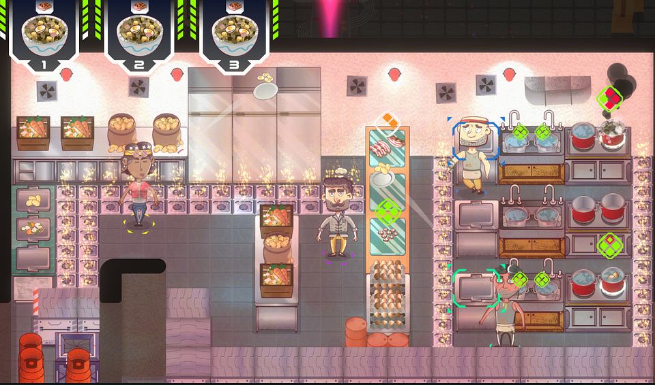

Let's Cook Together 2 tastes delicious thanks to key features like:

🥞 More, better, nicer – Let's Cook Together 2 is a sequel that significantly expands on the ideas introduced in the first installment. Players can look forward to even more exciting challenges and gameplay mechanics, as well as a completely new, stylized visuals.

🥟 Level editor – create your own levels to impress others and share them with the gaming community. With intuitive tools, anyone can design new challenges, ensuring the fun never ends.

🍕 Seasoned for all skill levels – the adjustable difficulty level, suited for players of varying skill levels, makes the game a great choice for family play. The co-op mode, where up to four players can have fun together, has been designed so that every participant remains equally engaged.

🥐 Kitchen nightmares – crazy challenges make the gameplay full of dynamism: rushing with hot pots, battling kitchen fires, tossing ingredients across the room – in Let's Cook Together 2, all of this is as normal as a walk in the park, but you definitely shouldn’t try it at home.

🌮 Culinary Class War – for those who prefer competition over cooperation, there’s the PvP mode – Kitchen Battles, where every second counts in the race for the culinary master title.

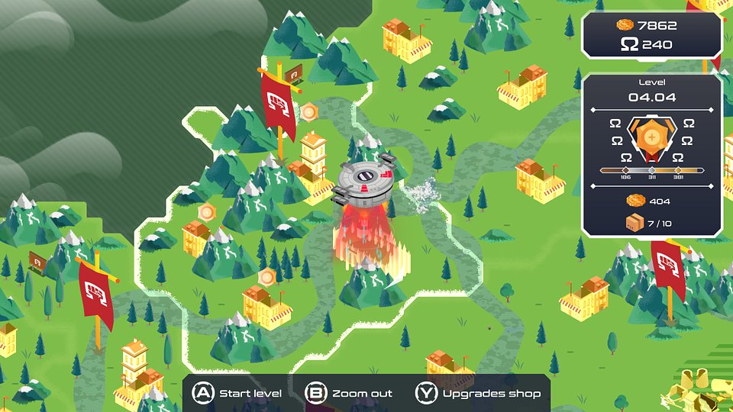

Let's Cook Together 2 will launch on Steam, PlayStation 4, PlayStation 5, Xbox One, Xbox Series S/X, and Nintendo Switch on February 6, 2025, making it the perfect time to add the game to your wishlist. Those eager to see if they can handle the challenges of working in a crazy kitchen can try the demo right now.

We also encourage keeping up with the latest news about the game and Yellow Dot's activities on the official website and social media. More materials will be revealed in the near future.

● Official website
● Twitter
● Facebook
● TikTok
● Discord

The full press kit is available here.

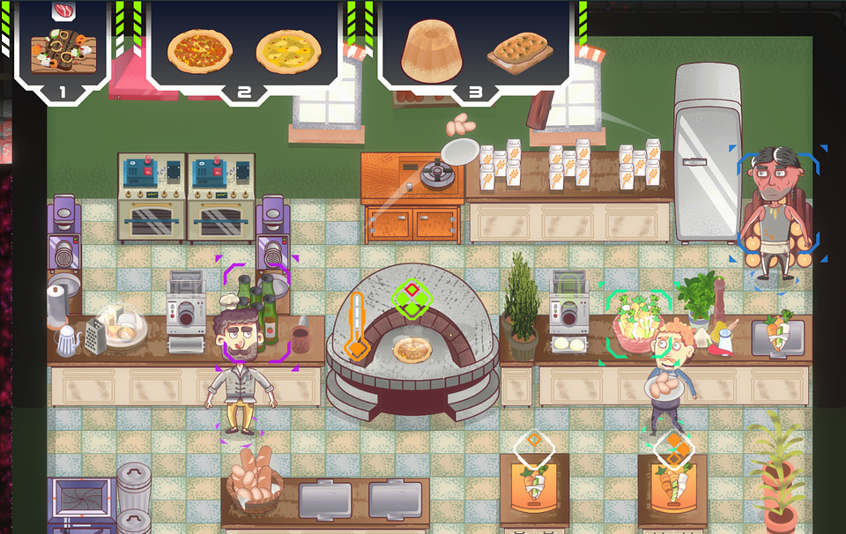

About Yellow Dot:

Yellow Dot is a small, independent game development studio based in Gdańsk, Poland. We specialize in creating cooperative games, with a focus on providing enjoyment for everyone – from experienced gamers to those just starting their journey in the world of virtual entertainment. The central theme of our games is communication. We aim for the gameplay dynamics to shift depending on who you're playing with – a partner, friends, or the whole family. Currently, we are working on Let's Cook Together 2, the sequel to our warmly received title, where players collaborate to tackle culinary challenges.

