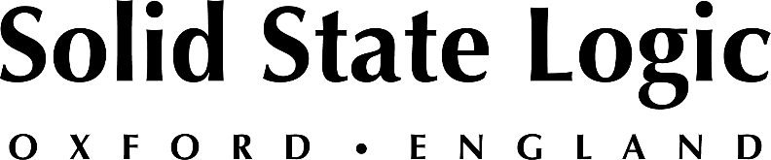

Solid State Logic Supports The Returning NAB Show, Showcasing
Advancements of its System T Broadcast Production Platform
Enhancements to System T include new scalable TE1 and TE2 Tempest Engines, enhanced multi-operator remote workflows and integrated 3rd party device control

LAS VEGAS — Solid State Logic [Las Vegas Convention Center, Booth C8008] announces its return to the NAB Show, scheduled to occur at the Las Vegas Convention Center between April 23 -27. SSL will be highlighting the many significant advancements of its System T broadcast audio platform, with their team of AoIP experts on hand for in-person consultations:

- New TE1 & TE2 Tempest Engines featuring scalable Pay-As-You-Go licensing capabilities designed to work in harmony with your production requirements.
- Flexible, multi-operator remote production workflows.
- NGA / Immersive production capabilities; channel and bus formats with 3D panning.
- Advanced Dante AoIP implementation, featuring full routing control directly from the console with AES67 and ST 2110 integration.
- Integrated control of Shure Axient wireless mics and Dante enabled Rednet MP8R Mic IO directly from the console.

Also debuting at NAB will be the new SSL Live L650 console and V5 software, featuring immersive / object based mixing control of L’Acoustics L-ISA / Meyer Spacemap Go loudspeaker systems, new processing tools, and operator focused workflow enhancements.

System T Consoles and Control Interfaces
SSL will also demonstrate the latest feature updates for their range of consoles and control interfaces. The large-format configurable S500 and fly-pack S500m surface, as well as pre-configured surface options in the S300 range suited to mid-size production facilities, make these consoles flexible for many different applications and scale of broadcast production. Tempest Control Rack (TCR) offers a 3 RU solution for production environments where a powerful broadcast audio mixer is required but a traditional console is not.

Interested attendees of the 2022 NAB Show can use SSL guest code LV8385 for free access prior to April 8th. To book an appointment, consultation, or demonstration, please visit the SSL events page at: https://www.solidstatelogic.com/events/nab-show.

Solid State Logic is the world’s leading manufacturer of analogue and digital audio consoles and provider of creative tools for music, broadcast, live and post production professionals. For more information about our award-winning products, please visit: www.solidstatelogic.com.

###
For further information contact:
Jeff Touzeau
+1 (914) 602-2913
jeff@hummingbirdmedia.com

Ross Gilbert
+44 (0) 1865 842300
rossg@solidstatelogic.com

