NAMM 2020: Powersoft Announces Major Update to Best-In-Class Audio System Management Software ArmoníaPlus
HealthPlus update streamlines real-time device monitoring and measurement for maximum performance

Anaheim, CA
10 January 2020

Professional power amplifier manufacturer Powersoft [Booth 17701] has announced the latest update to their best-in-class audio system management software ArmoníaPlus.
HealthPlus, which replaces the software’s previous ‘Events’ tab, gives sound engineers a streamlined monitoring environment of all elements in a given sound system with improved communication, control and reporting to ensure even better performance than ever before. HealthPlus is available now for all ArmoníaPlus users.

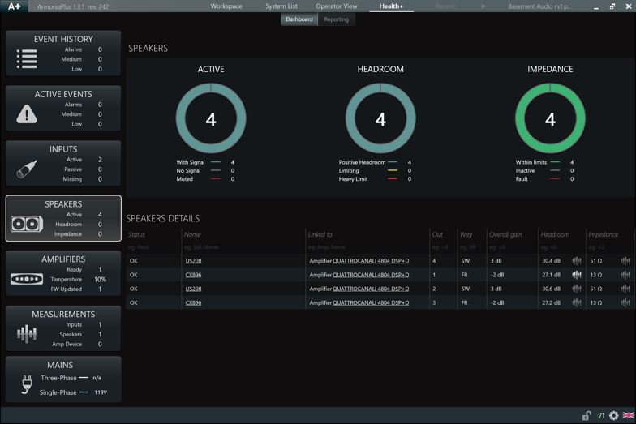
HealthPlus’s updated display gives engineers a complete suite of system diagnostic controls to monitor the health and effectiveness of any sound system in real-time, so can be used with a touring PA or in fixed installations like cinemas, airports, theme parks, etc… In addition to input monitoring for power amplifiers, speakers, and other connected devices, the system is also capable of measuring system health indicators such as headroom, temperature, voltage, and impedence to ensure optimal performances of all elements and will automatically alert users in case of malfunctions or element failures. Engineers can also now utilize the Event History function to track uploaded programs, user logins, and diagnose any long-term system issues. Finally, HealthPlus has improved reporting, giving users the ability to track multiple indicators at once over an hour time log period for more detailed system monitoring.

“We’ve designed ArmoníaPlus to be efficient and streamlined for effective use under any working conditions,” explained Powersoft U.S. Application Engineer Rick Woida. “With the new HealthPlus tab, engineers now have easier access to a peerless set of tools for system management, ensuring long-time health of any system and the ability to quickly diagnose and fix any potential problems better than ever before.”

For more information and the latest updates on ArmoníaPlus, please visit:
http://armonia.powersoft.it/

For further information

Francesco Fanicchi  POWERSOFT FIRENZE  francesco.fanicchi@powersoft.com  +39 346 9719798 | Jeff Touzeau  Hummingbird Media  jeff@hummingbirdmedia.com  +1 (914) 602-2913

ABOUT POWERSOFT:
Powersoft is the world leader in lightweight, high power, single rack space, energy efficient amplifiers for the professional audio market. Founded in Italy in 1995, headquartered in Florence, Italy, with offices in New Jersey, Powersoft couples the experience and precision of its production department with exceptional components to deliver products with perfect audio response and high-performance reliability. Its state-of-the-art amplifiers can be found in an array of markets, ranging from stadiums, sporting arenas, theme parks, performance venues and airports to convention centers, churches, and clubs, and are used by the world's leading tour sound companies. For more information, visit the Powersoft website: www.powersoft.com

