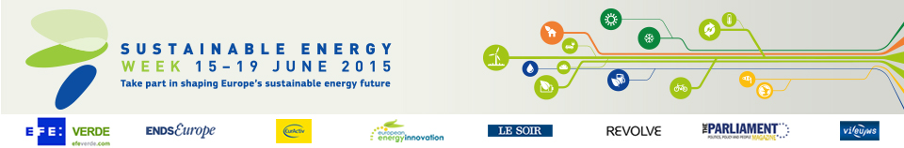

Energies POSIT’IF

Category

Energy efficiency

Location

Pantin, France

How to efficiently save energy and improve housing

Retrofitting residential buildings can achieve huge energy savings… if only the work wasn’t so complex and expensive. A new approach from France might provide a solution.

A French public-private-partnership has helped remove financial and bureaucratic barriers holding back the renovation of existing residential buildings. Through organising all the financial, legal and technical aspects of a complex retrofit project, Energies POSIT’IF aims to contribute towards France’s target of a 38% reduction in energy consumption of existing buildings between 2007 and 2020.

Since it was established in 2013, the company has signed retrofitting contracts worth €30 million for around 1650 housing units. The aim is to achieve a reduction in energy consumption by at least 40 %. With over 700 000 inhabitants in the Ile-de-France region currently spend more than 10 % of their income on heating bills, this will bring direct benefits to citizens. The Energies POSIT’IF project also has potential for replication in other areas of France and indeed Europe, where collective housing is predominant.

Organisation

Cité Régionale de l’Environement d’Ile-de-France
France
www.iledefrance.fr
Project website: www.energiespositif.fr

