First Class and Nonstop
Exceptional sound meets exceptional style

Wedemark, August 30th, 2023 – The Sennheiser MOMENTUM 4 Wireless follows its jam-packed mid-year update with two new colorways that bring additional flair to the portable audio powerhouse series.

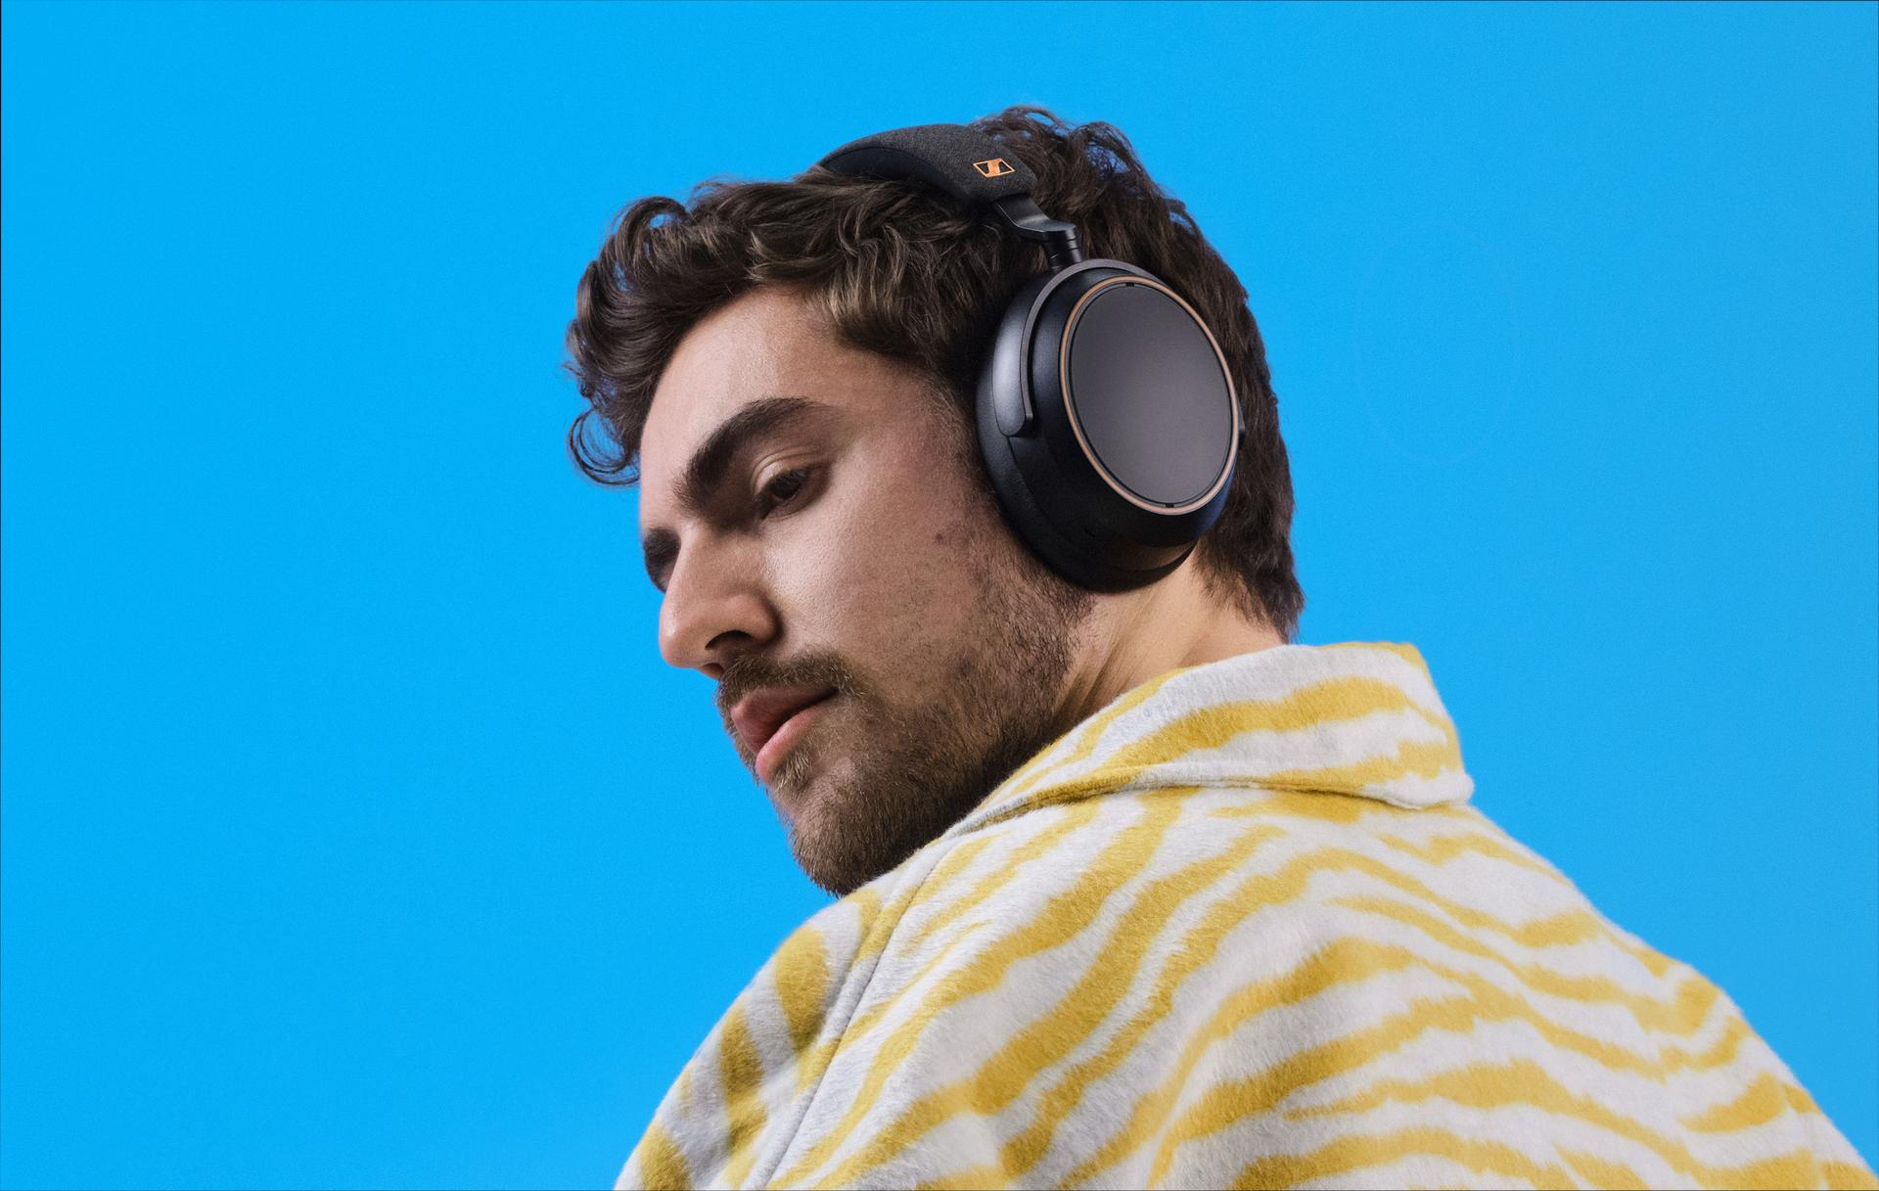

"MOMENTUM 4 Wireless became a brand best-seller in record time thanks to stellar acoustics, marathon battery life and sound-first features—of which we have continued to incorporate post-launch,” says Christian Ern, Sennheiser Principal Product Manager, “Our two new colorways add modern design flourishes while still retaining the sleek silhouette and world-class performance that helped make them a go-to choice for audio purists.”

As versatile as your favorite jeans
Since its launch, the traveler-friendly MOMENTUM 4 Wireless has found a groove not only in the skies, but in busy offices, commutes, households, and backpacks too—making them an audio enthusiasts’ dream for work or play. Now, Sennheiser is doubling the color choices available with two new variants to complement the current matte black/charcoal and white/stone finishes.

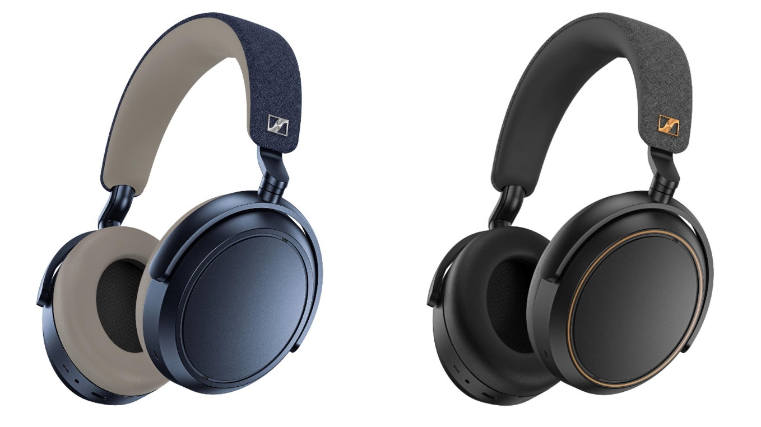

Echoing the timeless hue of deep-blue jeans, the inky “Denim” colorway blends understated class with the perfect amount of casual cool. Contrasting stone-colored padding underscores the familiar touch of the fabric-coated headband surface, which can also be found on the protective cases of the entire MOMENTUM series.

The “Black Copper” variant draws lineage from the metallic accents on the instant-classic HD 660S2 audiophile headphone, launched earlier in 2023. Both the “S” badge and earcup contour rings tastefully highlight the series’ premium design and audio heritage no matter where you take them. As with all MOMENTUM 4 Wireless models, the new color choices offer supple ear and headband cushioning to pair all-day comfort with class-leading 60-hour battery life per charge. Both styles feature the series’ renowned Adaptive Noise Cancellation technology, Bluetooth® 5.2 and aptX™ Adaptive support, and matching deluxe travel cases for storing the included USB and audio cables.

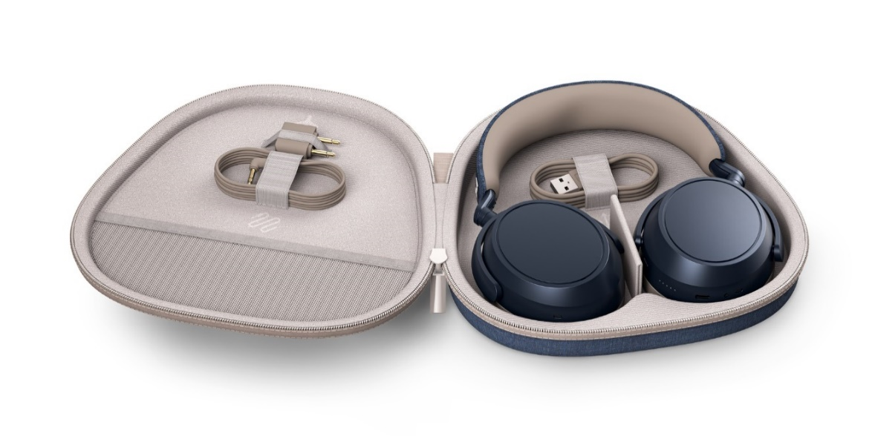

Smart Control, pricing and availability
All MOMENTUM 4 Wireless models feature advanced performance and customization options using the free Smart Control App (iOS App Store and Google Play) such as high-resolution audio mode, Sound Personalization, 5-band EQ and location-based Sound Zones. The “Black Copper” MOMENTUM 4 Wireless colorway will begin shipping on August 31st, 2023 on sennheiser-hearing.com and amazon.com. The “Denim” edition will begin shipping from select retailers and the sennheiser-hearing.com webstore in mid-October. The new MOMENTUM 4 Wireless colorways have an MSRP of EUR 399,90.

About the Sennheiser brand
We live and breathe audio. We are driven by the passion to create audio solutions that make a difference. Building the future of audio and bringing remarkable sound experiences to our customers – this is what the Sennheiser brand has represented for more than 75 years. While professional audio solutions such as microphones, meeting solutions, streaming technologies and monitoring systems are part of the business of Sennheiser electronic GmbH & Co. KG, the business with consumer devices such as headphones, soundbars and speech-enhanced hearables is operated by Sonova Holding AG under the license of Sennheiser.

Press contact
Sonova Consumer Hearing GmbH
Paul Hughes
Head of PR and Influencers, Sennheiser Headphone and Soundbars
T +49 (0) 162 2921 861
paul.hughes@sonova.com

