Lubrizol’s Apisolex™ Polymer Wins Silver at CPhI China’s 2026 Pharma Excipients Awards
Shanghai, China, Lubrizol’s Apisolex™ polymer excipient has earned a Silver award in the Drug Delivery Empowerment category at the 2026 CPhI China Pharma Excipients Awards. Part of the broader CPhI Celebration awards program, the recognition honors innovative excipient technologies that advance drug delivery, improve bioavailability, and demonstrate strong market potential.
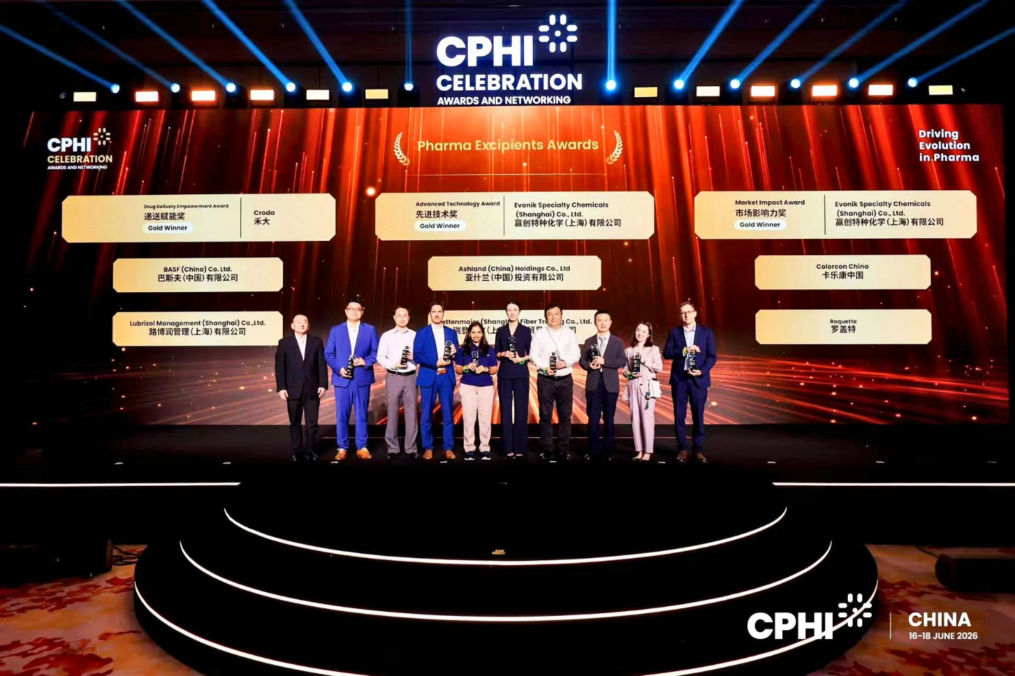
The Pharma Excipients Awards spotlight forward-looking companies and breakthrough products that are helping raise technical standards across the pharmaceutical excipients sector, shape best practices, and influence the future of the industry.
Selected from a field of more than 100 nominees across all award categories, Apisolex™ polymer was recognized for addressing one of drug development’s most persistent formulation challenges. The injectable excipient can enhance the solubility of poorly soluble BCS Class II and IV APIs by up to 50,000-fold, helping overcome a critical barrier in a pipeline where approximately 60% of candidate drugs face solubility limitations.
This latest recognition adds to Apisolex™ polymer’s growing track record of industry honors, including CPhI China’s Pharma Excipients Award in the Advanced Technology category in 2023 and a Finished Formulation award at CPhI Barcelona in 2023.
In addition, Lubrizol’s Apinovex™ polymer received a Celebration Award in the Pharma Excipients category at CPhI China 2025.
Says Kevin Song, Sr. Director, Global Nutraceutical and Pharmaceutical Businesses, who accepted the award on behalf of the Lubrizol China team, “Being recognized by CPhI, the industry’s primary showcase of pharmaceutical innovation, underscores Lubrizol’s continued commitment to next-generation excipient technologies that expand formulation possibilities and improve drug delivery.”
Learn more about our award-winning excipients here.
About The Lubrizol Corporation
Lubrizol, a Berkshire Hathaway company, is a science-based company whose specialty chemistry delivers sustainable solutions to advance mobility, improve well-being and enhance modern life. Every day, the innovators of Lubrizol strive to create extraordinary value for customers at the intersection of science, market needs and business success, driving discovery and creating breakthrough solutions that enhance life and make the world work better. Founded in 1928, Lubrizol has global reach and local presence, with more than 100 manufacturing facilities, sales and technical offices and more than 7,000 employees around the world. For more information, visit www.Lubrizol.com.

