For immediate distribution
PK Sound to Demonstrate Trinity 10 Robotic Line Array at NAMM 2019
Trinity Line Array Provides Remote Control Directivity,
while Reducing Transportation Costs and Physical Footprint
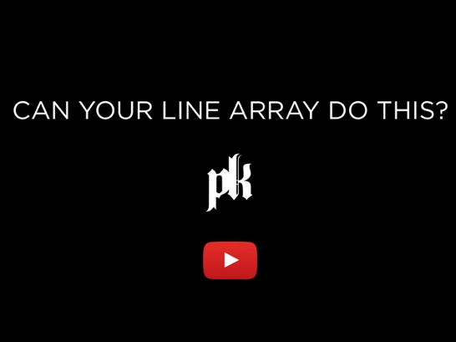
Anaheim, Calif., January 15, 2019 — PK Sound [Level 2, ACC North Booth 17515], company that revolutionized three-dimensional wavefront technology, will be demonstrating its new Trinity 10 at The NAMM Show — the first mid-size, three-dimensionally controlled sound system of its kind. The company will offer daily demonstrations of both the Trinity 10 and its Gravity series of subwoofers within its demo room, located in suite 203 B inside the ACC Brand Showcase Section on Level 2.
PK Sound’s demo room will feature a cast of special guests at the FOH position, each mixing a diverse selection of tracks featuring various artists through the Trinity 10 and Gravity loudspeakers. The current schedule is as follows — entry to each session will be handled on a first-come, first-served basis and scheduling may be subject to change:
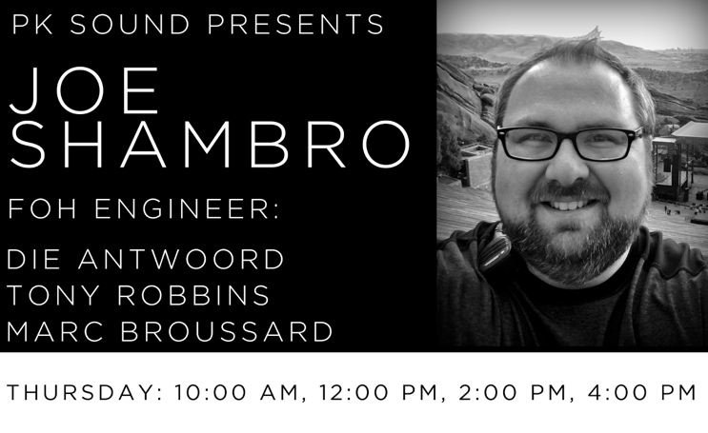
- Thursday, January 24 — Joe Shambro (10:00 a.m., 12:00 p.m., 2:00 p.m. and 4:00 p.m.)
Joe Shambro is a veteran audio engineer focused on live sound reinforcement and live event recording. Past clients include Marc Broussard, Robert DeLong, Die Antwoord, and the Obama and Trump White House administrations.

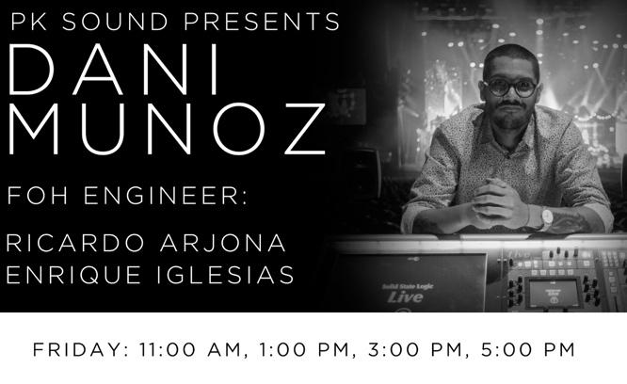
- Friday, January 25 — Dani Munoz
(11:00 a.m., 1:00 p.m., 3:00 p.m. and 5:00 p.m.)
Dani Munoz is a FOH/Monitor mixer with extensive experience mixing arena and stadium shows around the world. Past clients include Flo Rida, Enrique Iglesias, Animal Collective, Snoop dog and others.

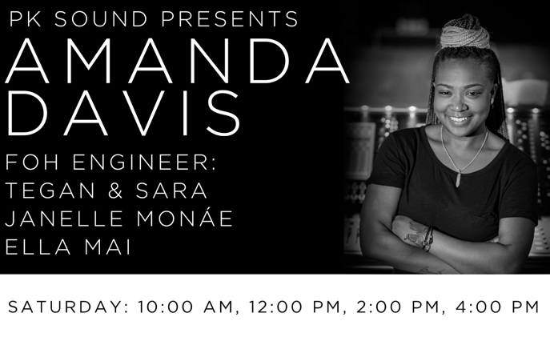
Saturday, January 26 — Amanda Davis (10:00 a.m., 12:00 p.m., 2:00 p.m., 4:00 p.m.)
Amanda Davis is a FOH engineer and monitor mixer, having worked with clients such as Janelle Monae, Tegan and Sara and R. Kelly among others. She has also been a music theory professor and handled audio within houses of worship.

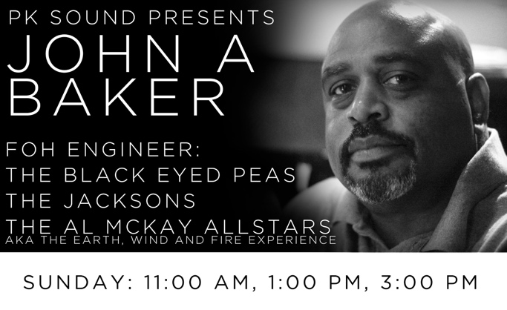
\Sunday, January 17 — John Baker
(11:00 a.m., 1:00 p.m., 3:00 p.m.)
John Baker has been working as a FOH engineer since 1997 alongside clients such as Rita Coolidge, Marilyn McCoo and Billy Davis, Jr. and many others. Presently he tours internationally as FOH engineer for The Legendary Jacksons and Rock & Roll hall of famer Al McKay of Earth Wind and Fire.
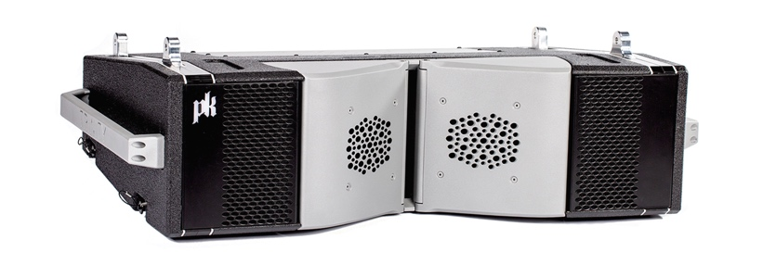
Combining the ultimate in sonic flexibility as well as cost/space efficiency, the Trinity 10 features the identical voicing as the full-size Trinity module. Like the larger version, the Trinity 10 is configured remotely, providing advanced users with a completely new set of tools and unparalleled control over the vertical and horizontal polar directivity of the entire array, while bringing world class sound field control to mid-size class line arrays. In addition, Trinity 10 is powered by a 3000 W Class D amplifier to maximize headroom while maintaining crystal clear audio and providing exceptional output.
Please visit PK Sound at The NAMM Show 2019 at Level 2, ACC North Booth 17515 or at its demo room, located in suite 203 B inside the ACC Brand Showcase Section on Level 2. For more information, please visit PK Sound’s website at: https://www.pksound.ca/

About PK Sound
At PK Sound we are passionate about providing a powerful connection between artist and fan. We believe that every audio experience should be exceptional. Our loudspeakers are well known for their transparent, full bodied, powerful sound; a result of new technologies created by people who love music, focusing on the evolving demands of artists, engineers and fans.

Media contacts
Jeff Touzeau
Public Relations
Hummingbird Media
+1 (914) 602 2913
jeff@hummingbirdmedia.com

