PILAR ZARAGOZÁ
EOS | MEN

Pilar Zaragozá has been interested in hairdressing since childhood. She even remembers that when she was only nine, she changed the look of her communion doll.
She started in the profession with great enthusiasm and from below, doing manicures in a barbershop, and that's how she discovered the job completely and from within. However, her passion for image and the profession led her to want to make it her way of life. Without mentors or acquaintances, but eager to progress, she has been training continuously, not only in hairdressing but also in male aesthetics and business management.
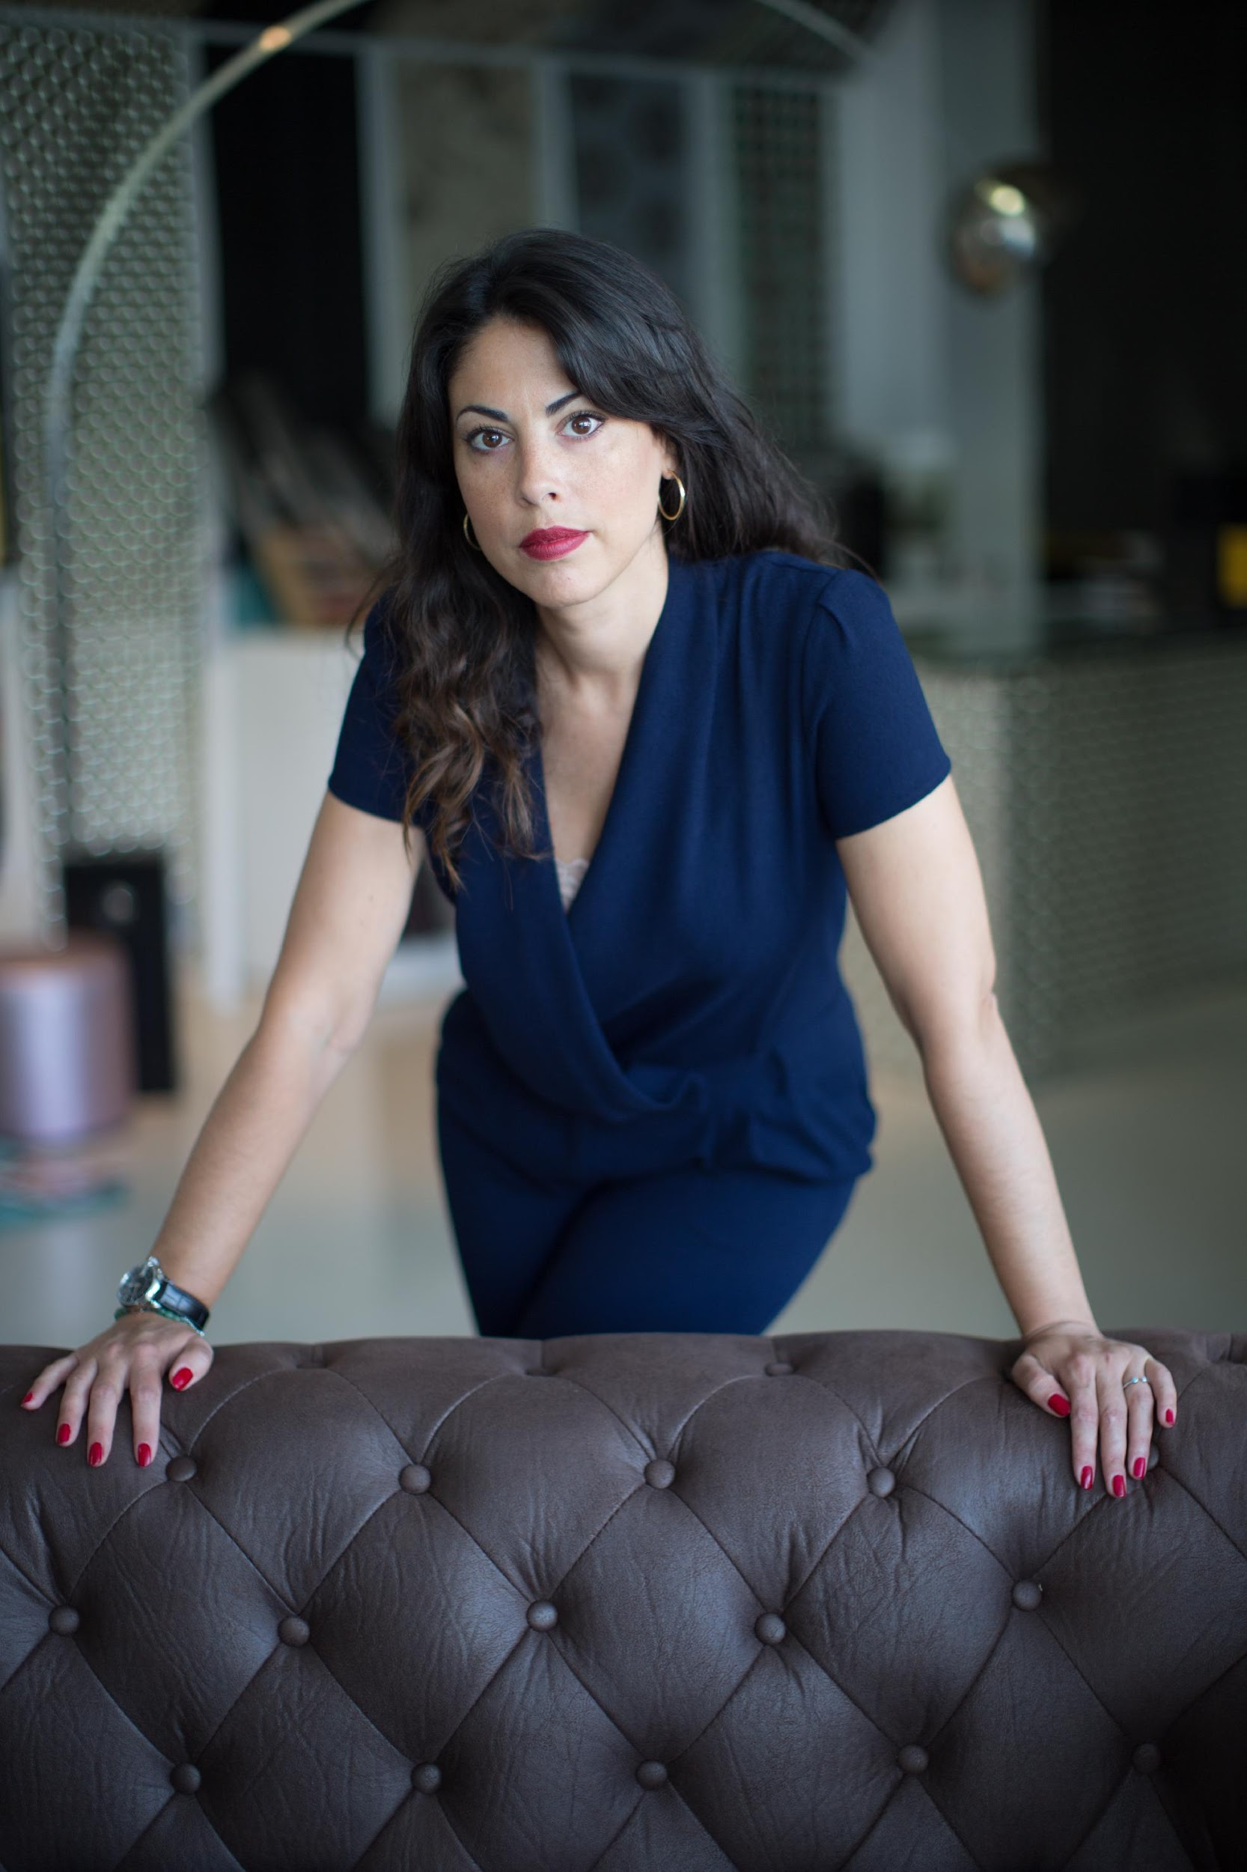
To make this life project a reality, she has spared no effort in offering excellence and a vision as well cared as personal of male image. In 1988 Centro Tres opened its doors in El Corte Inglés in Nuevo Centro, in Valencia, and it all began by offering men a comprehensive hairdressing service that combined tradition and trends, an innovative set that would consolidate and turn the salon into one of the most important in the sector, with a staff of thirteen excellent professionals.
In 2014, Pilar Zaragozá started a new personal and professional stage. She became the new director of the place and one of the few female managers at El Corte Inglés. She maintained the entire team, which gave her full support, and the management team of El Corte Inglés supported her too to carry out her innovative vision of male image.
Based on constant training as a driver of excellence, she created her own method of male haircut, design and brand. This new evolutionary methodology and technique, applied in hairstyling, managed to introduce her and her team to the forefront of male aesthetics.

PILAR ZARAGOZÁ
EOS | MEN

However, her professional evolution and her concerns did not stop there. Three years later, in 2017, she opened her second salon in Valencia with separate hairdressing, barber, and aesthetic spaces in a select and exclusive environment. Besides, she created a space for teaching, research and creation of new haircutting and design techniques to continuously train the entire team. As she herself states: “Our salon has always been clearly focused on masculine beauty and it has never gone out of style, not even after the unification (unisex). The goal remains a dream: to create a great avant-garde brand superimposed on the most deeply rooted tradition”. Currently, the salon on Colón Street has sustained growth of 30% per year and is managing to maintain the premises established since its creation.
In 2020 she goes one step further and reinvents her brand, renaming her project Eos | men because ‘’she wanted to be proud from the moment someone pronounced the name" and so, with this change, she keeps on consolidating her brand as a reference in the sector.
Pilar Zaragozá’s talent has been solicited to collaborate in some local film productions, as well as events at El Corte Ingles and Feria de Valencia. She has also been recognized by the professional press, as she has been published in some of the most prominent media outlets.
Similarly, her involvement with the profession has led her to become part of Barberías con Encanto and the Guild of Hairdressers of Valencia.
Nominations and Awards:
- Finalist International Visionary Awards 2020, men category
- Finalist AIPP Awards 2020/2021, men category
