Powersoft Appoints Tom Knesel to General Manager, North America

Former MUSIC Tribe executive will focus on systems integration market, development of key accounts and accelerating U.S. growth

Florence, Italy
October 1, 2019
Powersoft, the world leader in lightweight and energy efficient amplifier platforms, announced that it has appointed industry veteran Tom Knesel to the position of General Manager, North America. Knesel, who will be located at the company’s U.S. headquarters in Kearny, NJ and who will start on October 7th, will report directly to Luca Giorgi, Sales & Business Development Director, Powersoft. The announcement follows the successful relocation of Powersoft’s North American headquarters two years ago, and coincides with the company’s increased focus on the systems integration market and launch of the Mezzo amplifier platform earlier this year.

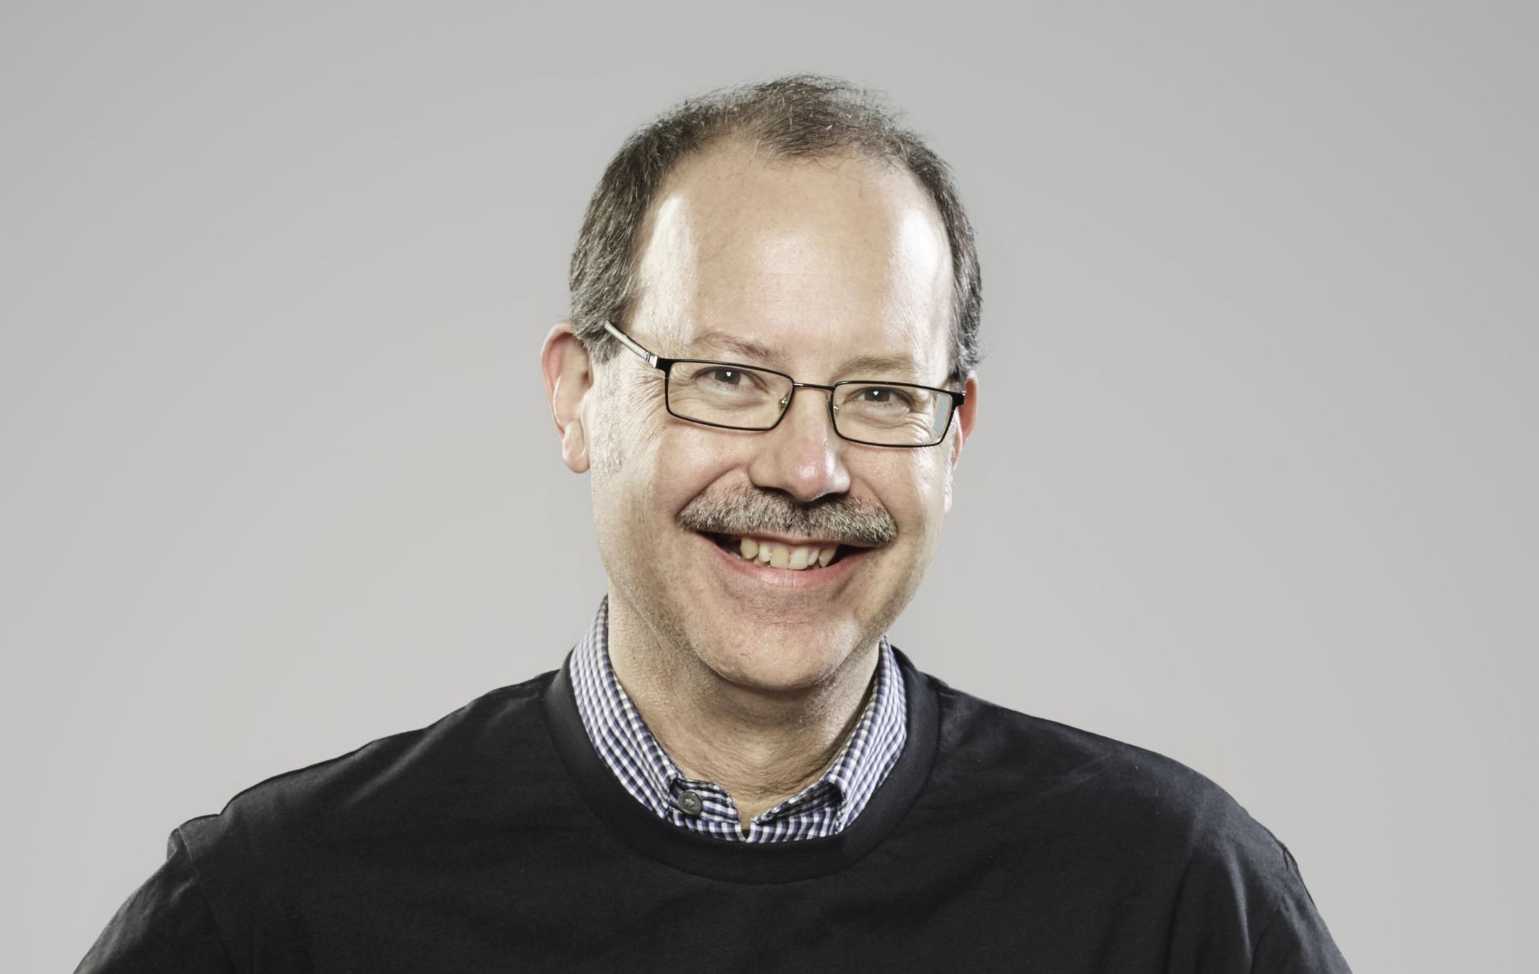
“We are very pleased to welcome Tom into the Powersoft family,” commented Luca Giorgi. “Two years ago we began a significant restructuring of our U.S. operations, which included relocating our headquarters to the east coast, hiring new operational and sales staff, and realigning our entire North American sales rep network. Having successfully completed these tasks, we are perfectly positioned in this region for sustained growth and net new revenue opportunities.”

“Tom brings over two decades of industry experience to his new role as GM, as well as a solid understanding of the overall competitive market context,” Giorgi continued. “Further, he shares the same family values as our organization and is committed to leading our U.S. team towards increased success in the U.S.

Before joining Powersoft, Knesel was Regional Business Development Manager, Americas, for MUSIC Tribe and responsible for driving revenue and managing the Americas for the company’s commercial audio brands — including Midas, Klark Teknik, Lake, Lab Gruppen, TC Electronics, Tannoy and Turbosound. Prior to that, Knesel spent several years in the manufacturer, design and systems integration markets, serving in both sales and executive roles at companies including Ashly Audio, AE Global Media and others. Knesel studied engineering at Southern Polytechnic State University.

“I am truly excited to be joining such an innovative, close-knit team of professionals,” said Knesel. “The most distinguishing factor in Powersoft’s brand is its passion. This factor, combined with the experience of our U.S. team and the market- leading innovations coming from our home office in Italy, will continue to differentiate us in the North American region. I look forward to playing an integral role within our global team and helping to accelerate our success.”

Luca Giorgi, who has served in a dual role for Powersoft as GM, North America and Sales & Business Development Director for the past two years, will relocate to the company’s global headquarters in Florence, Italy at the end of December, and now that the transition is complete, will continue in his role as Sales & Business Director for the global organization.

“This is an exciting time for Powersoft and we welcome Tom to our global executive team,” commented Luca Lastrucci, CEO and co-founder of Powersoft. “Our continued growth in this region, combined with our increased focus on the systems integration market, make this an opportune time for Tom to be leading the North American team.”

For more information on Powersoft, please visit http://www.powersoft.com.

Photo caption: Tom Knesel, General Manager, North America, Powersoft.

For further information

Francesco Fanicchi  POWERSOFT FIRENZE  francesco.fanicchi@powersoft.com  +39 346 9719798 | Jeff Touzeauy  Hummingbird Media  jeff@hummingbirdmedia.com  +1 (914) 602-2913

ABOUT POWERSOFT:
Powersoft is the world leader in lightweight, high power, single rack space, energy efficient amplifiers for the professional audio market. Founded in Italy in 1995, headquartered in Florence, Italy, with offices in Kearny, NJ, Powersoft couples the experience and precision of its production department with exceptional components to deliver products with perfect audio response and high-performance reliability. Its state-of-the-art amplifiers can be found in an array of markets, ranging from stadiums, sporting arenas, theme parks, performance venues and airports to convention centers, churches, and clubs, and are used by the world's leading tour sound companies. For more information, visit the Powersoft website: www.powersoft.com

