For immediate distribution

Sweetwater Studios Presents Workshop Lineup for GearFest 2019
Recording and mixing clinics will dive into recording and mixing techniques and include Sweetwater Studios’
Mark Hornsby, Nick D’Virgilio, Bobby Dellarocco and more…
June 17, 2019, Fort Wayne, IN — Sweetwater Studios, the recording studio arm of Sweetwater Sound, will be hosting a series of recording and mixing workshops in its multi-room, Russ Burger-designed studio facilities during Sweetwater’s annual GearFest celebration from Friday June 21st to Saturday 22nd. The workshops are free to all attendees and will be running in Sweetwater Studios’ tracking and control rooms.
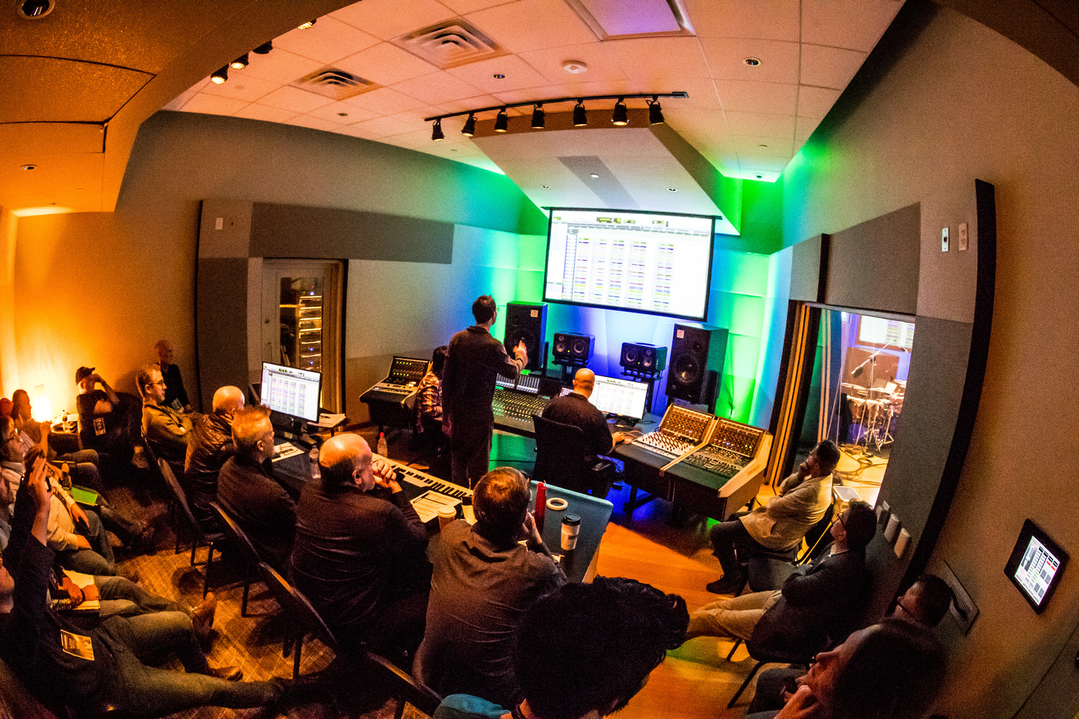
During the workshops, interested participants will have a chance to learn a variety of recording and mixing techniques from the Sweetwater Studios’ in-house production team, featuring Senior Producer/Engineer and VP of Music Production Mark Hornsby, Drummer/Engineer Nick D’Virgilio Guitarist Don Carr, Nashville producer/guitarist Tom Hemby and Engineer Bobby Dellarocco as well as special guest presenters such as renowned producer and mix engineer Sylvia Massey, Tower of Power vocalist and solo artist Marcus Scott, and Avid representatives Jeff Komar and Greg Chin.
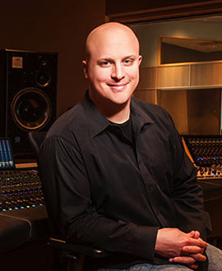
“As much as GearFest is a celebration of musical instruments and equipment, we also want to share our knowledge about how this gear is used in conjunction with some very talented artists, like Marcus Scott and Tom Hemby,” said Hornsby. “We’re thrilled to be able to offer so many studio workshops to attendees this year, and we hope to inspire all our participants.”
Scheduled workshops and start times are listed below:
Friday, June 21st:
- 9:30 a.m. – “Breaking Down the Mix: Examining a Mix from the Raw Tracks to the Finished Product” (Mark Hornsby – Studio A Control Room)
- 11:30 a.m. – “Avid Pro Tools 1 S6+ MTRX Deep Dive” (Jeff Komar – Studio A Control Room)
- 11:30 a.m. – “Recording Electric Guitar” (Mark Hornsby, Tom Hemby – Studio A Tracking Room)
- 1:30 p.m. – “Recording Vocals” (Mark Hornsby, Marcus Scott – Studio A Tracking Room)
- 2:00 p.m. – “Avid Pro Tools Ultimate Deep Dive” (Greg Chin – Studio A Control Room)
- 3:30 p.m. – “The 1 Hour Mix: Getting the Job Done When Working on a Deadline” (Mark Hornsby – Studio A Control Room)
- 3:30 p.m. – “Recording Drums” (Nick D’Virgilio, Bob Dellarocco – Studio A Tracking Room)
Saturday, June 22nd
- 9:30 a.m. – “Breaking Down the Mix: Examining A Mix from the Raw Tracks to the Finished Product” (Nathan Heironimus – Studio A Control Room)
- 11:30 a.m. – “Avid Pro Tools I S6 + MTRX Deep Dive” (Jeff Komar – Studio A Control Room)
- 11:30 a.m. – “Recording Acoustic and Electric Guitar” (Don Carr, Dan Ankney – Studio A Tracking Room)
- 1:30 p.m. – “Recording Vocals” (Mark Hornsby, Kat Bowser – Studio A Tracking Room)
- 2:00 p.m. – “Avid Pro Tools Ultimate Deep Dive” (Greg Chin – Studio A Control Room)
- 3:30 p.m. – “Recording Drums” (Nick D’Virgilio, Mark Hornsby – Studio A Tracking Room)
- 3:30 p.m. – “Ask Sylvia Studio Workshop” (Sylvia Massy – Studio A Control Room)

For more information about Gearfest or to RSVP, please visit: https://www.sweetwater.com/gearfest/

About Sweetwater Studios
Sweetwater Studios is a wholly owned subsidiary of Sweetwater Sound, Inc., the largest online music instrument retailer in the country. With three world-class studios designed by Russ Berger and access to a greater diversity of musical equipment and professional audio gear than any other recording studio in the world, Sweetwater Studios is able to accommodate just about any recording, mixing or mastering project, no matter how simple or complex. With renowned staff producer Mark Hornsby at the helm, who has worked on many Grammy-award winning albums, Sweetwater Studios also has an exceptional staff of producers, engineers, session musicians and studio technicians. For more information on Sweetwater Studios, please visit http://www.sweetwaterstudios.com.

Media Contacts:
Jeff Touzeau
Public Relations
Hummingbird Media, Inc.
+1 (914) 602-2913
jeff@hummingbirdmedia.com

Steve Bailey
Public Relations
Hummingbird Media, Inc.
+1 (508) 596-9321
steve@hummingbirdmedia.com

