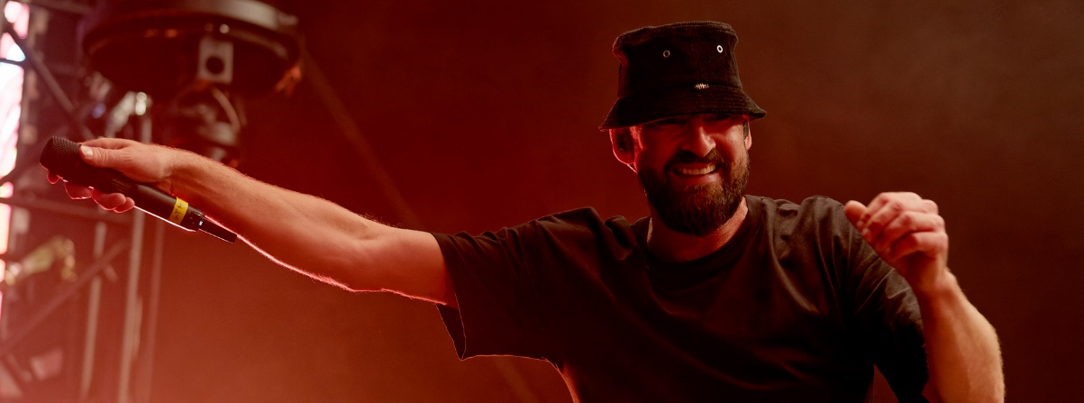

Caribbean Feel at Berlin’s Beach Chair Open Air
Reggae Vibes with Gentleman and Sennheiser Wireless Systems

Wedemark, 22 September 2021 – On 9 September 2021, Gentleman was the star guest at the Strandkorb Open Air series of concerts at Berlin’s Hoppegarten venue. The reggae artist from Cologne and his band delighted around 2,000 fans who watched from the comfort of a thousand two-seat beach chairs at the historic racecourse.

SKM 6000 with MM 435 for Gentleman
Wired and wireless microphones and IEM solutions from the Sennheiser portfolio are ubiquitous at concerts by Gentleman and his band. And by forming the first links in the audio signal chain, they play a key role in ensuring superb live sound quality.

Gentleman uses a Sennheiser SKM 6000 handheld transmitter with an MM 435 microphone head

For his performances, lead vocalist Gentleman, aka Tilmann Otto, uses a Sennheiser SKM 6000 handheld transmitter fitted with an MM 435 microphone head. The dynamic high-end capsule (cardioid) is seen as the legitimate successor to the renowned Sennheiser MD 9235 head, which has proven itself in countless live and broadcast productions throughout the world. Its standardised capsule interface ensures that the MM 435 microphone head is compatible with most Sennheiser wireless systems.

In the MM 435, a lightweight and therefore rapidly responding aluminium-copper voice coil in combination with a large-diameter diaphragm ensures highly detailed sound with a nuanced resolution of high frequencies. At the same time, the capsule is resistant to feedback, and its spring-mounted design provides an effective shield against structure-borne noise. A hum compensation coil suppresses electromagnetic interference, which means that there are no problems caused by LED panels or motors operated on stage. A sturdy metal basket protects the capsule against mechanical damage even when subjected to the toughest handling during tours.

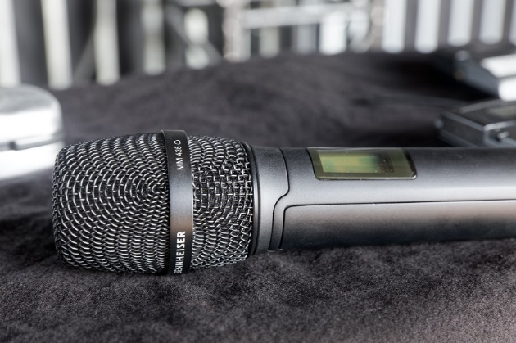 | Sennheiser MM 435 microphone head with a dynamic high-end capsule (cardioid)

The cardioid capsule has a pleasant sounding proximity effect and a frequency response of 40 – 20,000 Hz. The dynamic range is an impressive 146 dB(A), while self-noise (equivalent noise level A acc. to DIN IEC 651) is extremely low at just 17 dB. The MM 435 microphone head can handle maximum sound pressure levels of up to 163 dB, enabling it to be used even on very loud stages. As a wired version, the capsule of the MM 435 does its job in the Sennheiser MD 435 vocal microphone.

Digital wireless systems
At the Gentleman concert at Berlin’s Hoppegarten, a 19” rack was located directly next to the monitoring console set up at the side of the stage. The rack contained two Sennheiser EM 6000 receivers, an L 6000 charging station and three LM 6060 modules, as well as a drawer with five SKM 6000 handheld transmitters and various capsules.

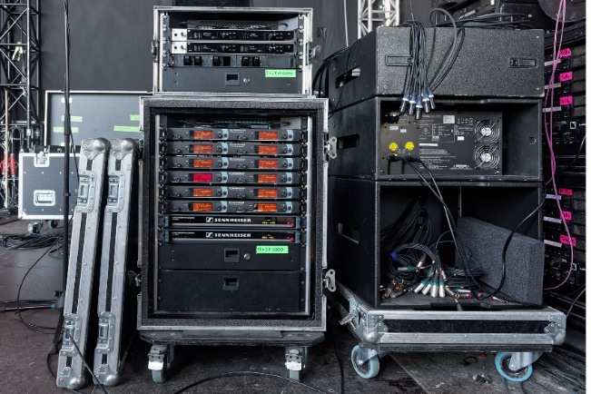 | Sennheiser wireless technology at the monitoring console

“We’ve been using the digital Sennheiser systems since the beginning of the 2021 summer season,” said Nepomuk “Muk” Tuschy, who has spent many years working as the monitor mixer for Gentleman. “It makes absolute sense for a touring band to take their own backline and all the mics along with them. And we intend to buy more Sennheiser microphones in the future so that we can completely mike the drum kit using suitable models from this manufacturer. At the moment, we are already using a Sennheiser e 901 boundary microphone for the bass drum and two e 604 microphones from the local equipment rental company for the toms.”

At the drum kit, a Sennheiser e 901 boundary microphone is used in the bass drum, while the toms have two e 604 microphones | 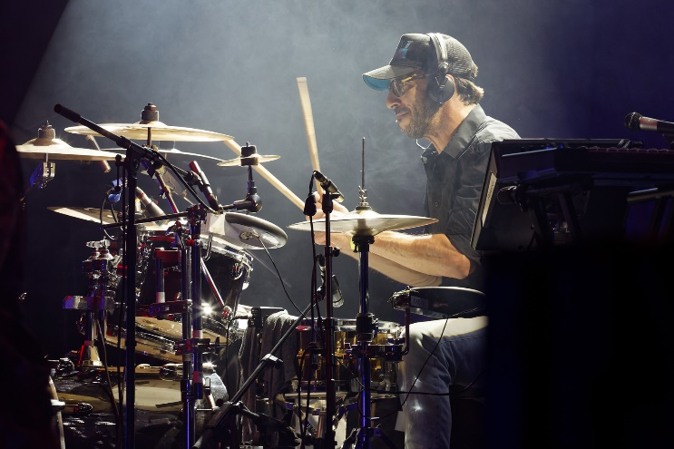

Spoilt for choice
At the Beach Chair Open Air concert at the Hoppegarten, SKM 6000 handheld transmitters were used by Gentleman, background vocalist Patricia “Treesha” Moore and guest rapper Ezhel. Another SKM 6000 was placed within easy reach at the entrance to the stage for use as a spare. The handheld transmitters were operated with different capsules. MM 435 microphone heads were provided for Gentleman and Ezhel, while Treesha’s handheld transmitter was fitted with an MMD 945.

Guest rapper Ezhel with his SKM 6000 handheld transmitter

“We have access to a wide selection of capsules and we’re really spoilt for choice. At the moment, we’re trying out which microphone heads fit best to which voice,” explained Muk. “For the backing vocals, we started with the MMD 935, which are known to be the classic microphone for this job. But in the meantime, we’ve changed over to the MMD 945 with a super-cardioid pick-up pattern, because we used to find that the loud drum cymbals were finding their way into the microphone capsules. According to our very personal taste, the MM 435 didn’t fit quite so well to Treesha’s voice. For Tilmann, on the other hand, this capsule makes sense because it offers very fine resolution of the high frequencies in particular, but has no tendency at all to generate feedback. Tilmann likes to have numerous wedges at the front edge of the stage, even though he also has in-ear monitoring, so I can turn these up extremely loud without the risk of causing feedback or having a negative effect on the microphone sound – that’s really awesome!”

Background vocalist Patricia “Treesha” Moore using an SKM 6000 handheld transmitter with an MMD 945 microphone head

FOH mixer Philipp Sachsenheimer, who has accompanied Gentleman for more than 20 years, added: “For the background vocals, the MM 435 even sounded a little too differentiated for our taste. The capsule makes the backing vocals sound very precise and gives them a lot of presence. But backing vocals generally need to be a little more subdued and, as their name suggests, they should form the background for the lead vocals. You could say that the MM 435 is just too good for this job…” (grins)

Easy setup
Muk didn’t have the opportunity to gain any hands-on experience with the Sennheiser Digital 6000 systems before their premiere at the Gentleman concerts: “I came to a show in Wiesbaden in July 2021 and it was there that I first took the handheld transmitters and their capsules out of their original packaging,” the monitor mixer said. “To be honest, I was a bit nervous, but the initial setup of the systems worked surprisingly well once I had learned how to operate the three buttons on the handheld transmitter.”

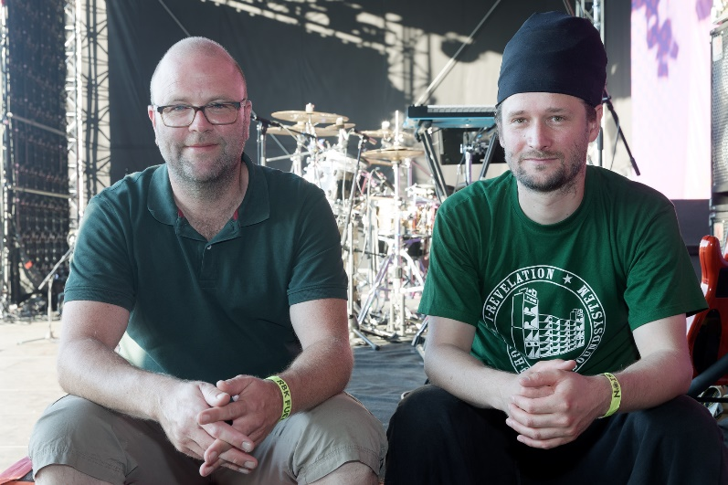 | An experienced sound team: FOH mixer Philipp Sachsenheimer (left) and monitor mixer Muk

In the meantime, setting up the systems before each show has become routine: "As there are not that many events taking place at the moment due to the pandemic, I get the impression that there is generally less wireless interference at the venues", said Muk. “As a rule, when setting up the system, my first step is to use the Easy Setup Sync function on our Sennheiser SR 2050 IEM stereo transmitter. Then I add the frequencies for the Digital 6000 channels. I only occasionally use the Sennheiser WSM software for setting the frequencies, but I always have it running during concerts so that I can keep an eye on the RF and AF levels and the battery status. That’s really convenient. The Scan & Auto Setup feature on the Digital 6000 systems is really easy to use and delivers perfect results! At first, the big red glowing triangle on the EM 6000 took some getting used to visually – but it means that you can see at a glance if there is no link between the transmitter and receiver.”

Robust and reliable
Gentleman’s audio crew are impressed by the robustness of the SKM 6000 handheld transmitter, even though a certain amount of wear and tear is unavoidable over time: “Tilmann wears a ring and there are parts of the show where he interacts with the audience and claps his hands while still holding the microphone,” said Muk. “Things like that will obviously leave their mark on every microphone in the long run…”

Gentleman generally has good microphone discipline and always takes care not to point the capsule towards the wedges when interacting with the fans. The German reggae singer largely avoids enclosing the microphone head with his hands, which is a typical feature of rap artists but one that doesn’t help to provide good sound.

Showtime at the Hoppegarten | 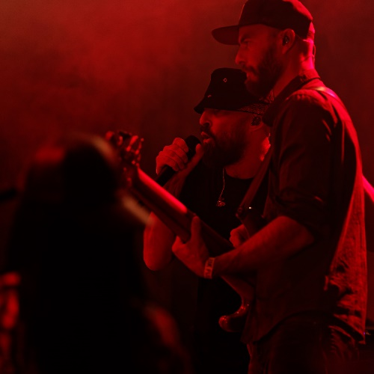

“I’ve never noticed any noise from the Sennheiser Digital 6000 systems,” explained Muk. “Perhaps a very low noise might be perceivable under laboratory conditions, but all other parts of the audio signal chain definitely cause more noise than our new digital wireless channels. Noise is absolutely not an issue with the Digital 6000 systems!”

FOH mixer Philipp Sachsenheimer: “As far as its transmission reliability is concerned, there have been no problems at all with the 6000 wireless systems so far, and the latency that is unavoidable with digital wireless systems is completely unnoticeable. We use two active Sennheiser AD 3700 broadband directional antennas that reliably cover Tilmann’s area of action, even when he spends time moving among the audience and sometimes even goes to the FOH area far away from the stage.”

Battery pack handling
Muk is highly impressed by the battery packs of the Sennheiser Digital 6000 systems: “The BA 60 rechargeable lithium-ion battery packs are fantastic! They last for about five and a half hours and I always leave the transmitter switched on for the whole time when I’ve finished setting up. Just before the show starts, I put in fresh battery packs and then I don’t have to worry about them for the rest of the concert. Not only that: the BA 60 have incredibly short recharging times, and you can rely one hundred percent on the hours/minutes display for the remaining battery life. Battery changes also work perfectly, and I’m pleased to say that the battery compartment doesn’t require a fiddly AA adapter. For me, the SKM 6000 handheld transmitters have the best battery handling of all the wireless systems I’ve ever tried.”

Wireless in-ear monitoring
Proven analogue wireless technology continues to be the solution of choice for wireless in-ear monitoring. Gentleman and his musicians rely on latency-free wireless systems from the Sennheiser 2000 series at their concerts. At Berlin’s Hoppegarten, six SR 2050 IEM stereo transmitters were installed in a rack next to the monitoring console and were operated with two eight-channel AC 3200-II antenna combiners. These were connected to two A 5000-CP circularly polarised antennas. At Gentleman concerts, up to twelve wireless in-ear channels are operated in parallel. And when on tour, the production team takes 14 Sennheiser EK 2000 IEM beltpack receivers (including spare beltpacks) with them.

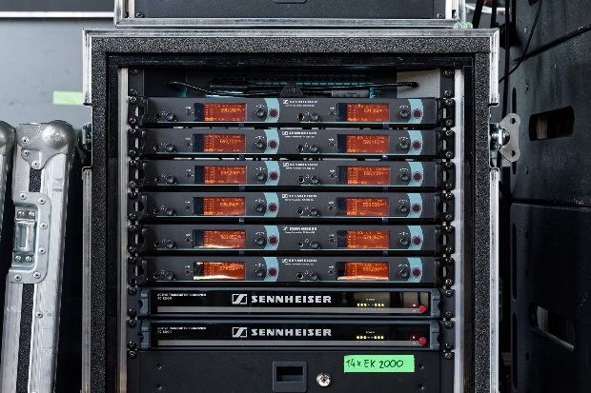 | At their concerts, Gentleman and his musicians rely on latency-free monitor systems from the Sennheiser 2000 series

Late summer evening at the Hoppegarten
The beach chair event concept had its premiere last year and made it possible for fans to attend concerts safely once again in the summer of 2021, due to its exemplary compliance with all the pandemic-related social distancing and hygiene regulations. Following their successful debut in 2020, Beach Chair Open Air events were held in 15 German cities this year.

The open-air events have their very own flair, and for the audience it’s like having a short holiday watching the concert from the comfort of their beach chairs. A relaxed atmosphere, great music, cold drinks from the cool box next to the chair – a real holiday feeling. And to guarantee social distancing in these difficult times, the audience is divided up into manageable sections named after Germany’s popular North Sea and Baltic Sea islands and separated by red and white plastic chains. This ensures that the fans can just relax and enjoy the music – especially in such idyllic settings as the “Hoppegarten cultural heritage monument” site just across the border to Brandenburg to the east of the German capital.

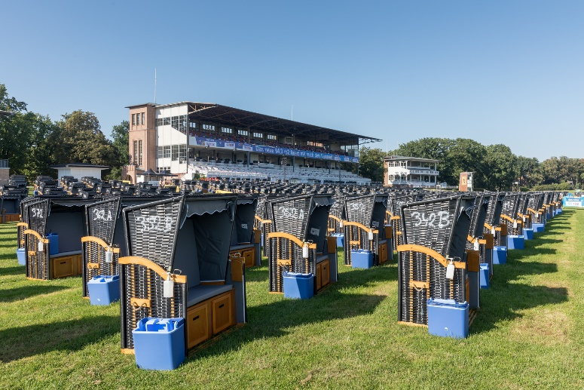 | Around a thousand beach chairs were set up to accommodate the Gentleman fans at the Hoppegarten nature reserve

“I think it’s really great that Gentleman’s sound engineers are always thinking about how they can further improve the sound quality for their artists even while they are on tour with them, for example by experimenting with different microphones heads, and Sennheiser’s wide product range offers heads for absolutely every type of voice and stage environment,” said Thomas Holz, Sennheiser Relations Manager, after the Berlin show. “The performance by Gentleman and his band at the Hoppegarten really whets our appetite for the upcoming ‘Blaue Stunde’ tour, which will see concerts in Germany, Austria and Switzerland from November 2021, provided that the pandemic situation allows them to go ahead. Of course, we all sincerely hope so after such a long time with very limited opportunities for cultural events!”

(Ends)

The images accompanying this press release and additional photos can be downloaded here. Please get in contact if you require higher resolution pictures.

About Sennheiser
Shaping the future of audio and creating unique sound experiences for customers – this aim unites Sennheiser employees and partners worldwide. The independent family company, which is managed in the third generation by Dr. Andreas Sennheiser and Daniel Sennheiser, is today one of the world’s leading manufacturers of headphones, loudspeakers, microphones and wireless transmission systems. In 2020, the Sennheiser Group generated turnover totaling €573.5 million. www.sennheiser.com

Local Press Contact Global Press Contact

Maik Robbe Stephanie Schmidt
maik.robbe@sennheiser.com stephanie.schmidt@sennheiser.com
+49 (5130) 600 - 1028 +49 (5130) 600 – 1275

