# **Silent Power Launches OMNI LAN: Designed for Purists, by Perfectionists**

**Southport, UK, April 15, 2025** – SilentPower, a subsidiary of iFi audio, a trailblazer in audio innovations and high-performance sound components, is proud to announce the OMNI LAN, an optically isolated network switch designed for discerning purists who demand the purest AV experience.

Even the finest AV setups can be quietly compromised by one overlooked component: the standard network switch. Designed for data, not detail, these switches introduce noise, jitter, and interference that limit the performance of the entire system. Without addressing this hidden bottleneck, your setup may never reach its true potential.

The OMNI LAN changes that. With triple-stage isolation, femto-precision clocking, and real-time performance monitoring, it strips away interference and restores timing precision at the source – unleashing a level of clarity and cohesion your system was built to deliver.

More than just an upgrade, the OMNI LAN is a safeguard for your entire system – a purpose-built foundation that ensures your network performs at its peak. With full remote control via the iFi Nexis app, it can be monitored, updated, and trusted to perform from anywhere in your home. Install it once, and forget it – while your system sounds and looks better than ever.

**Key Features**

• **Internal Optical Fibre:** Eliminates electrical noise by converting to an optical (light) signal, surpassing traditional galvanic isolation

• **Triple-Stage Isolation:** Delivers superior noise filtering for pristine AV clarity

• **Real-Time Data Analytics**: Built-in dynamic dashboard shows both incoming and outgoing port data speeds, also viewable from your phone

• **Versatile Integration**: 13 ports – 9 standard (1-stage isolation) for routers, servers, and more; 4 Ultra-Pure (3-stage isolation) for streamers, receivers, and DACs

• **10MHz Clock Sync:** Minimises system jitter with internal femto-precision clocking, with optional sync in/out

**Standard Switches: Designed for Data, Not Detail**

Standard network switches are designed to deliver acceptable data transfer speeds and low production costs, rather than audio or video quality. While this may be sufficient for general use, their limitations can quietly hold back the full potential of AV systems. With no provision made for targeting and blocking the interference introduced throughout the system, noisy components are instead linked together, and the issue is compounded.

When this noise is transmitted though the network cable alongside binary signal data, the performance of the AV devices is degraded. The clock timing required to ensure accurate data conversion will be affected, which in turn will result in jitter. Without clean, noise-free signal delivery, high-end AV setups may be performing at just a fraction of their true capability, leaving detail, clarity, and timing accuracy off the table.

**OMNI LAN: Where Precision Takes Priority**

The OMNI LAN eradicates this issue entirely.

At the core of its design lies optical isolation, converting incoming data to light and back again, to create complete electrical separation between input and output. This eliminates electrical noise, interference, and stray currents from reaching a user’s most sensitive components, thereby improving timing at the conversion stage – resulting in greater precision, enhanced system efficiency, and a more immersive, true-to-source AV experience.

Optical isolation is the most effective technique for removing electrical noise across the whole frequency spectrum. Galvanic isolation (based on transformers), while effective for some purposes, can potentially still allow high-frequency noise through due to parasitic capacitance – The OMNI LAN converting the electrical signal to a light signal eliminates this completely.

Traditionally, achieving optical galvanic isolation required a complex setup involving multiple media converters, power supplies, and extensive cabling. The OMNI LAN is designed from the ground-up as an elegant, purpose-built, plug-and-play solution to adding galvanic isolation to your system.

Users have 13 ports available: 4 ‘Ultra-Pure’ ports benefitting from 3 stages of isolation, including the internal optical isolation path purposefully designed for their most critical AV components, while the 9 ‘Standard’ ports include one stage of galvanic isolation designed for less critical devices such as routers, set top boxes, NAS drives, and consoles.

**More Strategies for Noise-Free Networking**

The OMNI employs multiple strategies to ensure a jitter and noise-free experience. After optically isolating the signal, it is then regenerated entirely using active circuitry to reconstruct the binary data stream and ensure pure, accurate signal transmission. This operates in tandem with the internal clock and our own advanced GMT (Global Master Timing) system – a proprietary, out-of-the-box digital solution that eliminates jitter at its root, using femtosecond-level precision for ultra-stable clock timing.

With the OMNI LAN’s dedicated clock input/output, it can be utilised as a master clock in your high-end system to leverage the quality of our clocking technology. For maximum compatibility, the OMNI LAN can also receive an external clock input, for those who have invested in an external dedicated master clock for their system.

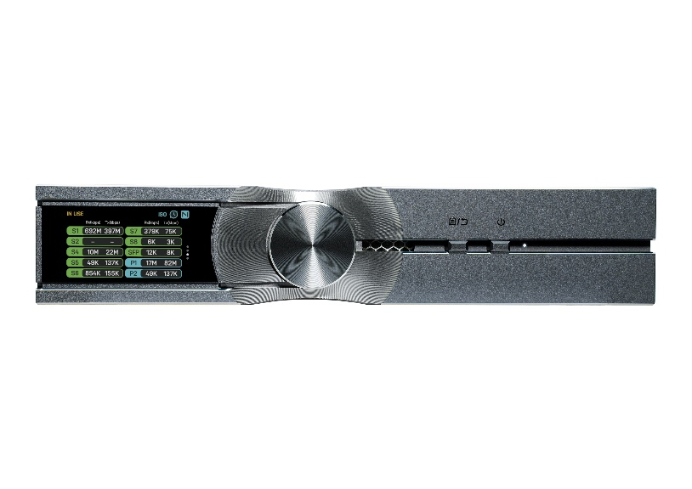

**Dynamic Data Dashboard**

A retina-grade, full-color TFT display keeps you informed with real-time bandwidth data for each port. Switch views, monitor live traffic, and adjust settings directly.

The OMNI LAN’s intuitive user interface offers more than just monitoring and update options. Clock sync input and output options can be controlled quickly and easily from the display and multi-function dial, while advanced grounding mode selection is also available, tailored to optimize noise across various setup environments:

**DC-RF**: Connects both DC ground and RF ground together

**RF**: Grounds RF only, with no DC ground

**ISO:** No DC or RF connection to ground

All dashboard settings are also accessible via the iFi Nexis app. Connecting through your smartphone lets you monitor traffic, manage grounding, adjust clock sync, and more – offering full control from the comfort of your listening chair, boardroom, or home cinema.

Firmware updates can also be completed seamlessly through the app, keeping your OMNI LAN current and fully optimized— without ever being removed from your system.

**Rack Mounting for Professional Systems**

For rack-mounted home theatre setups and professional server and networking environments, the OMNI Rack Mount Kit offers a streamlined compatibility option.

Made from cold-rolled steel and optimized for ventilation, the kit supports single and dual device configurations, front or rear mounting, and creates a powerful 24-port switch when doubling up.

### **Pricing & Availability**

The **SilentPower OMNI LAN** is available to purchase at silentpower.tech for $799 USD.

**US Media Contacts:  
  
Shelby Coppola**[shelby@hummingbirdmedia.com](mailto:shelby@hummingbirdmedia.com)

SilentPower is the sister-brand of iFi audio and is headquartered in Southport, UK. The two brands respectively design and manufacture innovative AV system solutions and portable, desktop and lifestyle audio products. Combined in-house hardware and software development teams and a ‘music first’ approach enable SilentPower and iFi to create advanced products that deliver new levels of design, functionality and performance at their respective price points. Since iFi’s formation in 2012, its products have earned many awards around the world, helping it to become one of the fastest-growing brands in its field.

**General Specification**

|  |  |
| --- | --- |
| **OMNI LAN** | |
| Standard Ports | 8x RJ45; 1x Optical SFP; 1x BNC Clock In |
| Ultra-Pure Ports | 2x RJ45; 1x Optical SC; 1x M12 |
| Bandwidth | 1000Mbps |
| Dimensions | 214 x 157 x 41mm |
| Net Weight | 1.06kg |