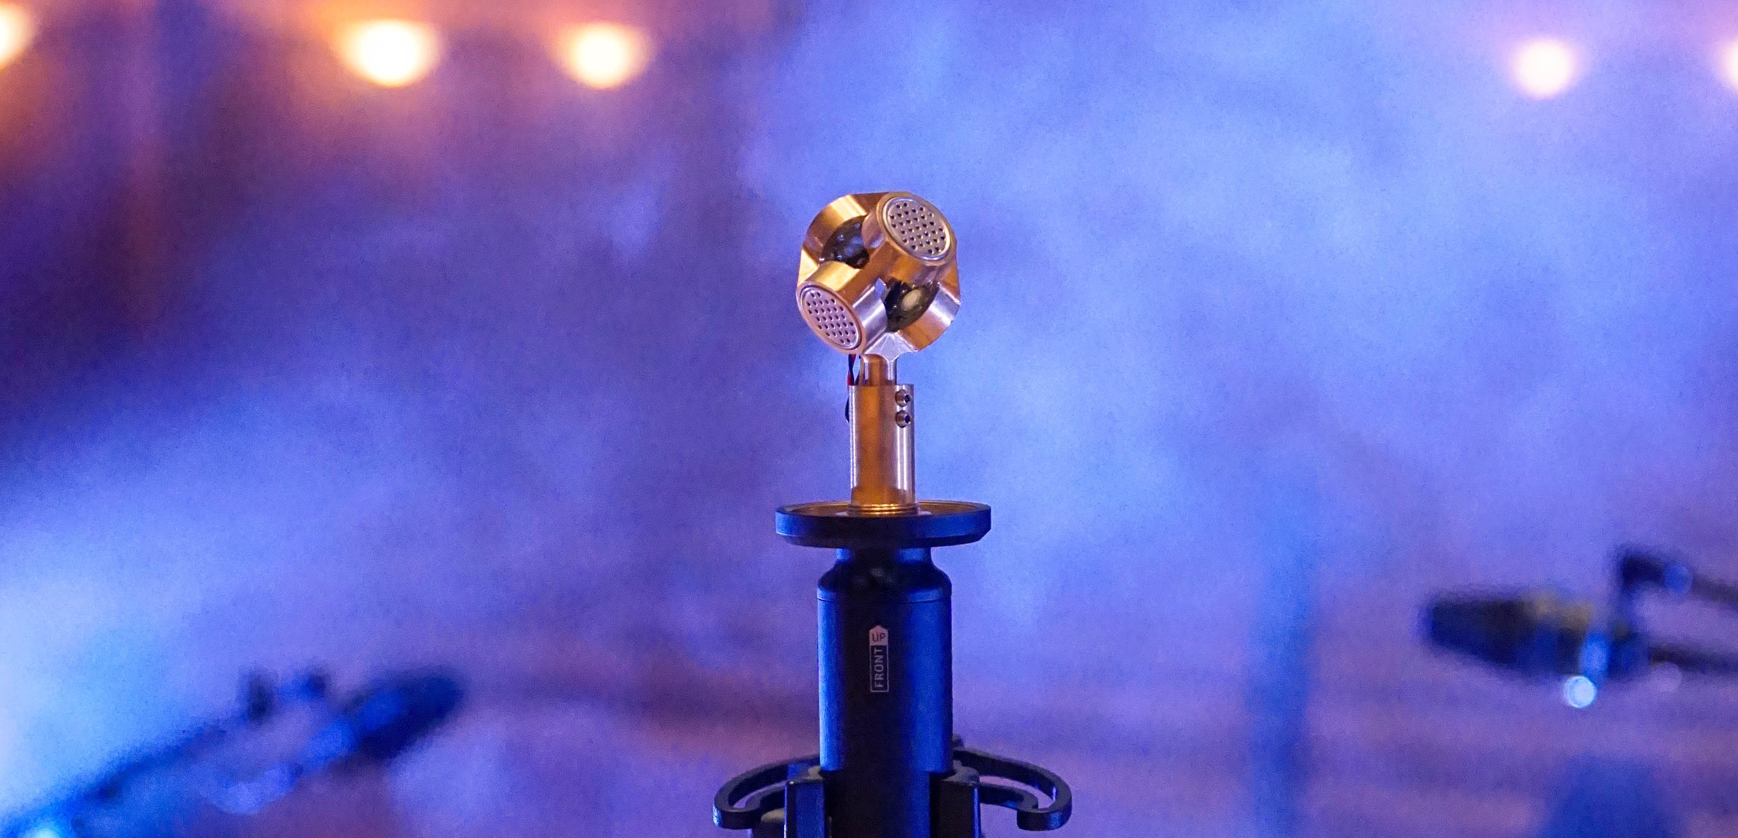

#DontStopTheEducation

Immersive Audio Round Table

Wedemark, May 14, 2020 – On May 19 the Sennheiser SoundAcademy will be discussing one of the hot topics of the day – immersive audio: Sennheiser hosts David Missall and Brian Walker have invited Leslie Ann Jones, Michael Romanowski, Steve Genewick, Jim Anderson and Ulrike Anderson to speak about this exciting area. The five industry experts will discuss their approach to recording, mixing and mastering the immersive sound experience, and share their views on how immersive audio can help open up new creative possibilities and connect listeners more intimately with music. Please note the new changed timing for this webinar: It will take place at 19:30 CEST (13:30 EST). Registrations are now open at https://zoom.us/webinar/register/WN_kiCShCe4SX2EjaClcVz-Sg.

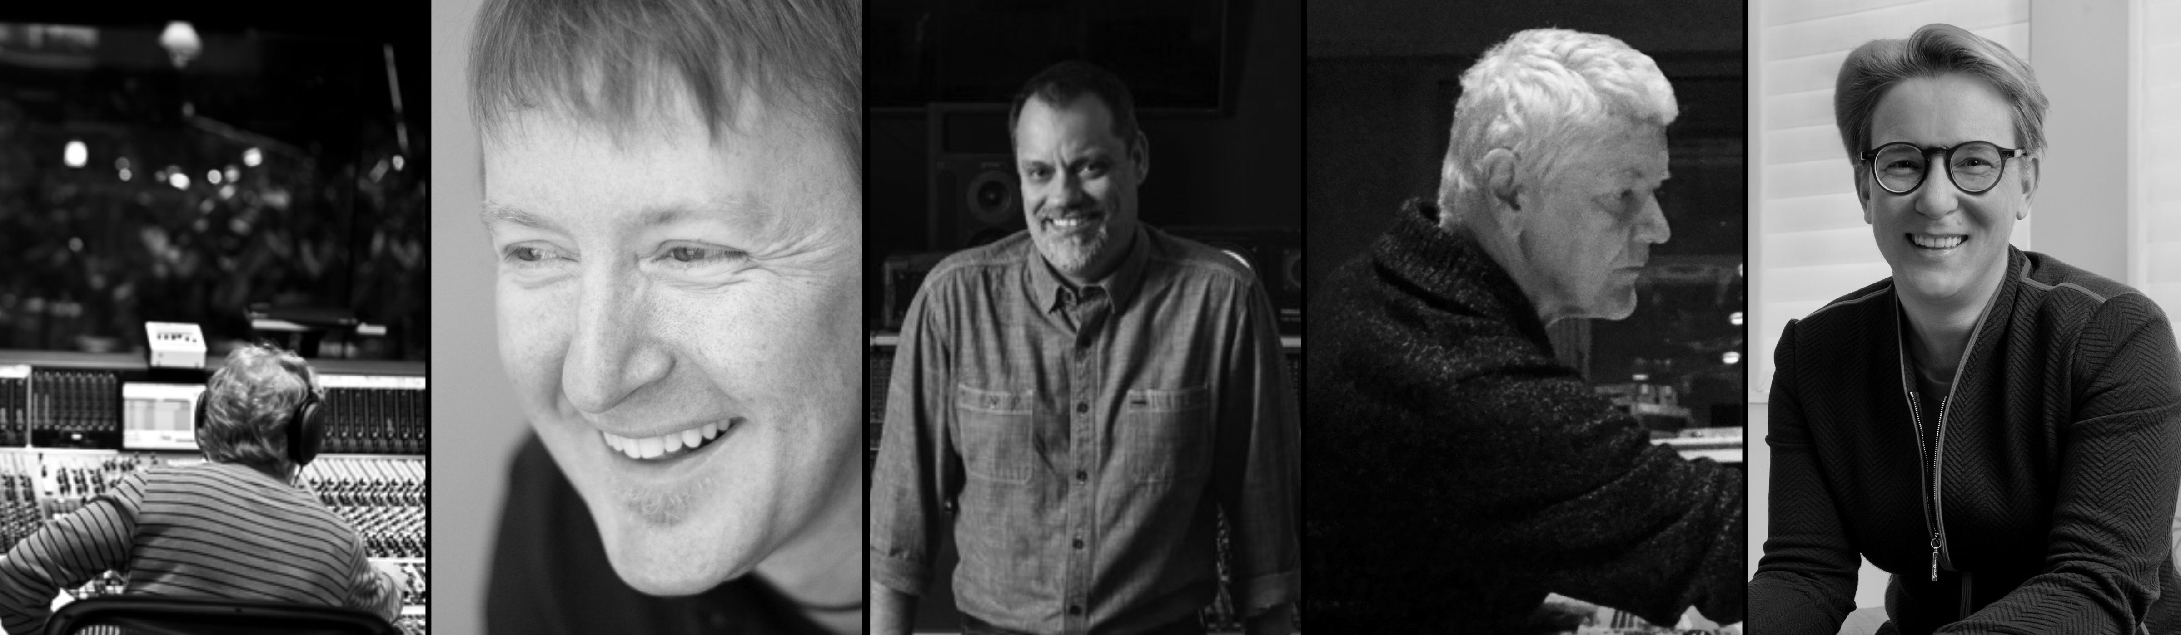
The panellists of the Immersive Audio Round Table: Leslie Ann Jones, Michael Romanowski, Steve Genewick, Jim Anderson and Ulrike Anderson (from left to right)

More about the panellists
Leslie Ann Jones, Lucasfilm
Leslie Ann is a multiple Grammy Award-winning recording engineer working as Director of Music Recording and Scoring at Skywalker Sound, a Lucasfilm, Ltd. company.

Michael Romanowski, Coast Mastering
Michael is a Grammy nominated mastering engineer based in the San Francisco Bay Area. He is owner and chief mastering engineer at Coast Mastering.

Steve Genewick, Capitol Studios
Three-time Grammy nominated recording engineer working as a staff engineer at Capitol Studios since 1994.

Jim Anderson
Jim is an internationally recognized recording engineer and producer of acoustic music for the recording, radio, television, and film industries. His music recordings have received eleven Grammy and Latin Grammy awards and 27 Grammy and Latin Grammy nominations.

Ulrike Anderson
Ulrike is a sound engineer and producer of acoustic music in the radio, television and recording industries. Her recordings have received multiple international nominations and awards: two Echo Klassik Awards, Preis der Deutschen Schallplattenindustrie, Ars Acoustica, Diapason d’Or, a Grammy Nomination and many others.

Expand your expertise with more webinars – totally free
In addition to round tables, Sennheiser’s SoundAcademy provides a host of other popular pro audio training webinars and in-depth product discussions. Please visit https://www.sennheiser.com/webinars for a full, up-to-date list and to register free of charge for a SoundAcademy webinar of your choice. The free training sessions are offered at several different times to allow as many people from around the globe to tune in as possible.

For your social media channels

Join leading immersive audio experts at Sennheiser’s round-table discussion on May 19, 19:30 CEST (13:30 EST). #Don’tStopTheEducation

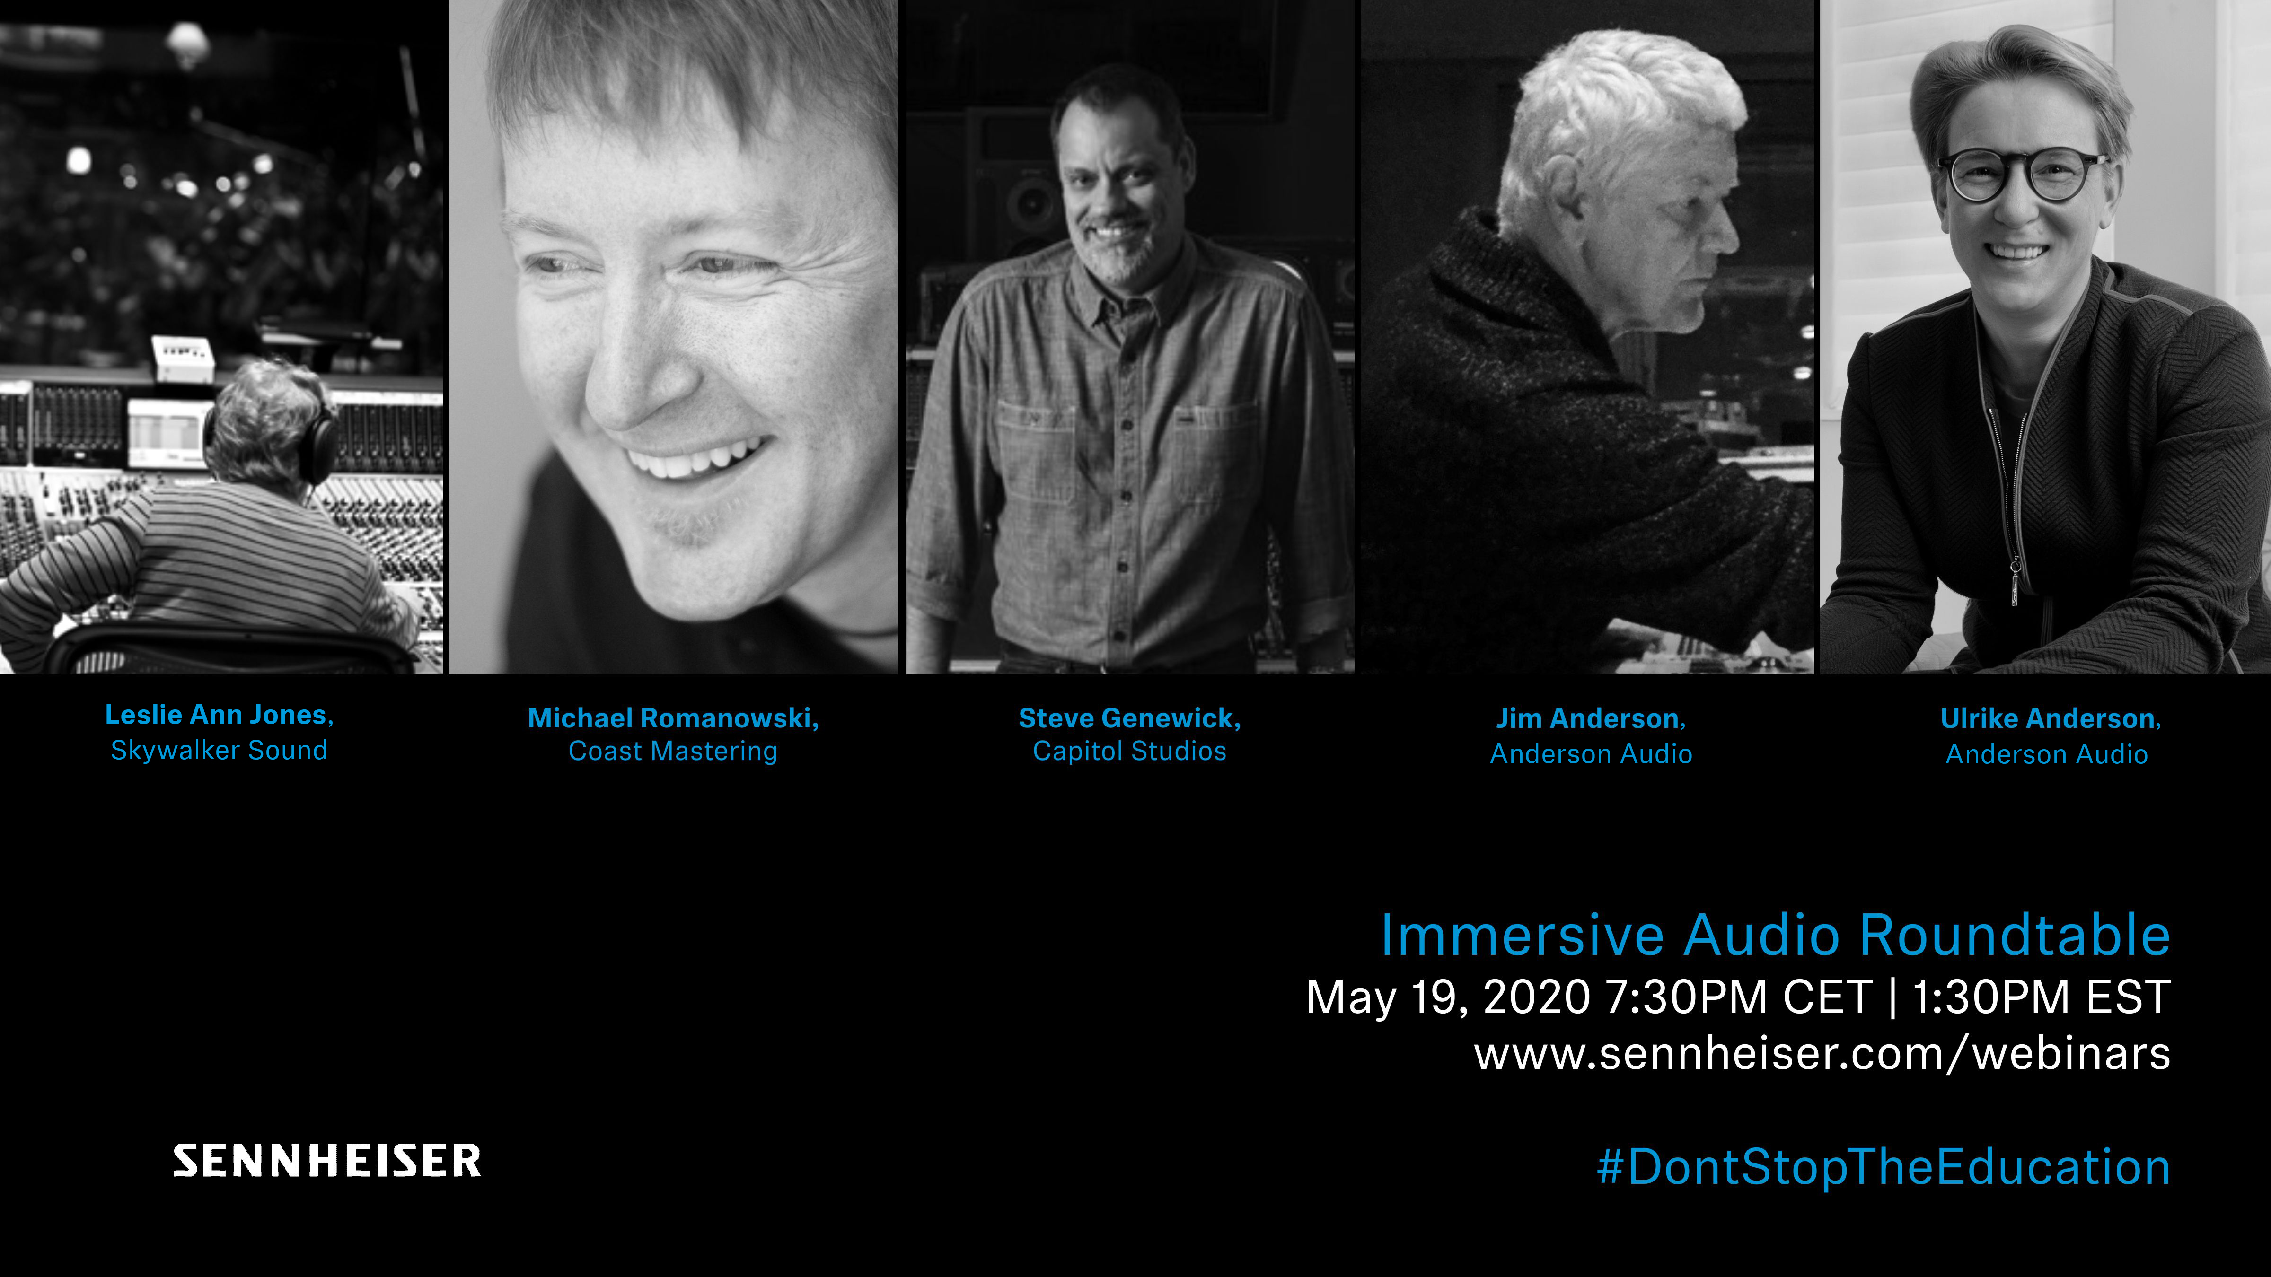 | Immersive Audio Round Table: Meet five leading industry experts and learn about their approach to recording, mixing and mastering immersive sound
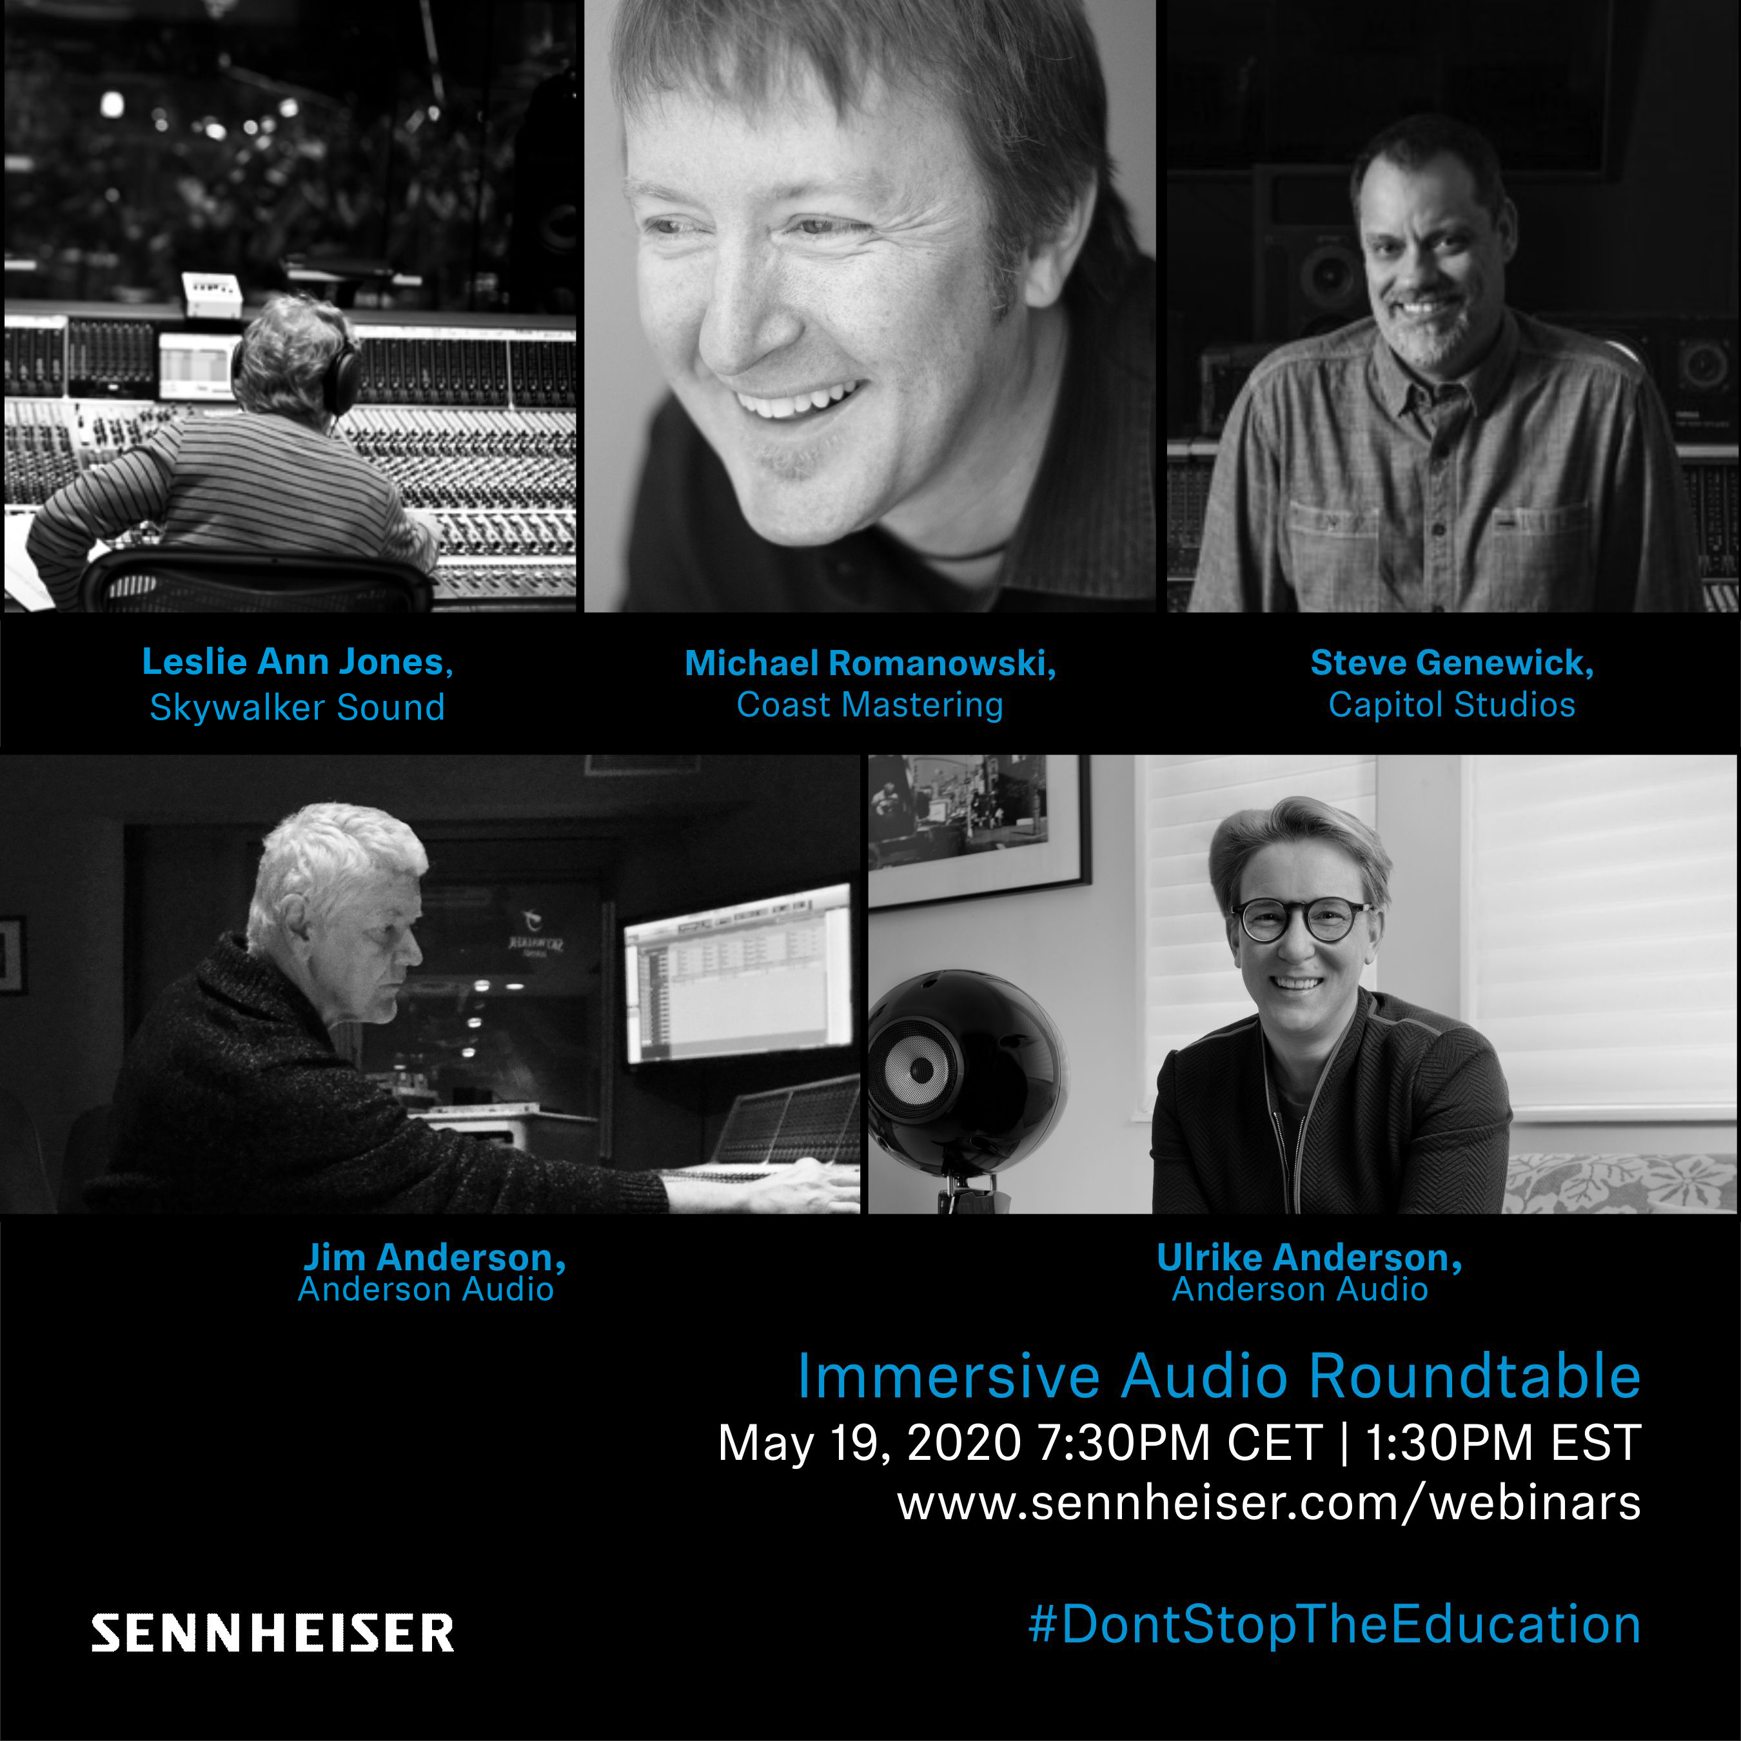 | 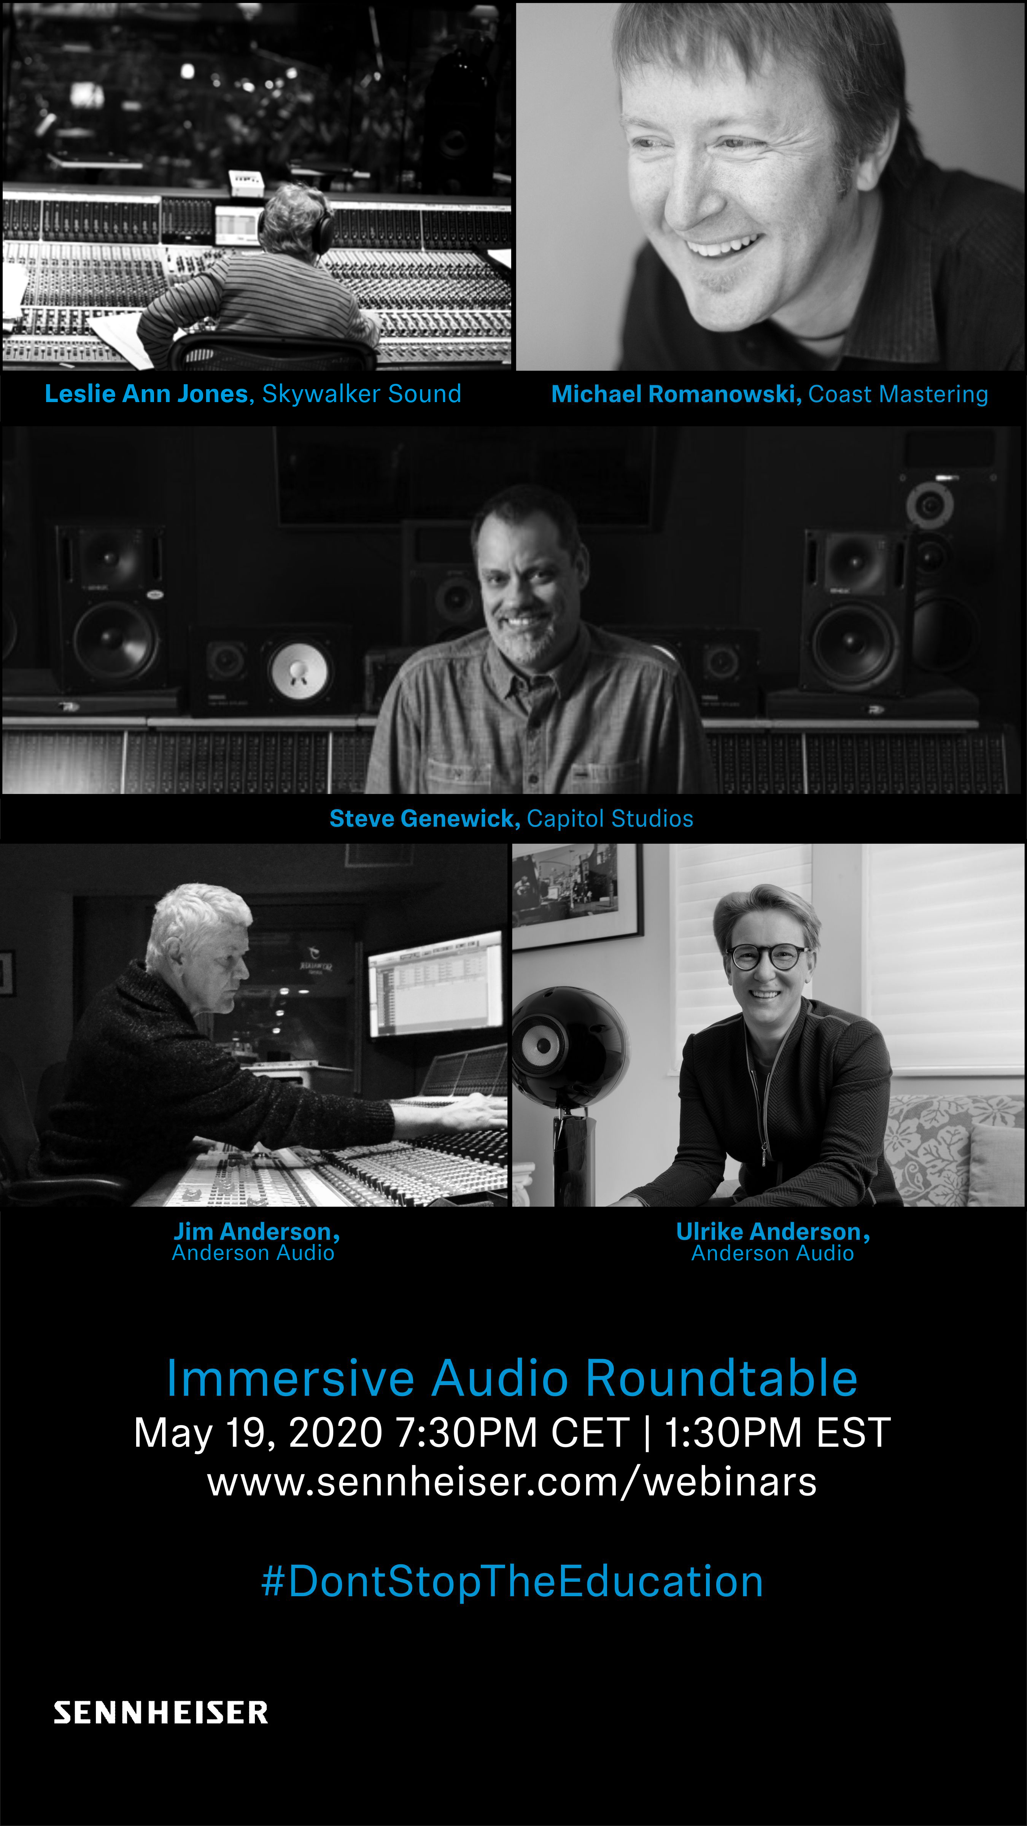

About Sennheiser
Founded in 1945, Sennheiser is celebrating its 75th anniversary this year. Shaping the future of audio and creating unique sound experiences for customers – this aim unites Sennheiser employees and partners worldwide. The independent family company, which is managed in the third generation by Dr. Andreas Sennheiser and Daniel Sennheiser, is today one of the world’s leading manufacturers of headphones, loudspeakers, microphones and wireless transmission systems. In 2018, the Sennheiser Group generated turnover totalling €710.7 million. www.sennheiser.com

Global Press Contact

Stephanie Schmidt
Stephanie.schmidt@sennheiser.com
+49 (5130) 600 – 1275

