For immediate distribution
Don’t Miss Flock Audio’s Black Friday Sale on the PATCH Series
The PATCH LT, PATCH & PATCH XT are now on sale for a limited time only

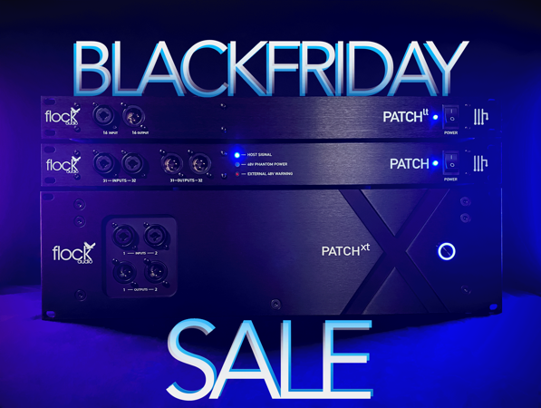
Kelowna, British Columbia, November 16, 2022— Black Friday came early this year with Flock Audio. The highly regarded PATCH Series, the digitally controlled analog Patch Bay created by the Canadian pro-audio manufacturer, is now available for a limited-time sale. The PATCH Series has revolutionized the hybrid audio workstation and now is the chance to purchase one for a rare-discount. The flagship PATCH, the PATCH LT and the recently released PATCH XT are all being sold at a discounted price now through the end of November with participating dealers. Please contact your local dealer to learn more.

PATCH LT
The sleek and compact 32-point Digitally controlled analog patch bay is perfect for small to mid-sized commercial studios that comes with the latest PATCH APP 3.0 software controller compatible with both OSX and Windows. The small, but mighty model contains the same internal componentry as the PATCH and the UI is just as powerful as the flagship model as well. Despite being controlled using a digital UI the system never converts the signal to or from the digital domain, the entire signal path remains strictly analog. The PATCH LT can dramatically improve workflow efficiency, while aiding users to make more informed decisions on equipment choices and sonic preferences. The PATCH LT is now available for $1,979.00 compared to regular $2,199.00 (10% off).

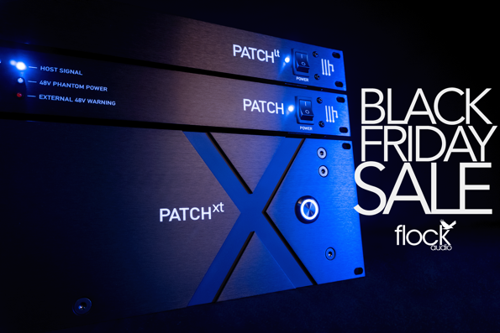
THE PATCH
The PATCH system is the flagship model for the brand, which debuted in 2017, is a powerful system used by hundreds of audio engineers, producers and broadcasters around the world. With 32 ins and 32 outs, the 64-point patch bay connects to a computer via USB to the PATCH APP. The PATCH continues to provide integral solutions for analog routing by eliminating patch cables, easily creating and storing recallable routings using a digitally controlled software. Needless to say, the PATCH grows stronger and current with software and firmware updates. The modernized patch bay is now on sale for $2,969.00, which is 10% off the original listing price of $3,299.00.

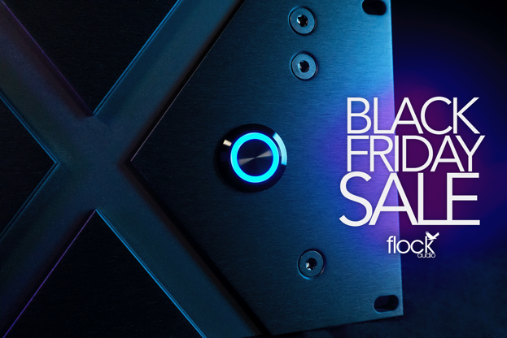
PATCH XT
The PATCH XT is the largest patch bay offers192 digital-conversion-free full-analog point connections. This comprehensive all-in-one patch bay from Flock debuted earlier this year in April alongside the XTH Cable Hanger Accessory, designed to create a strain relief solution and extend the lifespan of the 24 DB25/D-SUB cables connected to the rear panel. With 92 ins and outs the PATCH XT meets the connectivity requirements of many recording studios, broadcast control rooms and channel-intensive environments. Even more connectivity is possible through the PATCH APP 3.0, which now facilitates the configuring of up to 10 PATCH Series units. The PATCH XT is on sale for $13,495.00, a $500 discount off the regular $13,995.00, with the addition of a free XTH Cable Hanger accessory, which is $375 in value in celebration of Black Friday.

For more on the PATCH System, visit: http://www.flockaudio.com.
About Flock Audio
Flock Audio Inc. is a pro-audio manufacturer based in Kelowna, British Columbia, Canada, founded in 2017. The company is best known for its PATCH System Series, which is a Digitally controlled, 100% Analog Patch Bay routing solution for professional audio environments. For more information on Flock Audio and its products, please visit the company website at http://www.flockaudio.com.

Media Contacts
Shelby Coppola
Public Relations
Hummingbird Media
+1 (203) 598-8167
shelby@hummingbirdmedia.com

Jeff Touzeau
Public Relations
Hummingbird Media
+1 (914) 602 2913
jeff@hummingbirdmedia.com

