

Biuro prasowe better. gaming agency
bettergamingagency.prowly.com

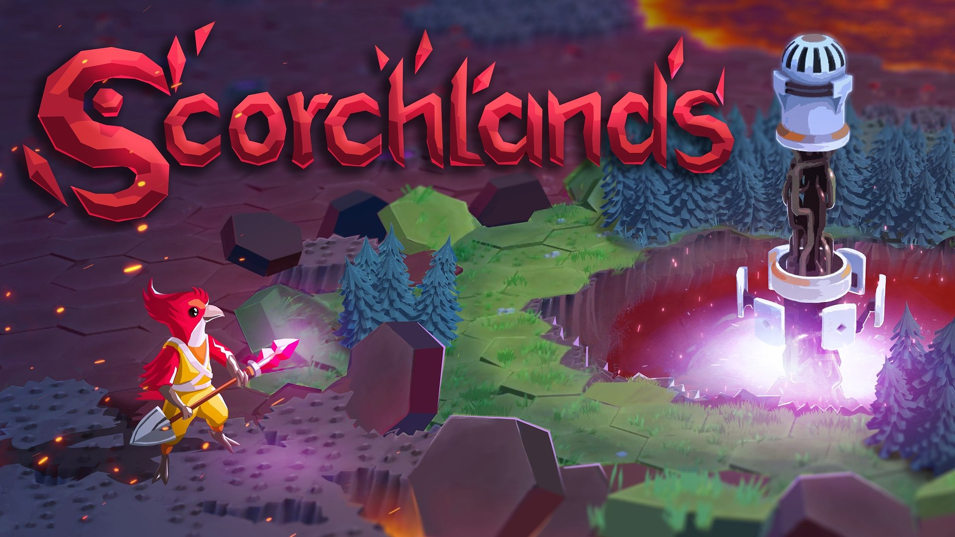

Well-baked Scorchlands will leave early access on July 25th

It's time for the next step in the adventure of creating Scorchlands. Jakub Rogalski – an independent developer and founder of Ringlab studio, along with the publisher Star Drifters – is releasing version 1.0 after more than a year in Early Access.

Scorchlands is a strategy game that tells the story of the birdfolk called Giwi. This nation has always dreamed of space travel to learn more about the cosmos and other celestial bodies. Despite all obstacles, the brave birds finally decided to organize an exploratory expedition to the moon Helia, where the Giwi will need to establish several settlements on the hostile surface of the alien world. Terraforming will be possible not only with available technology but also with magic. Thanks to their efforts, the desert landscape of the moon will be replaced by meadows, forests, and lakes.

Scorchlands - Full Release Date Trailer

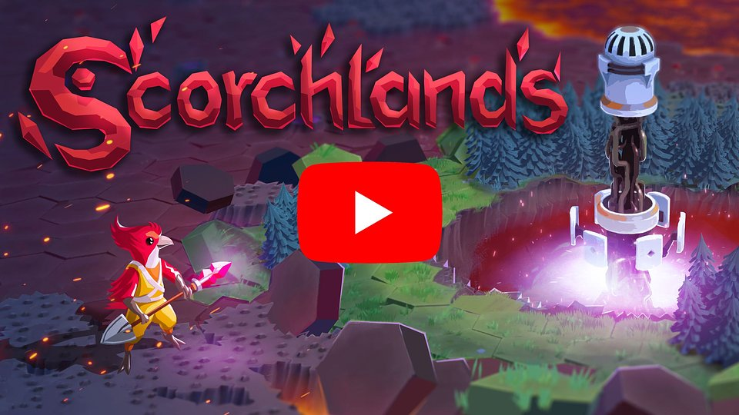
https://www.youtube.com/watch?v=QRO3XCgnmlY

In the world of Scorchlands, magic plays a significant role, adding a touch of chaos. This magical influence summons a variety of beasts to the surface of the moon Helia, and the relationship is straightforward: the more colonization efforts the Giwi undertake, the more surprises they encounter. With each settlement they establish, the gameplay becomes increasingly challenging.

With the release of the full version of Scorchlands, additional content will be implemented. The creators have achieved all the goals set out in the roadmap introduced on the day the game launched in Early Access, alongside numerous smaller updates that have also shaped the game. You can find the complete list of changes here, with the most important ones including:

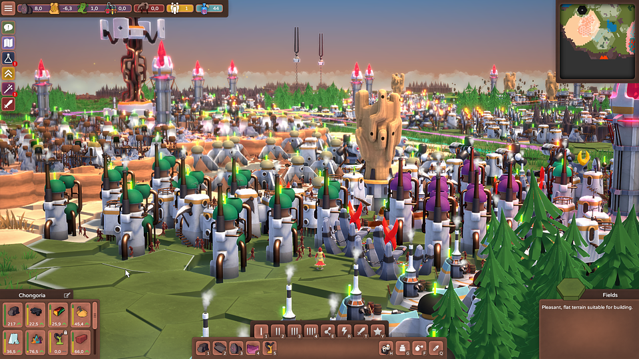

● Faster building and structure relocation – colonizing the surface of Helia has gained momentum. Now, all buildings will be constructed much faster, and players will have the ability to relocate structures or exchange them between colonies.

● New models – with the full release, many models have been improved and enhanced, making both the village and its inhabitants look even better.

● Controller support – in Scorchlands, players can use controllers comfortably with the assistance of a special radial menu.

● Achievements – Ringlab has prepared a total of 20 diverse achievements, and completing all of them will be a satisfying challenge.

Even though Scorchlands will leave early access on July 25th, it doesn't signify the conclusion of game development. In the near future, the creators are planning to add an additional 21 languages.

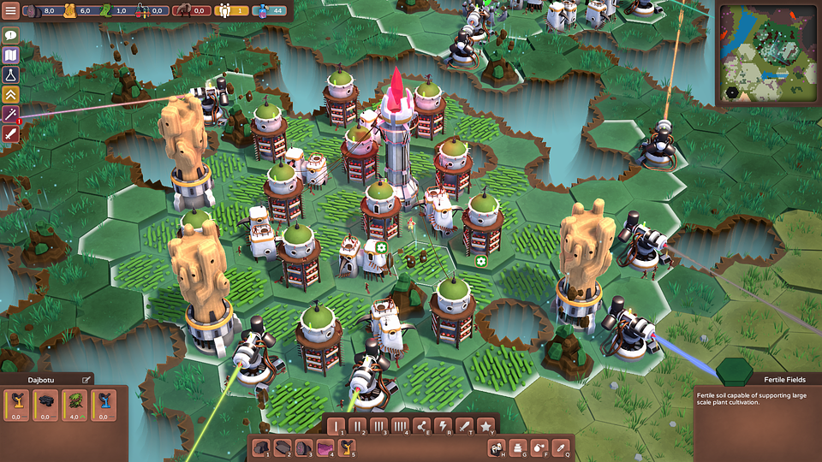

Scorchlands – key features:

🐦 Hex grid-based city-building – construct various buildings in your colonies. Each structure's productivity depends on neighboring resources and other constructions.

🐦 Complex resource management – it’s not only about extracting materials. Scorchlands takes account of logistics – the movement of resources between colonies and combining them in robust processing chains. And yes, we move resources using LASERS!

🐦 Terraforming for the greater good – use magic and technology to change the biomes on procedurally generated maps and exploit the new environment to gain its unique resources.

🐦 Technology designed to give fun – there’s no fun in a sandbox if you don’t have the toys to play with. The technology system in Scorchlands is key for player progression and new discoveries open up new ways to play with the game world.

🐦 Minimalistic combat system – when you get into a fight, positioning will be key. Destroy your enemies by surrounding them and placing your forces in optimal locations.

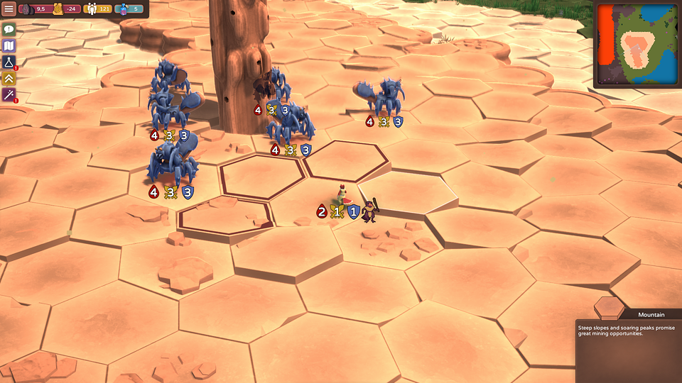

Scorchlands will exit Early Access on July 25th, and all strategy enthusiasts should mark this date on their calendars. The game by Ringlab will be available on Steam. It's worth noting that the game is currently available at a 40% discount, and the promotion will last until July 11th.

The press kit is available here.

About Ringlab:

Ringlab is an indie gamedev studio based in Łódź, Poland. It was initially started by Jakub Rogalski who also worked on all SUPERHOT titles. Since 2020 the studio focuses on the development of Scorchlands.

About Star Drifters:

Star Drifters is an independent game development studio based in Warsaw, Poland. The company was founded in 2014 by two industry veterans: Michal Sokolski and Krzysztof Jakubowski. During a nearly two-decades-long career, they’ve worked on numerous titles for all major gaming platforms and gained extensive experience in game development and management.

Since 2020, the team has begun incubating selected indie titles and the teams behind them. The scope of support is individually tailored and covers areas from production, design, and positioning through financing to the sale of the final product. Star Drifters’ mission is to create engaging, challenging, and highly replayable games that will remain in players’ memories for a long time.

The studio is known for creating and publishing the real-time 4X strategy game Driftland: The Magic Revival, the rogue-lite game Danger Scavenger, and the top-down shooter with base-building mechanics Lumencraft.

