SUPERIOR SOUND, TAILORED TO YOU
Sennheiser launches CX 400BT True Wireless earphones

Wedemark, September 1, 2020 – Rules are there to be broken: With the new CX 400BT True Wireless, Sennheiser has rewritten the rulebook for true wireless audio by bringing its high-end acoustic technology to an exciting new pair of everyday earphones. With intuitive customizable controls, all-day comfort and a 7-hour battery life that can be extended to up to 20 hours using the supplied charging case, they are the ideal, uncompromised choice for anyone with a passion for great sound.

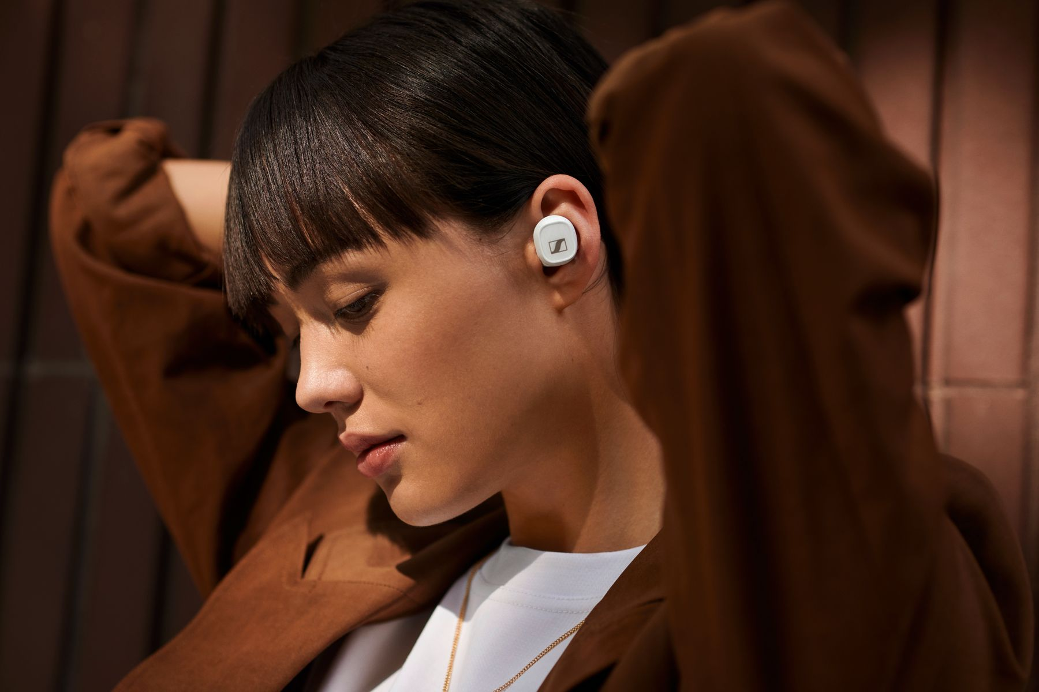
Superior sound, tailored to you
The CX 400BT True Wireless delivers astonishing high-fidelity stereo sound with deep bass, natural mids and clear, detailed treble thanks to Sennheiser’s 7mm dynamic drivers. You can further tailor your sound experience with the built-in equalizer via Sennheiser’s Smart Control app.

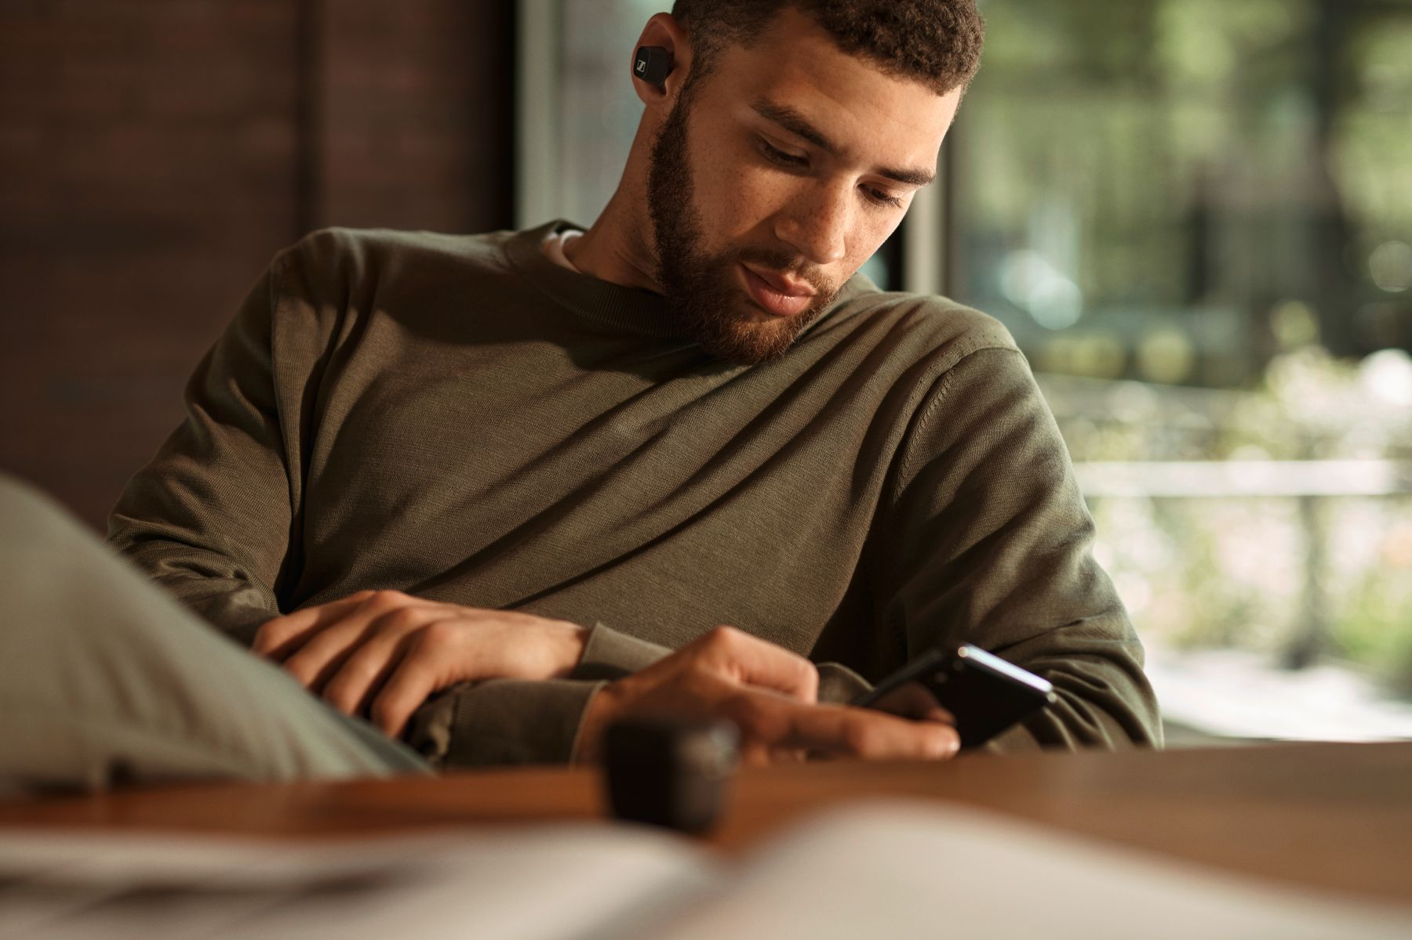
Intuitive and effortless
The earphones have been created for fast-paced, always-on lifestyles. Staying entertained, informed and connected is effortless and intuitive, thanks to the customizable touch controls that let you define your preferred way of controlling audio, calls or accessing voice assistants.

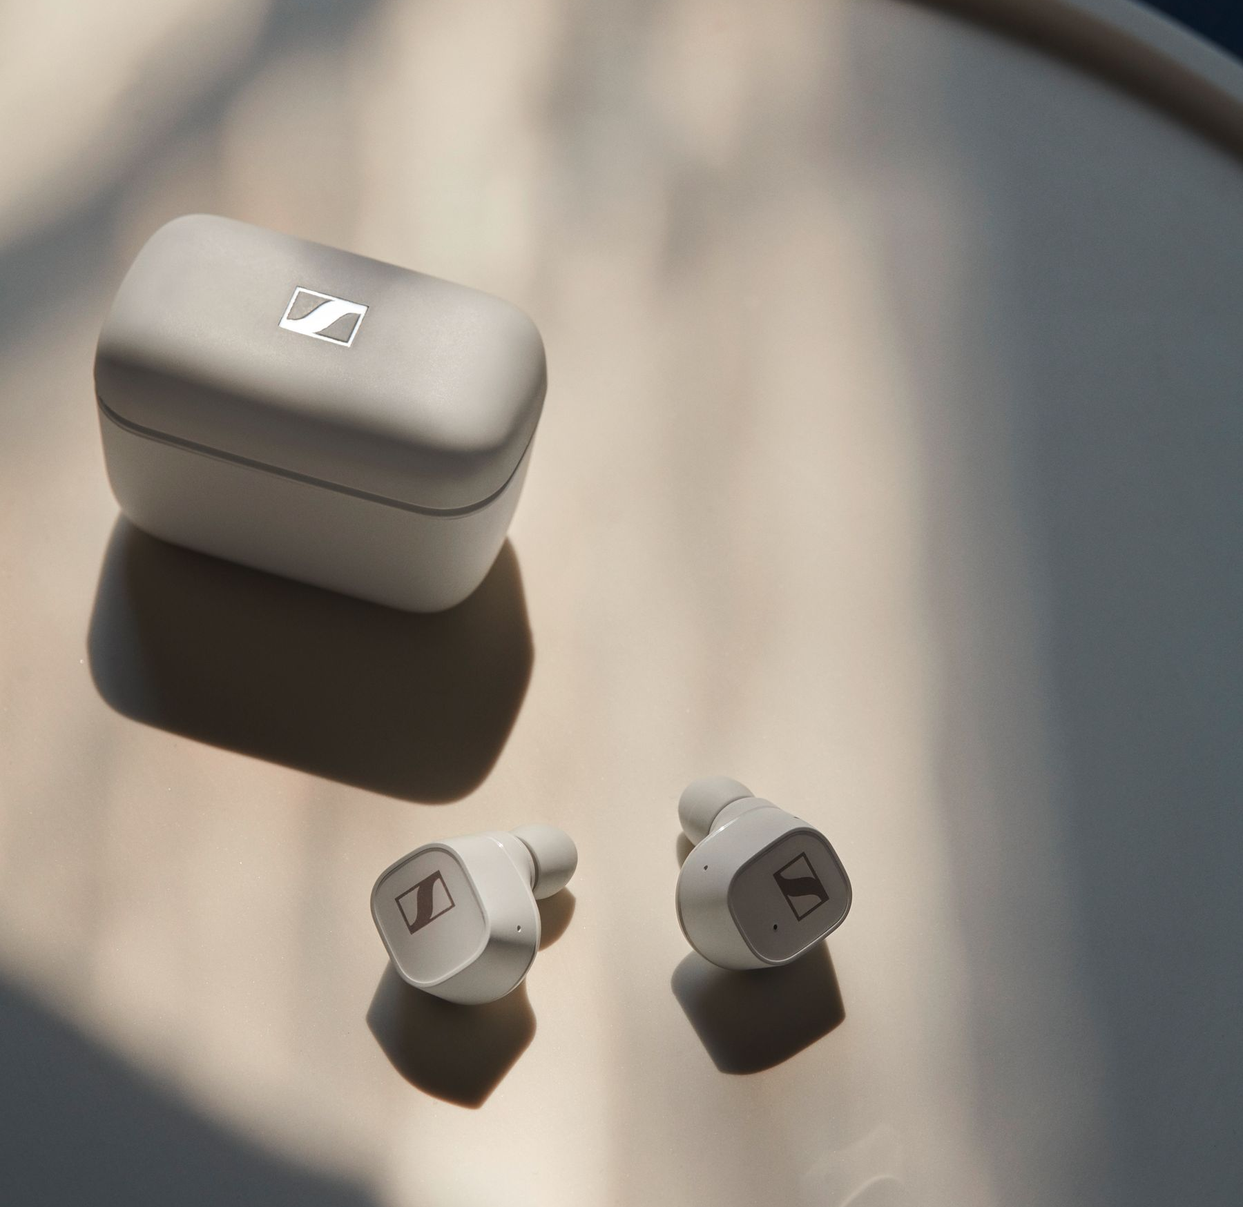
All-day entertainment
With 7 hours battery life and up to 20 hours available when charging on-the-go with the supplied case, the CX 400BT True Wireless keeps entertaining throughout the day – and comes with all-day comfort to match.

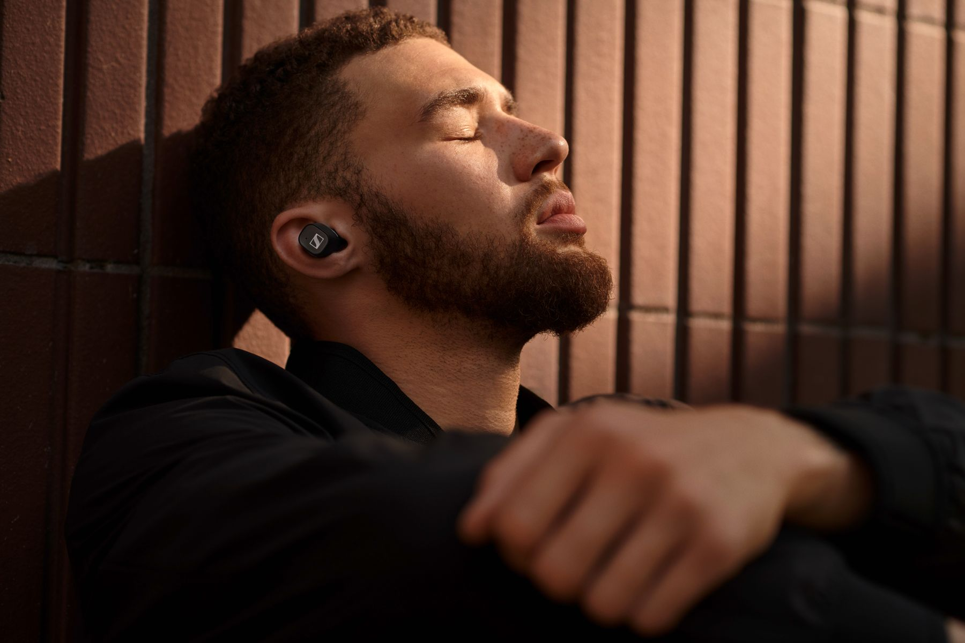
Comfort and style
Stylish, minimalist, and perfectly balanced, the earbuds’ ergonomic design offers all-day wearing comfort, while their exacting build quality ensures take-anywhere durability. For a perfect fit in the ear that effectively attenuates outside noise, adapters are provided in a choice of four sizes.

The CX 400BT True Wireless will be available in black and white from September 15 for 199 EUR (MSRP).

About Sennheiser
Founded in 1945, Sennheiser is celebrating its 75th anniversary this year. Shaping the future of audio and creating unique sound experiences for customers – this aim unites Sennheiser employees and partners worldwide. The independent family company, which is managed in the third generation by Dr. Andreas Sennheiser and Daniel Sennheiser, is today one of the world’s leading manufacturers of headphones, loudspeakers, microphones and wireless transmission systems. In 2019, the Sennheiser Group generated turnover totaling €756.7 million. www.sennheiser.com

Global Press Contact

Jacqueline Gusmag
Communications Manager Consumer
jacqueline.gusmag@sennheiser.com
T +49 (0)5130 600-1540

