For immediate distribution

Sweetwater to Host Robben Ford's Guitar Dojo
The three-day event will take place from Thursday–Saturday, April 25–27, at Sweetwater and will include instruction from Robben Ford, John Jorgenson and Jeff McErlain
April 15, 2019, Fort Wayne, IN – Sweetwater — the No. 1 online retail destination for music gear in the U.S. — will host Robben Ford's Guitar Dojo, an immersive course in the art of the playing guitar led by the guitar hero himself, as well as by Ford's distinguished guest guitarists, John Jorgenson and Jeff McErlain.

During the three-day course, which will take place from Thursday, April 25 to Saturday, April 27, attendees will have the opportunity to learn everything from note choice and improvisation, to songwriting— plus, they will get the chance to jam with the virtuoso instructors and the other guests.
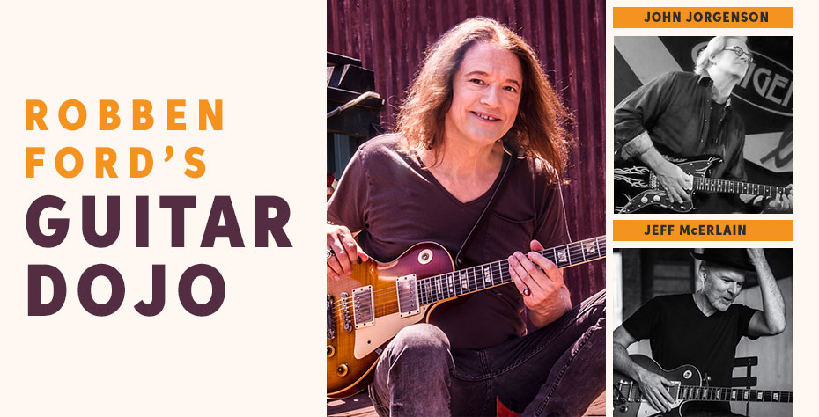
Each day of the session will begin at 10 a.m. with a two-hour Master Class taught by one of the Guitar Dojo instructors. Following a lunch break, guests will then spend the afternoon in breakout groups with instructors, and each day will conclude with a two-hour jam session. Additionally, the guitar-hero trio will treat attendees to a private performance at the end of the final session.

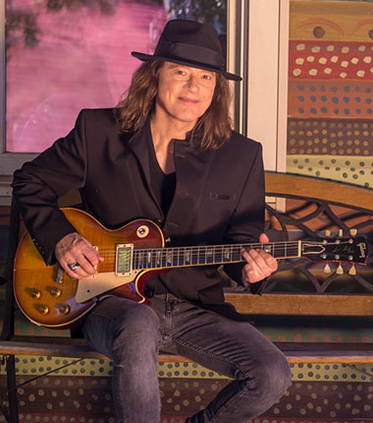
Sweetwater Senseis: Meet the Guitar Dojo Instructors
Robben Ford has proven himself to be one of the premier guitarists in blues, jazz and R&B throughout the course of his career — whether during his earlier years of touring with Charlie Musselwhite and Jimmy Witherspoon, as a member of the LA Express or Yellowjackets, or with his own band, The Blue Line. Over his more than thirty-year career, Ford has built a resume that includes collaborations with Miles Davis, Joni Mitchell and George Harrison, with accomplishments that reflect the versatility and musicality of a true guitar master, including five Grammy nominations.
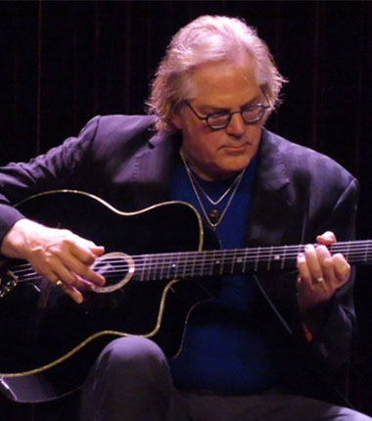
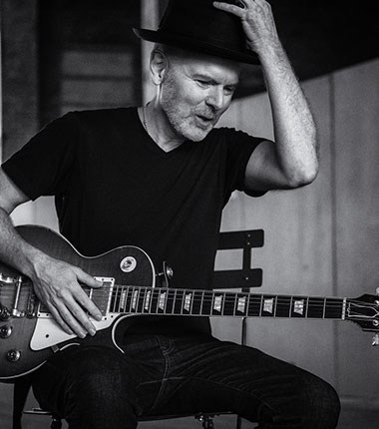
Known for his blistering single-note licks and mastery of a broad range of musical genres and styles, John Jorgenson has earned his status as a top-tier musician around the world. Jorgenson first gained national attention in the 1980’s as a cofounder of the country-rock group The Desert Rose Band, and since then he has continued a long and successful career with an eclectic array of artists, including Bonnie Raitt, Bob Seger and Luciano Pavarotti.

Brooklyn guitarist Jeff McErlain has cultivated a unique style of blues rock that brings together a disparate set of influences, including Allan Holdsworth, Michael Schenker, Miles Davis and Howlin’ Wolf. McErlain’s decades-spanning stylistic blend has made him the go-to sideman for players like David Grissom, Matt Schofield, Jimmy Haslip, Keith Carlock and the dojo master himself, Robben Ford.

Registration for Robben Ford’s Guitar Dojo starts at just $1,295 per person and includes three full days of learning sessions, workshops and classes, as well as lunch and dinner (does not include transportation). For $1,695 per person, registration additionally includes three-night, one-room hotel accommodations at Don Hall’s Guesthouse and breakfast (does not include transportation).
To register, please email rachel_ryan@sweetwater.com or call (260) 432-8176 x1993.
To learn more, please visit https://www.sweetwater.com/events/robben-fords-guitar-dojo

About Sweetwater
Since 1979, Sweetwater has been committed to giving music makers the ultimate shopping experience. As a pioneer of ecommerce in the early 1990’s, Sweetwater has methodically leveraged the internet to expand their business. As a result, Sweetwater.com now serves as the #1 online retail destination for music gear in the United States. Whether it's Sweetwater's human approach to building personal relationships with their customers, the numerous free value-adds or their unparalleled "too-good-to-be- true" customer service, Sweetwater.com continues to be the preferred shopping destination for music makers — whether beginners or rock stars.

Media contacts
Steve Bailey
Public Relations
Hummingbird Media
+1 (508) 596 9321
steve@hummingbirdmedia.com

Jeff Touzeau
Public Relations
Hummingbird Media
+1 (914) 602 2913
jeff@hummingbirdmedia.com

