Modern Audio Masters: RME Announces Digiface AVB, M-32 Pro AVB Series
are Now Shipping
Available now, the two AVB solutions offer greater connectivity options for integrators and end-users

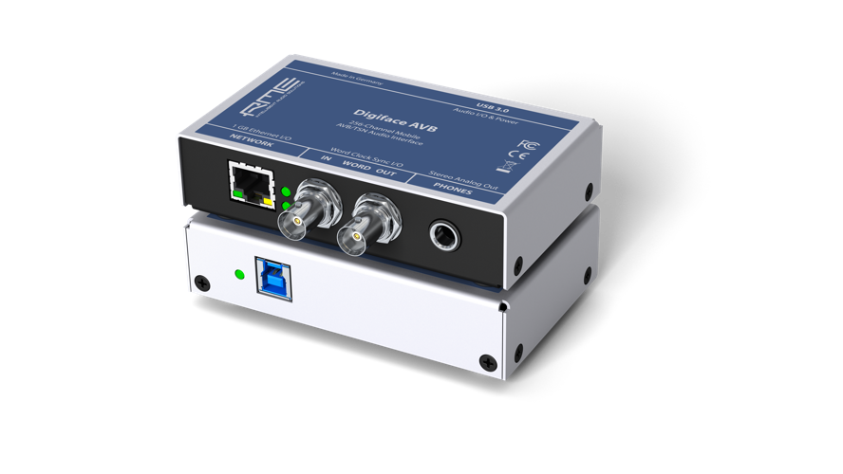
Fort Lauderdale, Florida, October 25, 2018 – Premium German interface manufacturer RME has announced the newest addition to its Digiface series of mobile audio interfaces — the Digiface AVB — is now shipping along with RME’s new M-32 Pro AVB Series of 32-channel converters.
“Not only is RME known for its premium audio interfaces, preamps and converters, but we are also leading the way in networking by connecting audio engineers to the next generation of audio distribution standards,” said Derek Badala, Director of Sales, Americas for Synthax, distributor of RME. “Built with the high-quality design and components RME is known for, these new solutions are taking audio transmission to the next level.”
Mobile AVB Solution
The Digiface AVB meets the growing need in the AV industry to distribute audio over a local area network. The Digiface AVB USB audio interface uses AVB to transfer up to 256 channels of audio between PC and audio networks.
The integrated USB 3.0 connection allows up to 128 audio channels to be streamed back to the AVB network and another 128 channels to the computer — with sampling rates of up to 192 kHz. Users can adjust the channel sizes of streams between 2 and 32 channels as needed to ensure maximum compatibility with AVB audio devices available on the market.
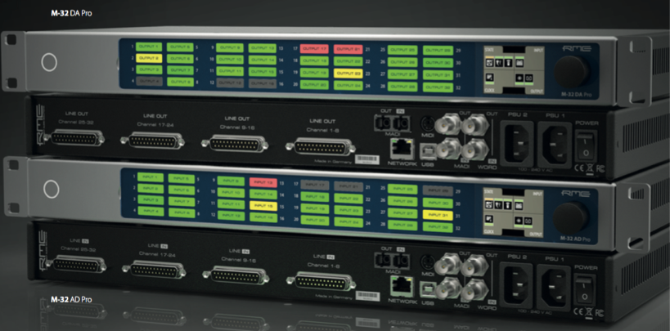
Moving the Dial with the M-32 Pro AVB
RME’s new M-32 Pro AVB Series is designed in response to the demands of productions and installations requiring high analog channel counts. The M-Series is comprised of the M-32 AD Pro and M-32 DA Pro, two high-end, 32-channel 192 kHz converters. With these units, users can adjust the channel sizes of streams between 2 and 32 channels as needed to ensure maximum compatibility with AVB audio devices available on the market.
Based on state-of-the-art, high-resolution converter components and a fully balanced analog circuit design, the new M-Series offers a signal-to-noise ratio of 120 dB(A) with extremely low THD values — placing the converters in the reference class.
In addition to the two fully equipped MADI I/Os including separate signal routing, the new M-Series converters boast an AVB interface based on the open network standard IEEE 802.1 and 1722.1, enabling transmission of the 32 analog channels at maximum 192 kHz sampling rate via a single Ethernet cable.
The RME Digiface AVB is available now and priced at $999 MAP.
The RME M-32 AD Pro and M-32 DA Pro are available now and both priced at $3,999.
For more information on RME, visit http://www.rme-usa.com/

About Synthax, Incorporated
Synthax Inc. is the exclusive USA distributor for RME digital audio solutions, Ferrofish advanced audio applications, myMix audio products, and ALVA cableware. We supply a nationwide network of dealers with these products for professional audio, broadcast, music industry, commercial audio, theater, military and government applications. For additional information, visit the company online at http://www.synthax.com.

Media Contacts:
Katie Kailus
Public Relations
Hummingbird Media
+1 (630) 319-5226
katie@hummingbirdmedia.com

Jeff Touzeau
Public Relations
Hummingbird Media
+1 (914) 602 2913
jeff@hummingbirdmedia.com

