SUPERIOR SOUND FOR TOP TV ENJOYMENT
Sennheiser’s new RS 5200 enhances the personalized TV listening experience

Wedemark, September 30, 2021 – The Sennheiser RS 5200 makes the TV listening experience even more enjoyable with digital wireless capabilities and effortless simplicity. The audio specialist also focuses on user-friendliness with personalized sound options and improved wearing comfort with a lightweight design.

The RS 5200 simplifies tailoring audio settings to individual needs. The Speech Clarity Function can be activated at a touch to reduce distracting background sound, making TV and dialog easier to understand. On top of that, three hearing profiles enhance the clarity of different frequency ranges. To balance sound, the RS 5200 also offers independent left and right volume controls.

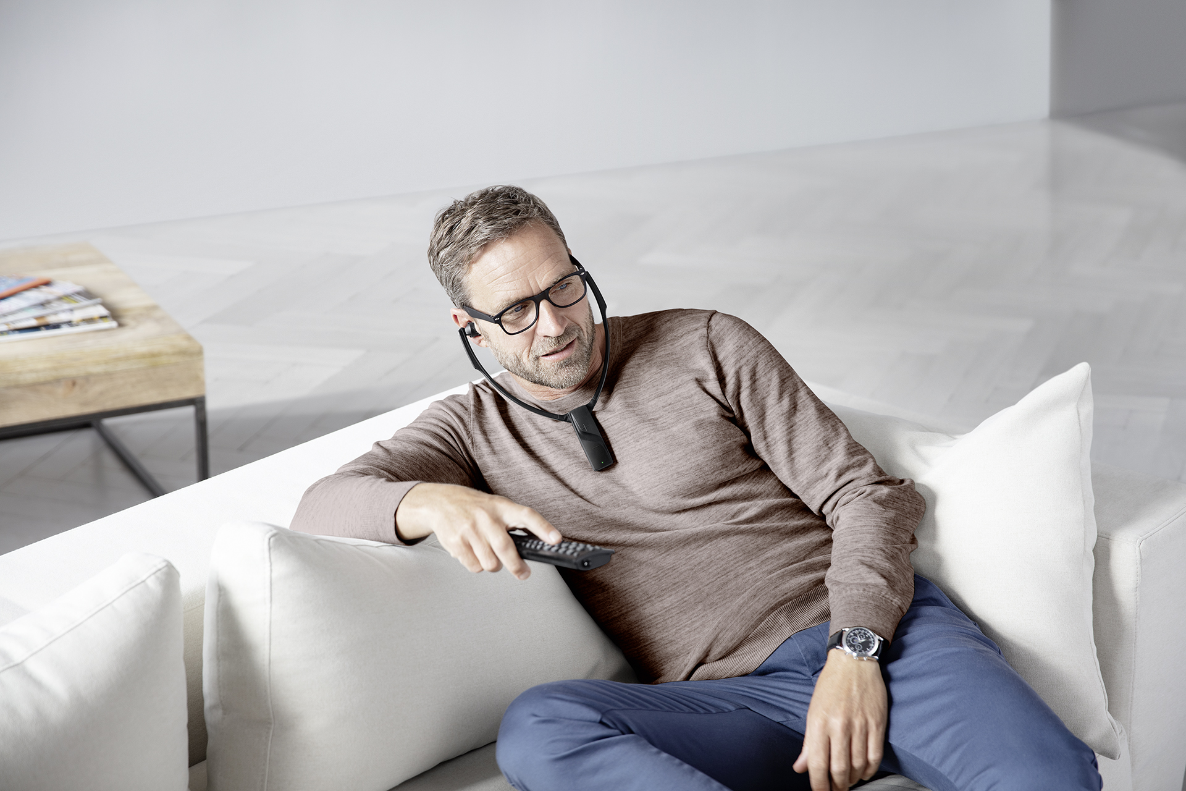 | Designed for longer viewing sessions: Sennheiser’s new RS 5200 makes the TV listening experience even more enjoyable

“This next generation of Sennheiser’s RS 5000 series delivers an enhanced TV sound experience to listeners. The RS 5200 packages superior audio quality, clearer spoken dialog, and wireless capabilities in an elegant and easy-to-use solution with enhanced comfort for longer viewing sessions,” says Irene Strüber, Product Manager Enhanced Hearing at Sennheiser. “Even when your hearing needs change, the RS 5200’s audio customization options will be able to keep up.”

Wireless connection with easy setup
Thanks to crystal clear digital wireless transmission, the viewing experience with the RS 5200 is not complicated by cables. Listeners are free to move around the room and can even enjoy an unparalleled sound experience from up to 70 meters away from the sleek transmitter unit.

Set-up and everyday use of the system is refreshingly easy. The elegant horizontal docking station can be connected to the TV via either digital (optical) or analog audio cables. The receiver’s built-in rechargeable battery provides up to 12 hours of playback for uninterrupted viewing pleasure. Users can charge the receiver battery by docking it in the base station. The system will notify the user when the battery is low and, to save power, automatically turns off when not in use.

With the RS 5200, listeners can now choose from four styles and sizes of ear tip adapters to find the perfect fit

Comfort-enhancing design
The RS 5200’s lightweight ergonomic design increases comfort by reducing pressure on the ears. To find the perfect fit, listeners can now choose from four styles and sizes of ear tip adapters, including silicon adapters in S and L sizes. The memory foam adapters shape to the ear for better noise isolation. On the other hand, users can opt for the open foam ear tips to let in more ambient sound. The under-the-chin wearing style does not put pressure on the temples and guarantees ease of wear for users with glasses.

The Sennheiser RS 5200 is available now for 249.90 EUR (MSRP).

ABOUT SENNHEISER
Shaping the future of audio and creating unique sound experiences for customers – this aim
unites Sennheiser employees and partners worldwide. The independent family company,
which is managed in the third generation by Dr. Andreas Sennheiser and Daniel Sennheiser, is
today one of the world’s leading manufacturers of headphones, loudspeakers, microphones
and wireless transmission systems. In 2020, the Sennheiser Group generated turnover totaling
€573.5 million. www.sennheiser.com

Global Press Contact
Sennheiser electronic GmbH & Co. KG
Milan Schlegel
PR and Influencer Manager EMEA
T +49 (0)5130 600-1139
milan.schlegel@sennheiser.com

