Embargoed until October 1, 2020, 10 a.m. CEST

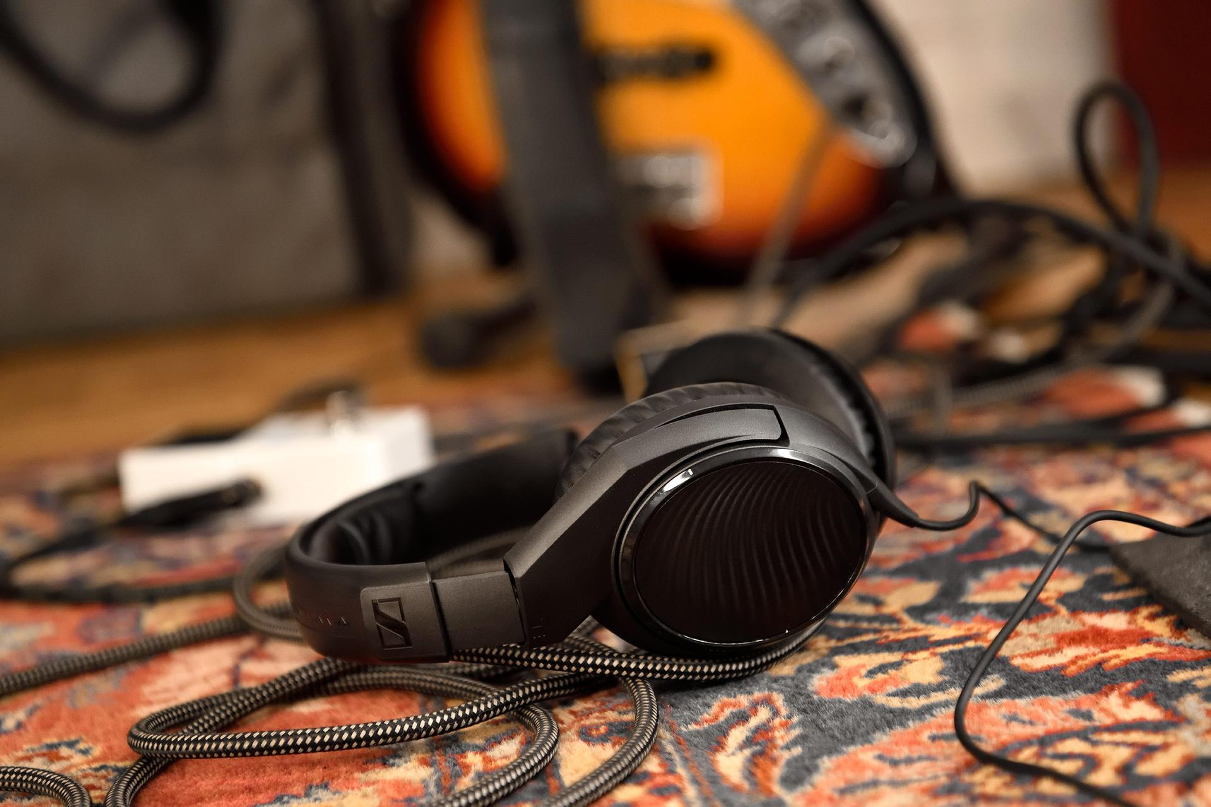

Get all-time classics for your (home) studio

Sennheiser offers legendary MD 421-II microphone and popular HD 200 PRO headphones at special anniversary prices

Wedemark, October 1, 2020 – The Sennheiser anniversary offers continue with the legendary MD 421-II – one of the best-known microphones for recording, live music and broadcasting in the world – and the HD 200 PRO studio headphones! To celebrate its 75th anniversary, Sennheiser is offering an incredible 49% on the MD 421-II throughout the month of October. The microphone will retail at EUR 199 MSRP (instead of EUR 399 MSRP), while the HD 200 PRO will retail at EUR 49 MSRP (instead of EUR 75) until year-end. Please visit www.sennheiser.com/special-deals for a list of dealers offering these promotions.

Upgrading your gear
With the dynamic MD 421-II, you will own a true all-rounder for almost any situation. Originally introduced in 1960 as the MD 421, this cardioid microphone classic ensures clear, natural sound while offering effective feedback rejection.

During the month of October, the Sennheiser MD 421-II is available at EUR 199 (MSRP) | 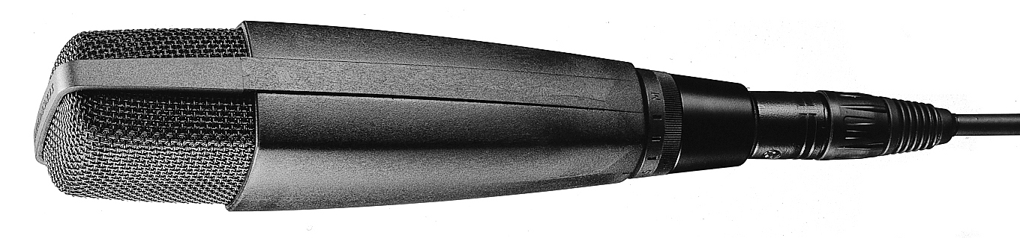

Thanks to its large diaphragm, the MD 421-II has a wide, condenser-like frequency response of 30 – 17,000 Hz. It is fitted with a five-position bass roll-off switch (from M for music to S for speech), which helps to compensate for the proximity effect where needed and reduces impact sound. The filter can also be dialled in if you prefer to place an emphasis on the higher frequencies, as may be the case with acoustic guitars or speech applications such as podcasting and streaming.

The MD 421-II has become a classic for recording guitar and bass amps and drums – toms and kick especially but also snares, and it has even been seen in overhead use. It also does a great job on all kind of percussion, saxophone, and brass, and is often used as an announcer or vocal microphone. You will find at least one MD 421, very old or brand-new, in almost every rental warehouse, music club or studio around the world. A true workhorse.

Detail and focus with the HD 200 PRO monitoring headphones
The closed, circumaural HD 200 PRO allows you to focus on your sound – no matter whether you are practicing, recording, playing or monitoring a gig or simply want to listen to your favorite music. The HD 200 PRO delivers powerful studio sound with wide dynamics, while effectively attenuating ambient noise. Its soft earpads and ergonomic design ensure the comfort you need for long music sessions.

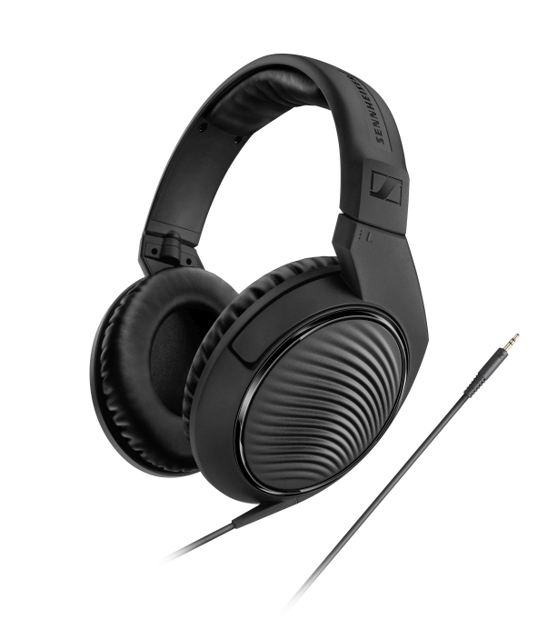
From October 1 to December 31, the Sennheiser HD 200 PRO will be available as a special deal for just EUR 49 (MSRP)

The headphones are fitted with a rugged, single-sided cable (2m) with 3.5mm jack connector; an adaptor to 6.3mm jack is included.

The images accompanying this press release plus additional images can be downloaded at https://sennheiser-brandzone.com/c/181/ifErFnju.

About Sennheiser
Founded in 1945, Sennheiser is celebrating its 75th anniversary this year. Shaping the future of audio and creating unique sound experiences for customers – this aim unites Sennheiser employees and partners worldwide. The independent family company, which is managed in the third generation by Dr. Andreas Sennheiser and Daniel Sennheiser, is today one of the world’s leading manufacturers of headphones, loudspeakers, microphones and wireless transmission systems. In 2019, the Sennheiser Group generated turnover totaling €756.7 million.
www.sennheiser.com

Global Press Contact

Stephanie Schmidt
Stephanie.schmidt@sennheiser.com
+49 (5130) 600 – 1275

