Ola Onabulé
Capturing the spirit of Point Less

New York, October 16, 2019 – British-Nigerian singer/songwriter Ola Onabulé’s latest studio album Point Less has 14 original tracks that tell tales of violence, immigration, xenophobia, betrayal, and dignity too. The album is at once a celebration of life and also a warning of the social forces that threaten it. Onabulé’s short US tour kicked off with the album launch, before taking the jazz artist to the Exit Zero Jazz Festival (November 8 and 9), the South Jazz Club Philadelphia (November 10) and Scullers in Boston (November 15). Ola is a veteran of the recording studio and, with the help of Sennheiser and Neumann microphones, has fully captured the complexity of his music, its heart and its spirit.

Ola Onabulé has a career spanning more than 20 years. He has performed at some of the most prestigious jazz festivals – Montreal, Vancouver, San Sebastian, Istanbul, Washington and Umbria to name a few – as well as at concert halls and jazz clubs around the world. His compositions cross cultural and musical boundaries with Ola taking a hands-on approach, immersing himself in not only his songwriting but also in the technology that faithfully brings his distinctive sound to his recordings.

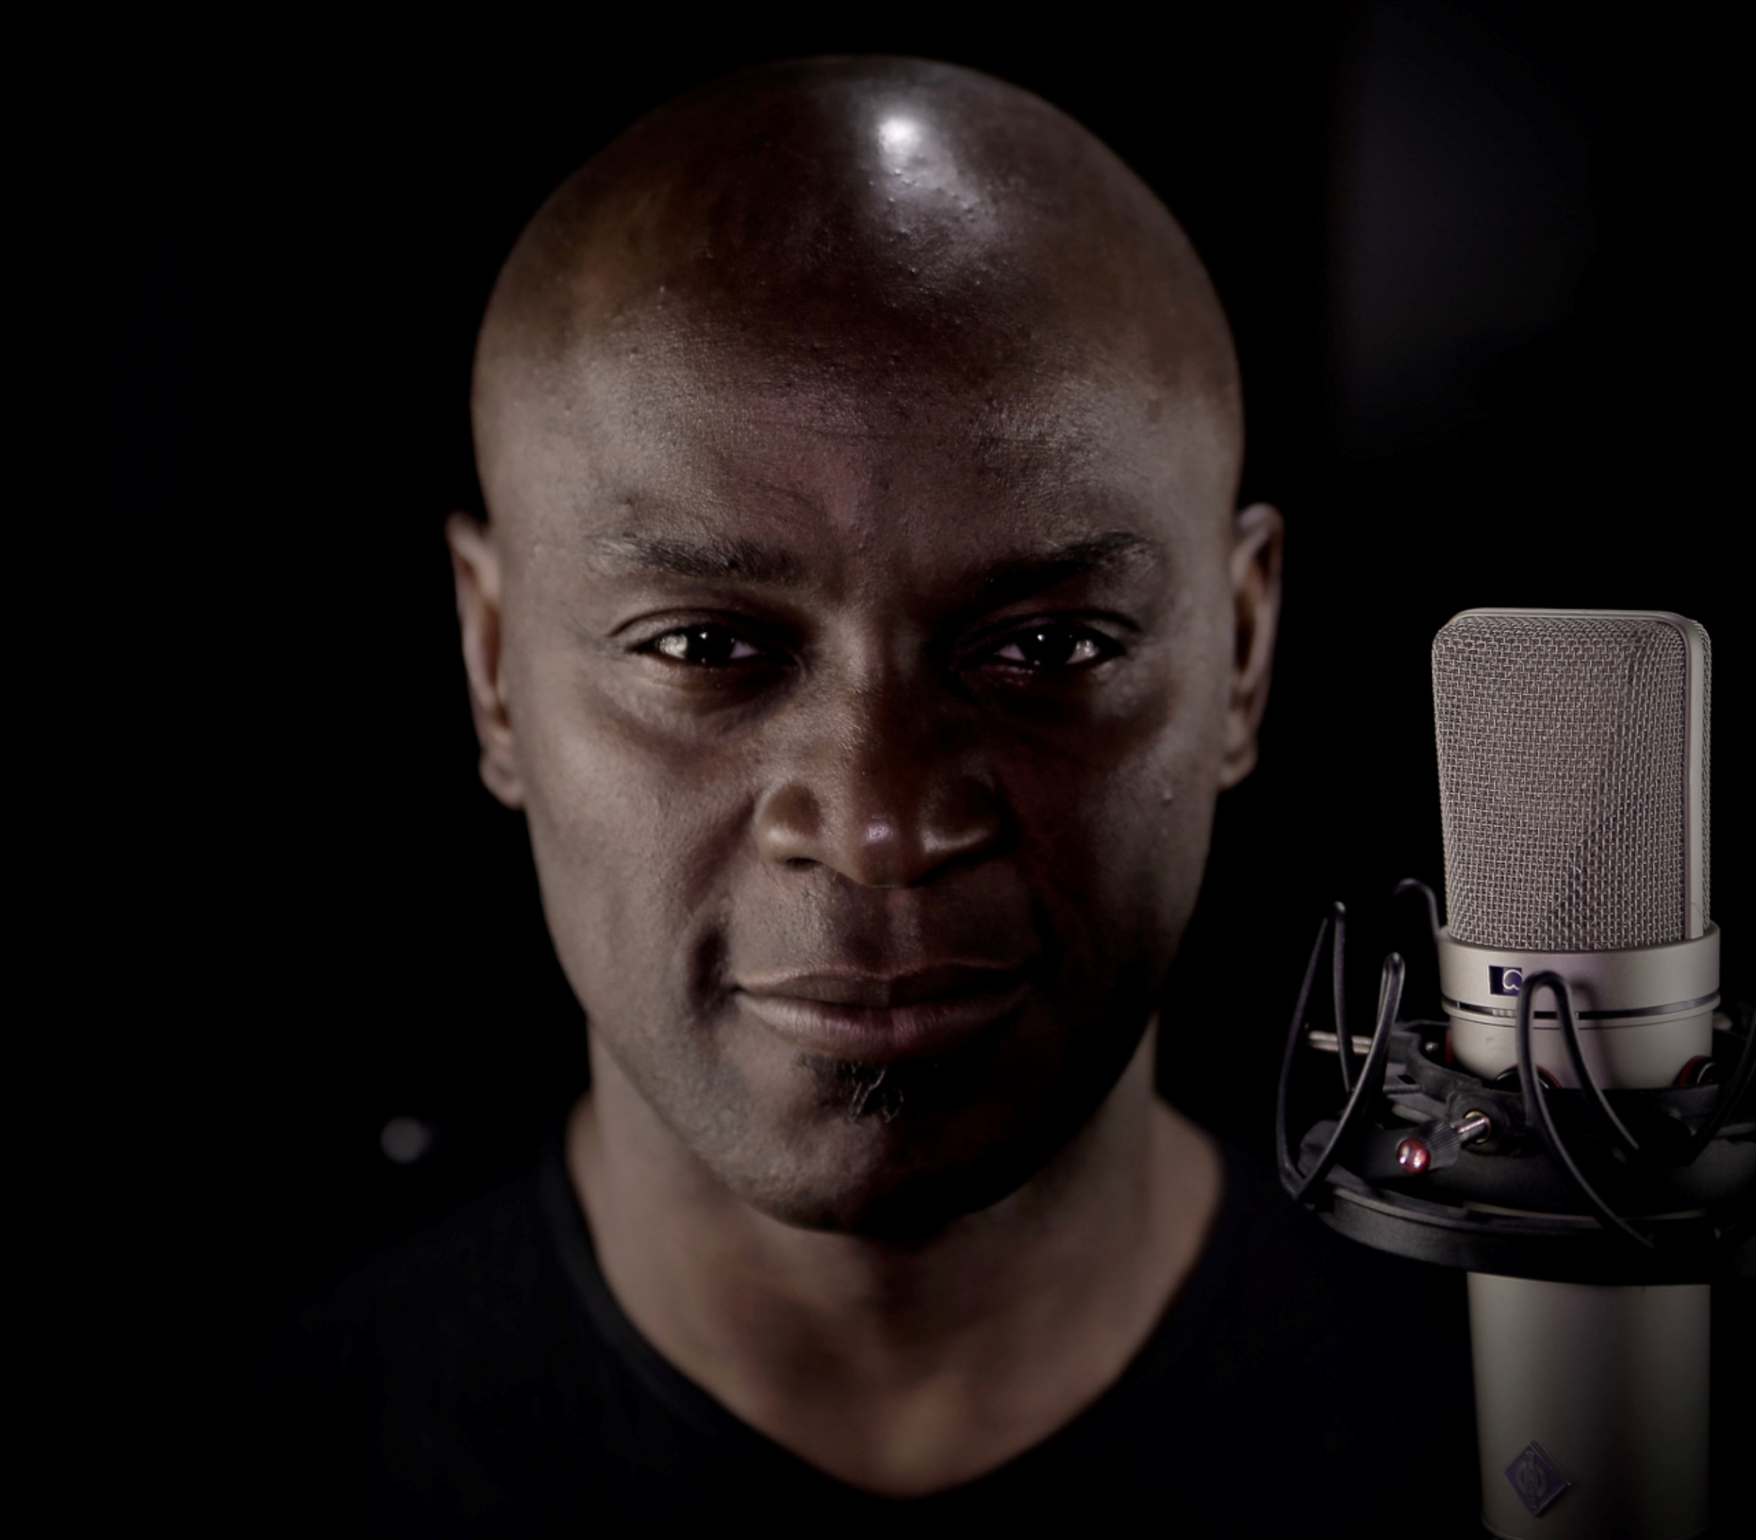 | Socially conscious singer/songwriter Ola Onabulé is touring the USA with his latest album Point Less

While Ola is always open to new ideas, there are certain things that are constants: For many years, Neumann and Sennheiser microphones have played a large part in both his recording and live work. His devotion to the two brands is, he says, based on audio fidelity and the support the two companies provide.

“I generally work with acoustic instruments, so I need microphones that allow me to hear everything in the recording; the thing that got me emotional, or inspired me, or gave me 20 other new ideas…,” he explains. “I want to hear that on the recording, so any microphone that can give me what I heard with my ears is the one for me. Both Sennheiser and Neumann have developed a range of tools for people who don’t want things to sound too lofty and want to capture the truth. Neumann in particular has a reputation for designing microphones that do that. Sennheiser has a slightly wider range of microphones, with dynamic as well as condenser mics available in the range, giving me a different part of the spectrum to play with. Between the two ranges, they cover just about all of my needs.”

Point Less has been recorded in Ola Onabulé’s own recording studio using a Neumann M 150 Tube, a U 87 Ai and M 149 for vocals. Ola knows the M 150 Tube is an unusual choice, being a small-diaphragm omni microphone, but says that it works particularly well for male vocals, especially those in the low/mid-range, for avoiding the proximity effect when getting up close and personal. Monitoring is via a Neumann KH 310 A system with a KH 810 sub.

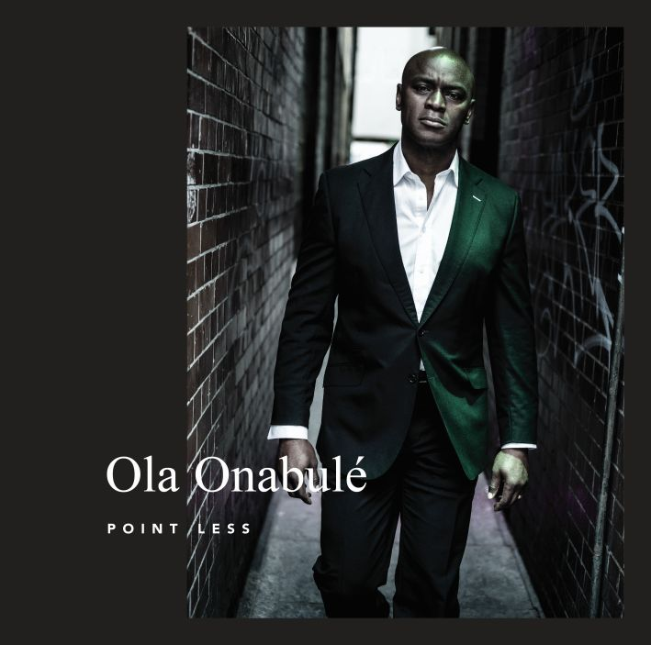 | Point Less has been recorded in Ola’s own recording studio. Neumann and Sennheiser microphones have played a large part in the recording

Ola and his band, which includes a bass player, pianist, guitarist and drummer, record in his live room with no real isolation between instruments – only the drummer has the most minimal of drum screens. As Ola wants to maintain eye contact between everyone, emulating their stage performance, this necessitates setting up the songs and the recordings so that, although there would be bleed in the room, it would not ruin the performance.

“None of the instruments will have too much captured in another’s mic, so when the mix engineer gets it, it will still make musical and audio sense,” he explains. “These are the kinds of challenges I think about when I am writing, too. I’ve always felt that writing a song, recording a song, and production and arrangement are all part of a wider process. The guys that I admired whilst growing up, people like Prince, more or less lived in the studio – the distance between his bedroom and the mixing desk was a very short one. I have always envisaged music making in the same way.

“I know a lot of folks think I write my songs on a note pad, I sing them, then a whole team of other people gets involved to make it the thing that I’ve imagined. But that’s not the way I do it. Writing and production – both technical and creative – are all part of the same process to me. Every idea immediately starts to formulate a concept of how I might mic it, how I might EQ it, how many parts I might play, the frequency arrangement for the guitar to play, does that conflict with the chord or maybe the spread of notes that I want the pianist to play? I might choose different chords so there’s no conflict between instruments. Each thing is distinct and can be heard, even though the music is busy and lively.

“I also do very elaborate and detailed demos which are essentially mock-ups of exactly what I want the guys to play. I’ll play the percussion bits, guitar, bass and drums first, so I know exactly what’s going to be happening on session day. That means I have all the possible miking options available to me. I can kind of future-proof what is about to happen with the recording. The music is so intricate, with lots of fiddly bits that need to be caught, so I have a very detailed recording list and plan sorted out so that I can make sure I avert any shocks or surprises on the day.”

Over his last three albums, Onabulé has refined this process, making everything ‘sing’ in his studio space. He uses careful mic placements, making sure that each one is perfectly positioned so that, for instance, the double bass mic does not become a glorified drum mic, capturing everything else in the room.

“I have also created this thing I call a bass cave around the double bass,” he says. “It’s a structure that protects it from a lot of the sound around. I have the mic facing directly at the f-hole, which is the most sensitive part of the quietest instrument in a room such as mine.”

Whilst Ola is hands on in the studio, he has never mixed any of his albums: “I just spend so much time with the songs through all the processes from conception to recording that it is a huge relief to hand them over to a fresh set of experienced and critical ears.”

These ears belong to US-based George Whitty – a much in demand pianist and keyboardist (Dave Matthews, The Brecker Brothers and Santana) who also moonlights as a Grammy Award winning producer and mix engineer. Whitty has mixed Ola Onabulé’s last two albums.

“I love the clarity and depth of George's mixes,” Ola explains. “Each instrument holds its space with confidence and nothing feels like it has been whittled down to its bare essentials to allow something else to be heard. I like the way he applies EQ and compression to my voice and how he places it high in the mix, prioritising intelligibility and narrative such that it makes it feel almost like I’m a folk singer/songwriter featuring on a jazz soul album.”

Onabulé is increasingly finding himself both connected and working in the United States. “As well as my connection with George, I’m fortunate to have American management and representation,” he says. “It seems I’m on the verge of forging a strong relationship with the country.”

To find out more about Ola and Point Less visit: www.olasmusic.com, www.facebook.com/olaonabuleofficial, or www.youtube.com/user/OlaOnabule.

The images accompanying this press release can be accessed here: https://sennheiser-brandzone.com/c/181/XyyfZXEZ.

About Sennheiser and Neumann
Shaping the future of audio and creating unique sound experiences for customers – this aim unites Sennheiser employees and partners worldwide. Founded in 1945, Sennheiser is one of the world’s leading manufacturers of headphones, loudspeakers, microphones and wireless transmission systems. Since 2013, Sennheiser has been managed by Daniel Sennheiser and Dr. Andreas Sennheiser, the third generation of the family to run the company. As part of the Sennheiser Group, Georg Neumann GmbH, known as “Neumann.Berlin”, is the world’s leading manufacturer of studio microphones. Founded in 1928, the company has been recognized with numerous international awards for its technological innovations. Since 2010, Neumann.Berlin has expanded its expertise in electro-acoustic transducer design to also include the studio monitor market, and has recently added studio monitoring headphones to its portfolio. In 2018, the Sennheiser Group generated turnover totaling €710.7 million. www.sennheiser.com | www.neumann.com

Global Press Contacts

Andreas Sablotny Stephanie Schmidt
andreas.sablotny@neumann.com stephanie.schmidt@sennheiser.com
T +49 (30) 417 724 – 19 +49 (5130) 600 – 1275

Studio Microphone List
Kick drum: Neumann M 149 Tube (outside), Sennheiser e 602 (inside)
Snare - 2 x Sennheiser e 904 (top and bottom)
Drum Overheads - 2 x Neumann KM 184
Toms - 3 x Sennheiser MD 421
Piano (Under lid) - 2 x Neumann TLM 170 R (matched stereo pair, under lid), Neumann TLM 107 (under the piano on the floor)
Double Bass - Neumann M 147 Tube (wedged in bridge hole), Neumann TLM 102 (In ‘Bass Caveʼ 1ft from F hole)
Room Mic - Neumann M 150 Tube
Guitar - Sennheiser e 906, Cascade Fathead Ribbon
Acoustic Guitar (M/S config) - Neumann TLM 170 R (matched stereo pair)
Guitar Amp - Shure KSM 44
Sax - Sennheiser MD 441 (Tenor) - Neumann U 87 Ai (Tenor and Alto), Cascade Fathead Ribbon Sax (Alto)
Vocals - Neumann M 150 Tube, Neumann U 87 Ai, M 149 Tube

Mic Preamps: Hazelrigg VLC-1; 3 x D.A.V. Electronics BG Series; Focusrite ISA428; Dakin Mic Pre II; TC Electronic Gold Channel Gold; TLA EQ1; Midas Venice 320

Outboard: Audio Design F760X-RS; 2 x BSS DPR 402; TK Audio Buss Compressor; Drawmer Quad Gate DS404; ART Pro CLA II

Instruments: Blüthner Aliquot Grand 6ft Baby Grand; Yamaha 5000 1970s drum kit

Monitoring: Neumann KH 310 A system; Neumann KH 810 Subwoofer; M4ckie HR824

Audio Interface: 3 x RME Fireface 800

